


1 / 172
duoink
RA

Dl

SWT

yizhibibao

RL题目列表 - 242题
PTE Academic 242题 按创建时间 - 倒序
15-Apr-2026 20:57

已开启答案后置功能 ，部分题型答案会在文档末尾单独列出。
多墨PTE
https:/duoink.co
FIB

1. Practice / 实践 #10085 超高频

音频原文
Deliberate practice takes time and people also need to ﬁnd and solve problems and mistakes during it.
To be a high performing solo musician for the violin you also have to spend several dozen hundreds of hours in solitary practice.
When it comes to other things, for example, studying geometry, it is still the case.

During practice you should identify your weakness, focus on it, and carry out further deliberate practice to demonstrate how important deliberate practice is.
Even for talents, they generally need spend ten years to achieve the high international level of recognition.
So there is no need for average people to be ashamed to practice.

参考答案
The lecture emphasizes that achieving mastery, whether in music or geometry, requires
thousands of hours of deliberate practice. This involves identifying weaknesses and focusing on them. Even talented individuals need about ten years to reach an international level, so
average people should not feel ashamed of the need for practice.

solo - L1 - / ˈ soʊloʊ/ n. 独唱 （ 曲） ，独奏 （ 曲） ；单飞； 单人表演；
geometry - L1 - /dʒi ˈ ɑmətri/ n. 几何学； 几何形状； 几何图形； 几何学著作； violin - L2 - / ˌ vaɪə ˈ lɪn/ n. 小提琴； 小提琴手；

2. Earth v.s. Mars / 地球vs. s火星 #10084 超高频
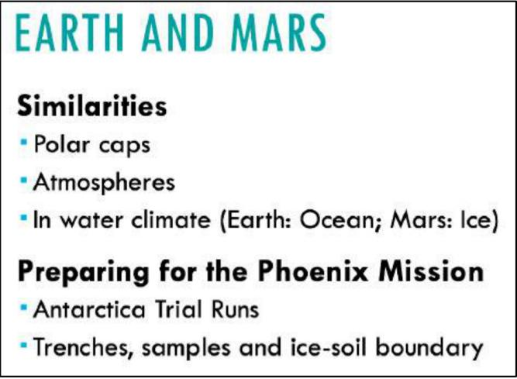
音频原文
A blue PPT is given, and you can read it accordingly.

This lecture compares the conditions on the earth and Mars, as well as the habitability of Mars.
There are some similarities such as polar caps, atmospheres and water climate.

But Mars and the earth also have lots of diﬀerences.

Even the most inhabitable areas on the earth are way diﬀerent from those on Mars.

In preparing for the Phoenix Mission, scientists have done Antarctica trial runs.

The lecture also describes diﬀerent forms of water (hydrology) on the surface and underground of the earth and Mars: on earth, ocean; on Mars, ice.

参考答案
The lecture compares Earth and Mars. They have similarities like polar caps and some water, but are very diﬀerent. Scientists tested equipment in Antarctica for the Phoenix Mars
mission. A key diﬀerence is water: Earth has surface oceans, while Mars has ice.

3. Lecture Outline / 讲座大纲 #9960 低频
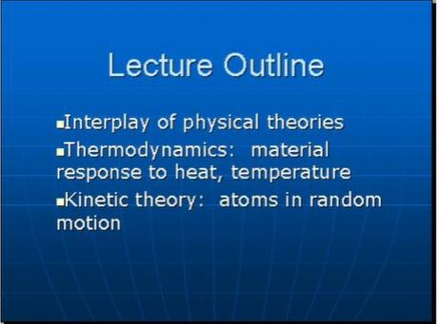
音频原文
Coming out of the nineteenth century with all that happened, and so quickly. Some of these ideas, some of these theories like thermodynamics and kinetic theory, they didn 't blend the way they should have. Thermodynamics has its roots in matter, how material things respond to heat. And temperature, and so forth. The laws of thermodynamics were thought to be
absolute. Now take kinetic theory, if matter consists of atoms in random motion. And that 's what matter is. Then you open up the possibility that there will be ﬂuctuations in samples of matter such. That the laws of thermodynamics can momentarily be violated are the laws of
thermodynamics valid? Absolute. Are they obeyed? Statistically, on average, they're obeyed, but they can be violated during unusual times. All right?
参考答案
The lecture discusses the relationship between thermodynamics and kinetic theory in the
19th century. Thermodynamics, based on the behavior of matter under heat and
temperature, was initially considered absolute. However, kinetic theory introduced the idea of atoms in random motion, suggesting that matter could exhibit ﬂuctuations. These
ﬂuctuations mean that while the laws of thermodynamics hold statistically on average, they can be momentarily violated in rare cases. Thus, thermodynamics is not absolute but
statistically valid.

thermodynamics - L1 - / ˌ θɜrmoʊdaɪ ˈ næmɪks/ n. 热力学；
violate - L1 - / ˈvaɪə ˌ let/ vt. 违反； 妨碍； 侵犯； 亵渎 ，强奸；
kinetic - L2 - /kɪ ˈ nɛtɪk , kaɪ-/ adj. 运动的 ，活跃的 ，能动的 ，有力的； [物]动力 （ 学） 的 ，运动的； obeyed - L2 - // vt. obey的过去怯；

4. Double pendulum / 双摆 #8874 高频
音频原文
The chaos physics equation for a double pendulum is a fascinating topic that explores the
intricate dynamics of this system. The equation involves a set of coupled diﬀerential
equations that describe the motion of the two linked pendulums. Factors such as the length of each arm, the mass of the pendulum bob, and the initial angles of displacement all
contribute to the complexity of the equation.What makes the double pendulum intriguing is its sensitivity to initial conditions. Even the smallest deviation in the starting position or
velocity can lead to drastically diﬀerent outcomes. This phenomenon, commonly known as
the butterﬂy eﬀect, highlights the chaotic nature of the double pendulum 's motion.The chaos physics equation for the double pendulum has practical relevance in various ﬁelds, such as robotics and physics education. Researchers use computer simulations and physical models to experiment with this system, gaining insights into its nonlinear behavior.In conclusion, the chaos physics equation for the double pendulum showcases the complexity and
unpredictability of its motion. This system serves as an intriguing example of chaos theory, reminding us of the intricate dynamics hidden within seemingly simple physical systems.
参考答案
The chaos physics equation for a double pendulum explores the unpredictability and complexity of its motion.
Even minor diﬀerences in initial conditions can lead to signiﬁcant variations in behavior, known as the butterﬂy eﬀect.
Researchers use computer simulations and physical models to study this system, gaining insights into its nonlinear dynamics.
The double pendulum serves as an intriguing example of chaos theory and highlights the intricate dynamics of seemingly simple physical systems.

chaos - L1 - / ˈ keɪɑs/ n. 混乱 ，紊乱； （ 天地未出现的） 浑沌世界； 〈古〉 无底深渊； 一团糟； differential - L1 - / ˌ dɪfə ˈ rɛnʃəl/ adj. 差别的； 特意的； [数]微分的； [机 ，物]差动的；
sensitivity - L1 - / ˌ sɛnsɪ ˈtɪvɪti/ n. 敏感 ，感受性； 仪器等的)灵敏性； [摄]感光度；
chaotic - L1 - /keɪ ˈ ɑtɪk/ adj. 混沌的； 一片混乱的； 一团糟的； 无秩序的；
displacement - L2 - /dɪs ˈ plesmənt/ n. 取代 ，替代； 免职 ，停职； [船] 排水量； [化]置换；
bob - L3 - /bɑb/ vt. 使上下 （ 或来回） 快速摆动； 剪短 （ 头发） ；截短 （ 尾巴） ；轻拍 ，轻叩；

deviation - L3 - / ˌ divi ˈ eʃən/ n. 背离 ，偏离； 离经叛道的行为； [航]偏航； [数]绝对偏差； pendulum - L4 - / ˈ pendʒələm/ n. 摆 ，钟摆； 摇摆不定的事态 （ 或局面） ；

5. Licking and grooming. / 舔舐和理毛 #8868 超高频
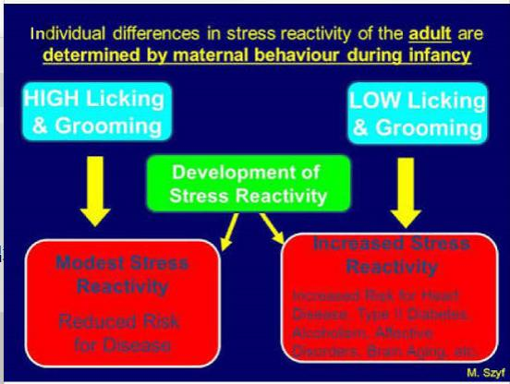
音频原文
The study explores the impact of maternal licking and grooming (LG) on the stress reactivity of adult rats. LG refers to the level of attention and care provided by mother rats to their
oﬀspring through licking and grooming behaviors. The experiment examined the eﬀects of
high and low levels of LG on the stress reactivity of the rats as they grow into adulthood.The ﬁndings reveal that high LG leads to a more moderate stress reactivity in the rats. This has
signiﬁcant implications as it suggests that a nurturing and attentive environment during
infancy can potentially reduce the risk of poor development and diseases later in life. On the other hand, low LG results in an increased stress reactivity in the rats. This, in turn, elevates the risk for various health conditions such as heart disease, type II diabetes, alcoholism,
aﬀective disorders, and brain aging.These ﬁndings highlight the crucial role of maternal care and attention in shaping the stress response system in oﬀspring. It demonstrates that early
experiences and maternal care can have long-lasting eﬀects on an individual 's stress
reactivity and overall health. This study underscores the importance of providing nurturing
and supportive environments for infants to promote optimal development and reduce the risk of various health issues in adulthood.
参考答案

Diﬀerences in stress reactivity of adult rats are determined by maternal licking and grooming ( LG ) during infancy.
L means licking and G means grooming.

The experiment tested on high and low level of licking and grooming that mother rates give to their children, to test out its eﬀect on the children’s stress reactivity.
High LG will bring modest stress reactivity, which can reduce the risk for poor development and diseases.
Low LG will increase the stress reactivity, which can increase the risk for heart disease, type II diabetes, alcoholism, aﬀective disorders and brain aging, etc.

rat - L1 - /ræt/ n. 大老鼠； 似鼠动物； <非正怯>鼠辈 ，卑鄙小人；
groom - L2 - /ɡrum , ɡrʊm/ vt. 使整洁； 使 （ 动物） 清洁； 准备；
underscore - L2 - / ˌʌndər ˈ skɔ(r)/ vt. 划线于 下 ，强调；
supportive - L2 - /sə ˈ pɔrtɪv/ adj. 支持的 ，拥护的 ，赞助的；
lick - L3 - /lɪk/ vt. 舔； <口>打败；
infancy - L4 - / ˈ ɪnfənsi/ n. 婴儿期 ，幼年时代； 初期 ，摇篮时代； [法]未成年； alcoholism - L4 - / ˈ ælkəhɔlɪzəm/ n. 酒精中毒； 酗酒；
reactivity - L5 - // n. 反应性； 反应 ，反动；

6. Cosmic Civilization / 宇宙文明 #8854 中频
音频原文
It begins by stating that every year, seven new stars are formed. However, most of the
planets orbiting these stars are either too hot or too cold to sustain life. Only around 20% of all planets meet the necessary criteria to have the possibility of hosting life.Despite these
favorable conditions, the chances of life actually appearing are incredibly small, almost close to zero. This has made the search for other cosmic civilizations extremely diﬃcult. Scientists have been tirelessly exploring the vast expanse of the universe, using various methods such as radio signals and telescope observations, in the hope of ﬁnding evidence of
extraterrestrial life.While the lecture does not provide concrete proof of the existence of other civilizations, it emphasizes the importance of continuing the search. The quest to discover
other cosmic civilizations not only helps us understand the universe better but also raises fundamental questions about the origins of life and our place in the cosmos.
参考答案
The lecture talks about the possibility of existence of other cosmic civilizations.

Every year, there will have 7 stars be created, but most planets around them either too hot or too cold to appear life.

Only 20% of all planets meet all necessary criteria that have chance to have life.

However, the change of appearance of life is very small, which is near 0.

It is very hard to ﬁnd other cosmic civilizations.

expanse - L4 - /ɪk ˈ spæns/ n. 广阔的区域； 扩张 ，展开； 苍天；

7. Latin America & Globalization / 拉丁美洲与全球化 #8668 高频
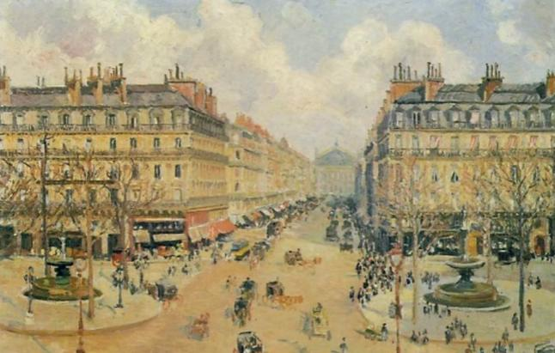
音频原文
What has happened in Latin America as a result of globalization? Well, they have had now
more than a decade of what is called reform, a decade of globalization. And throughout the continent, people are asking questions like has reform failed us? Has globalization failed us? Because clearly things have not worked out the way they were told they ought to. Just to
give you a picture, they were told that reform would lead to faster economic growth after a
decade. What are the numbers? In fact, recent growth is far slower than it was in the ﬁfties, sixties and seventies before reform. That is not a very inspiring success story. Even in the
beginning part of the nineties, growth was still below what it was in the ﬁfties, sixties and
seventies. But the growth it got in the beginning of the period was not sustainable and it was not sustained throughout the region, poverty as measured on the two dollars a day standard as a percentage of the population was actually up.
参考答案

The speaker talks about Latin America 's experience with over a decade of globalization -
related reforms. People there question if these reforms and globalization have failed, as
outcomes didn 't match expectations. Reform was supposed to boost economic growth, yet recent growth is far slower than pre - reform decades (50s - 70s). Even 90s' growth lagged. Early - period growth wasn 't sustainable region - wide. Poverty, measured by the $2 - a - day standard, increased as a population percentage.

ought - L1 - /ɔt/ aux. 应该 （ 指道义上有责任） ；应当 （ 显⽰所采取行动正确或明智） ；可能会； 预料会做 （ 某事） ；
seventy - L2 - / ˈ sɛvənti/ n. 七十； 从七十到七十九的数目 、年数或温度；
ninety - L4 - / ˈ naɪnti/ num. 九十；

8. Universal philosophy / 普遍哲学 #8667 超高频
音频原文
Okay. So this is the this is the big beneﬁt of a universal philosophy. It says it applies to
everybody. Well, looks that doesn 't, you know, 205 or 206 countries in the world. And you 've got something that applies to everybody. That 's a bit strange, isn 't it? No, says liberal theory. There are some value structures that apply to all of us. You couldn 't have the United Nations without it. It couldn 't tell you that the Universal Declaration of Human Rights without this idea of values that apply to all of us just because we are humans. Now, the idea is to test that as well. Why is sport universal? Why does everybody play football? It 's because the values are speciﬁed at a very thin level at the top. There are these rules and we all have to abide by just these rules. But there are lots of things about football that aren 't rules speciﬁed. So Brazilian football is diﬀerent from Italian football, from British football, from German football, from
Spanish football. It 's culturally speciﬁc, but acknowledges that there are these universal general rules to apply to everybody.
参考答案
The lecture talks about a universal philosophy.

According to the lecture, there are some value structures that apply to all of us.

Now, the idea is to test that as well.

Sport is universal because the values are speciﬁed at a very thin level at the top.

There are these rules and we all have to abide by just these rules.

But there are lots of things about football that aren 't rules speciﬁed.

In conclusion, there are these universal general rules to apply to everybody.

okay - L1 - /o ˈ ke/ n. 认可 ， 同意；

liberal - L1 - / ˈ lɪbərəl , ˈ lɪbrəl/ n. 自由主义者； 自由党党员；
declaration - L1 - / ˌ dɛklə ˈ reʃən/ n. 宣言 ，布告 ，公告 ，声明； （ 纳税品在海关的） 申报； [法] （ 原告的） 申诉， （证人的） 陈述 ， 口供； [牌]摊牌 ， 叫牌；
specified - L1 - / 'spesɪfaɪd/ v. 指定( specify的过去怯和过去分词 ) ；详述； 提出 的条件； 使具有特性；

9. Gas giants / 气体巨星 #8557 低频
音频原文
So there are two theories for how the gas giants formed. One is the same theory I showed
you just now core accretion, right? And the other is called disk instability and one of our
colleagues at DTM has done a lot of work on that. And so it 's unclear exactly how they
formed but you 're right what we 're trying to do, the reason we 're trying to get the higher and higher pressure in the lab is because we are trying to understand more about the pressure
inside the gas giants. It 's thought that the gas giants also have a metallic core, but maybe a metallic core is not made of iron. Hydrogen, for example, becomes metallic at a certain
pressure. ok? So it 's very possible that the insides of these planets could have metallic
cores, could have hydrogen cores, could have rocky portions. We 're not sure. But the higher pressure we can get in the lab, the closer we can get to understanding the interiors of the
gas giants and the exoplanet that are so big.

参考答案
The lecture talks about two theories for how the gas giants formed.

According to the lecture, one theory is called core accretion, and the other is called disk instability.
It 's unclear exactly how they formed but you 're right what we 're trying to do.

So it 's very possible that the insides of these planets could have metallic cores, hydrogen cores, and rocky portions.
But the higher pressure we can get in the lab, the closer we can get to understanding the interiors of the gas giants and the exoplanet that are so big.

instability - L2 - / ˌ ɪnstə ˈ bɪlɪti/ n. 不稳定 ，不稳固； 不坚决 ，反复无常； 基础薄弱； metallic - L3 - /mə ˈtælɪk/ adj. 金属的； 金属性的； 金属制的； 含金属的；

10. Three principles / 三种原则 #8556 低频
音频原文
From reading philosophy, I came up with three principles as the guiding principles for a just city, of the principles of equity, democracy, and diversity. Of these were derived from the

works of a number of philosophers, most preeminently I supposed on Ross. My choice of
word equity rather than equality is in fact based on Ross's argument that a policy ought to
distribute beneﬁts to people where the worst oﬀ become better oﬀ . So the worst oﬀ don 't
have to become equal to everybody else but no policy should in fact make those who are
most disadvantaged, more disadvantaged. And it means that we have to talk about the
policy at the time it 's being enacted. To say, while we have to make our city more competitive because sometime and by and by, the beneﬁts will trickle down to those people who were
worst oﬀ doesn 't justify making them worst oﬀ at that time. We have a lot of examples in the world of people whose homes were destroyed in the name of the greater good and say
eventually they will beneﬁt. But equity means that you do not in fact take advantage of those people who are weakest.
参考答案
The lecture talks about equity.

That is one of the guiding principles for a just city.

According to the lecture, his choice of word equity is in fact based on Ross's argument that a policy ought to distribute beneﬁts to people where the worst oﬀ become better oﬀ .
In addition, we have to talk about the policy at the time it 's being enacted, and equity means that you do not in fact take advantage of those people who are weakest.

ought - L1 - /ɔt/ aux. 应该 （ 指道义上有责任） ；应当 （ 显⽰所采取行动正确或明智） ；可能会； 预料会做 （ 某事） ；
enact - L2 - /ɛn ˈ ækt/ vt. 制定法律； 规定； 颁布 ，颁布； 担任 角色；
weakest - L2 - /wikɪst/ adj. 弱的( weak的最高级 ) ；微弱的； 无说服力的； 淡的；
trickle - L3 - / ˈtrɪkəl/ v. 滴； 细细地流； 使淌下； 慢慢地移动；

11. Four fundamental forces / 四种基本力 #8555 超高频
音频原文
There are four fundamental forces at work in the universe. Some of them are very familiar
from everyday life. Some of them are not. So we all know about gravity. That 's one of the
four forces. It 's what keeps our ankles to the surface of the earth, and keeps the Earth in
orbit around the Sun. There is another force that we 're very familiar with, which is the
electromagnetic force. That is the force that is responsible for the electricity, electric currents for light, for the sun 's light, that 's electromagnetic radiation coming from the Sun to the
Earth.

There are two other forces though that are somewhat less familiar. They are the nuclear
forces. They are forces that are at work within the nuclear atoms. One of those forces is
called the strong nuclear force. That really is the force that bides protons to protons, bides

the corks inside of the protons and neutrons keeping them from ﬂying out. The other nuclear force is called the weak nuclear force. And that 's a force that predominantly we know of
because it 's responsible for radioactivity, radioactive decay.

So those four forces, strong nuclear force, weak nuclear force, electromagnetic force and gravitational force, those are the forces that work in the universe.
参考答案
The lecture talks about four fundamental forces that work in the universe.

According to the lecture, gravity is one of the four forces. It 's what keeps our ankles to the surface of the earth, and keeps the Earth in orbit around the Sun.
Another force is the electromagnetic force.

That is the force that is responsible for the electricity, electric currents for light.

There are two other forces that we 're less familiar with, one of those forces is called the strong nuclear force.
The other nuclear force is called the weak nuclear force.

ankle - L1 - / ˈ æŋkəl/ n. 踝 ，踝关节； 脚脖子；
decay - L1 - /dɪ ˈ keɪ/ vt.& vi. （使） 腐烂 ，腐朽；
cork - L4 - /kɔrk/ n. 软木； 软木塞； （ 钓鱼用） 软木浮子； [植]外皮；
bide - L5 - /baɪd/ vi. 等待 ，停留； 居住；

12. Alaska / 阿拉斯加人 #8554 高频
音频原文
One of the social issues faced by the state of Alaska is the lack of mental and emotional
well-being of the native Alaskans. It is very unfortunate that many of the Native Americans
are living under poor conditions throughout the country. In the cases of native Alaskans, even virtually entire villages are suﬀering from a lack of mental and emotional well-being, which
includes continuing poor physical and mental health. Alcohol abuse, domestic violence,
homicides, and suicides are frequent among them, which of course, lead to families falling
apart. It is tragic to see that many children are abused and not educated properly. As a
matter of fact, the children themselves are abusing alcohol and other chemicals, and the rate is increasing over time. Since parents are suﬀering from mental illnesses and alcohol abuse, they can 't take care of their children. So many children are being taken care of by others or
simply neglected. Therefore, we can conclude that Alaskan natives are losing hold of their
communities, cultural identities, and most importantly, their childhoods. So you can see how serious the issue is. Plus, rather than making a living for themselves, they are depending on

public services and subsidies. They have lost control of and responsibility for their economy and governing institutions.
参考答案
The lecture talks about social issues.

According to the lecture, native Alaskans are suﬀering from a lack of mental and emotional well-being.
This is because many of the Native Americans are living under poor conditions, and alcohol abuse, domestic violence, homicides, and suicides are frequent among them, which of
course, lead to families falling apart.

In conclusion, Alaskan natives are losing hold of their communities, cultural identities, and most importantly, their childhoods.

unfortunate - L1 - /ʌn ˈfɔrtʃənət/ adj. 不幸的 ，倒霉的； 不吉利的； 不成功的； 可惜的 ，可叹的； suicide - L1 - / ˈ suɪ ˌ saɪd/ n. 自杀； 自杀者； 自杀行为；
subsidy - L1 - / ˈ sʌbsɪdi/ n. 补贴； 津贴； 助学金； 奖金；
tragic - L2 - / ˈtrædʒɪk/ adj. 悲剧的； 悲惨的；
homicide - L3 - / ˈ hɑmɪsaɪd/ n. 杀人 （行为） ；杀人犯； 杀人罪；

13. Tobacco / 烟草 #8553 高频
音频原文
Over the past few months, the government has been pushing to remove all advertising
outlets for the tobacco industry, and in particular pushing for plain packaging. The tobacco industry, however, is against this and they in particular argue that the cigarette box is not a form of advertising. Michaela has been doing her Ph.D. looking at cigarette advertising and how it 's changed over the last 50 years.
Basically, I 've accessed advertising from the tobacco industry since the 1950s and just
analyze the images and looked at the use of the cigarette box within the adverts. In the very early adverts, the cigarette box is a very small part of the adverts and they focus much more on the social aspects of smoking. However, as you move through the decades and get closer to the present day, the cigarette box became more and more of a focal point in the adverts.
My argument is that the cigarette box has actually become iconic to each brand. So when a smoker takes a box out of their pocket, they are actually advertising that brand.
So what we hope will come out of this is that the government will introduce plain packaging. And like Australia which has already introduced its policy and Ireland which is again

beginning to introduce its policy, we hope that the UK will stop cigarette companies from using their box as a form of advertising.
参考答案
The lecture talks about cigarette advertising.

According to the lecture, over the past few months, the government has been pushing to remove all advertising outlets for the tobacco industry, and in particular pushing for plain packaging.
The tobacco industry argues that the cigarette box is not a form of advertising, while
Michaela and the speaker believe that the cigarette box has actually become iconic to each brand.
So we hope that the government will introduce plain packaging, and the UK will stop cigarette companies from using their box as a form of advertising.

pocket - L1 - / ˈ pɑkɪt/ n. 口袋 ，钱袋； 金钱 ，财富； 容器； 凹处；
advert - L2 - / ˈ ædvɜrt/ n. 〈英口〉 同 “advertisement ”；
focal - L2 - / ˈfoʊkl/ adj. 焦点的 ，有焦点的； 集中在点上的； 病灶的 ，病灶性的； smoker - L4 - / ˈ smoʊkə(r)/ n. 吸烟者；

14. Red planet / 火星 #8052 低频 不可练习
回忆要点：About the red planet Mars Which is the fourth planet in the solar system, smaller than earth, Colder than earth, and bigger than the moon.

15. Body language / 肢体语言 #7961 低频 不可练习
回忆要点：About the importance of body language for actors, who have to learn to
understand their body behaviors according to the diﬀerent emotions and how to express them and interpret real life situations.

16. Marco Polo / 马可波罗 #7960 低频 不可练习
回忆要点： 讲Marco Polo ，提到了 the lone wanderer ，middle east ， of Asia and Africa ，欢迎大神来补充

lone - L1 - /loʊn/ adj. 孤单的； 孤独的； 人迹稀少的； 孤寂的； polo - L2 - / ˈ poʊloʊ/ n. 马球； 水球；
wanderer - L4 - / ˈ wɑndərə(r)/ n. 流浪汉； 闲逛者； 游走动物；

17. Melbourne's traﬃc / 墨尔本的交通 #7699 低频 不可练习
回忆要点：2021年4月1日阿德莱德考到。 墨尔本的交通 ， 图片是弗林德斯火车站。 一开始说了工业化 ， 大概就是改变生活的意思。 然后文中提到了墨尔本 ， 说以前人们都只去近的地方 ，现在有了公共交通 ，人们可以去更远的地方。

18. From farm to table / 从田野到餐桌 #7675 高频 不可练习
回忆要点： 贡献一道新题： 一张图是各种蔬菜 ，有青椒 ，茄子 ，辣椒。然后内容说的是包含饮食健康以及from farm to table ，有小伙伴最近考到这道题吗？

19. A successful entrepreneur / 成功的企业家 #7641 超高频
音频原文
To be a successful entrepreneur, you should have good ideas, but the deﬁnition of a good
idea varies depending on whom you ask. A great idea should have several features. Firstly,
the great idea should be various and novel. Secondly, the great idea should be unique, which means no one has thought about it. Thirdly, it is essential for great ideas to be transformative and productive. All ideas are essentially a combination of other smaller ideas, but this
doesn 't mean they can 't be unique. Merely copying doesn 't make anything idiosyncratic, it 's the individuality that one puts in which makes a concept stand out. Constant innovation
leaves no room for stagnation and thus, adds on to the basic idea, eﬀectively making it
unique. Unique ideas are inspired by basic things, they are simply extensions of pre-existing notions. And, an idea or a concept is unique only when it transcends its predecessor and
serves its purpose in a better and more precise way.

参考答案
The lecture mainly talks about good ideas.

According to the lecture, a great idea should have several features.

Firstly, the great idea should be various and novel.

Secondly, the great idea should be unique, which means no one has thought about it.

Thirdly, great ideas need to be transformative and productive.

Finally, unique ideas are inspired by basic things.

transcend - L1 - /træn ˈ sɛnd/ vt. 超越 ，超出 的限度； 优于或胜过 ；高于或独立于 （ 宇宙） 而生存； stagnation - L2 - /stæɡ ˈ neʃən/ n. 淤塞 ，停滞； 不景气； 滞止；
individuality - L3 - / ˌ ɪndə ˌ vɪdʒu ˈ ælɪti/ n. 个人； 个性； 个人特征；

idiosyncratic - L5 - / ˌ ɪdɪrsɪŋ ' krætɪk/ adj. 乖僻的； 怪您的；

20. Leadership / 领导力 #7611 超高频
音频原文
A leader can deﬁne or clarify goals by issuing a memo or an executive order, an edict or a
fatwa or a tweet, by passing a law, barking a command, or presenting an interesting idea in a meeting of colleagues. Leaders can mobilize people 's energies in ways that range from
subtle, quiet persuasion to the coercive threat or the use of deadly force. Sometimes a charismatic leader such as Martin Luther King Jr. can
deﬁne goals and mobilize energies through rhetoric and the power of example. We can think of leadership as a spectrum, in terms of both visibility and the power the leader wields. On
one end of the spectrum, we have the most visible: authoritative leaders like the president of the United States or the prime minister of the United Kingdom, or a dictator such as Hitler or Qaddaﬁ . At the opposite end of the spectrum is casual, low-key leadership found in
countless situations every day around the world, leadership that can make a signiﬁcant
diﬀerence to the individuals whose lives are touched by it. Over the centuries, the ﬁrst kind, the out-in-front, authoritative leadership, has generally been exhibited by men. Some men in positions of great authority, including Nelson Mandela, have chosen a strategy of " leading
from behind more often, however, top leaders have been quite visible in their exercise of
power. Women(as well as some men) have provided casual, low-key leadership behind the
scenes. But this pattern has been changing, as more women have taken up opportunities for visible, authoritative leadership.
参考答案
The lecture mainly talks about leaders.

Firstly, a leader can deﬁne goals and mobilize people 's energies.

Secondly, we can think of leadership as a spectrum, in terms of both visibility and the power the leader wields.
Thirdly, authoritative leadership has generally been exhibited by men.

Finally, women have provided casual, low-key leadership behind the scenes, but this pattern has been changing.
rhetoric - L1 - / ˈ rɛtərɪk/ n. 修辞学； 辩论法 ，雄辩术； 华丽的文词； 花言巧语； visibility - L1 - / ˌ vɪzə ˈ bɪlɪti/ n. 能见度； 可见性； 可见距离； 清晰度；
memo - L2 - / ˈ memoʊ/ n. 备忘录； （ 美） 内部通知；
tweet - L2 - /twit/ vi. 鸣叫；
mobilize - L2 - / ˈ moʊbəlaɪz/ vt. 调动； 动员； 组织 ，动员起来；

persuasion - L2 - /pər ˈ sweɪʒn/ n. 劝说 ，说服 （ 力） ；信仰；
coercive - L2 - /koʊ ˈ ɜrsɪv/ adj. 强制的 ，强迫的； 高压的；
wield - L2 - /wild/ vt. 使用 （ 武器、工具等） ；运用 （权力） ，施加 （ 影响） ；行使； 支配；

21. Graphical representation / 图解表⽰法 #7328 超高频 不可练习
回忆要点： 一个RL视频题 一个男的在讲台上演讲 背景是放映的ppt ，标题是graphical representation 提了很多次graphical representation 图片是一个视频/音频剪辑软件的画面 ，开始说music 可以record modiﬁed redone, 接下来说是一种software ，可以在
computer上使用 ，最后说这些都是electronic的 ，这个job很professional。

22. Street stalls / 地摊 #7316 高频 不可练习
回忆要点： 只记得图片 ， 内容不记得了。像个集市 ，有很多人在摆摊 ，摊位有三排 ，每一排中都有一个是空白的

23. General-purpose car / 通用小车车 #7315 低频 不可练习
回忆要点：左边一个红色的车 车牌VJ 后面跟三个数字 内容 general-purpose car 主要讲他给人们带来许多生活变化 People can drive and go everywhere more comfortably. 提到go to Scotland It changed the way we live and the way we educate because we can go to
school by car. Improve individual mobility and be more wealthy.剩下的忘了

24. Procedural fairness / 程序公正 #7249 高频 不可练习
回忆要点：屏幕上有个淡橘色的PPT ，有kumar case的标题 ， ，写了justice, procedural fairness,conclusion是一男一女的对话 ，男的问女的你对于法律系统有什么concern ，举了一些专业术语justice, 什么independency, procedural fairness ，然后女的说就是PF ，他可以让这个party able to see the other’s evidence, provide information/ opportunity to
question the other side但是最后结论是actually影响到了fairness ，我听下来的意思是程序正义影响了实体公正。
背景： 在1991年“库马案(Subash Kumar case)” 中 ，印度法院认为 ，“第21条保障的生命权包括享受满足生命需要的无污染水和空气的权利。”通过这些案件 ，法院确认对健康环境的权利是生命权的一部分。 而且重申了政府的有效实施环境法律的义务 ， 因为防治环境退化是国家的义务。

procedural - L2 - /prə ˈ sidʒərəl/ adj. 程序的； 有关程序的；
fairness - L3 - / ˈfernəs/ n. 公正 ，公平； （ 皮肤的） 洁白 ；金发； 顺利性；

25. Globalization / 全球化 #6863 高频
音频原文
I 've been thinking a lot about the world recently and how it 's changed over the last 20, 30, 40 years. Twenty or thirty years ago, if a chicken caught a cold and sneezed and died in a
remote village in East Asia, it would have been a tragedy for the chicken and its closest
relatives, but I don 't think there was much possibility of us fearing a global pandemic and the deaths of millions. Twenty of thirty years ago, if a bank in North America lent too much
money to some people who couldn 't aﬀord to pay it back and the bank went bust, that was bad for the lender and bad for the borrower, but we didn 't imagine it would bring the global economic system to its knees for nearly a decade. This is globalization. This is the miracle
that has enabled us to transship our bodies and our minds and our words and our pictures
and our ideas and our teaching and our learning around the planet ever faster and ever
cheaper. It 's brought a lot of bad stuﬀ , like the stuﬀ that I just described, but it 's also brought a lot of good stuﬀ . A lot of us are not aware of the extraordinary successes of the Millennium Development Goals, several of which have achieved their targets long before the due date.
That proves that this species of humanity is capable of achieving extraordinary progress if it really acts together and it really tries hard.
参考答案
This is globalization about the example of chicken died and bank bust.

This is the miracle enabled us to transship our bodies and our minds around the planet ever faster and ever cheaper.
There is a lot of bad stuﬀ and good stuﬀ .

A lot of extraordinary successes of the Millennium Development Goals.

Humanity is capable of achieving extraordinary progress if acts together and tries hard.

bust - L1 - /bʌst/ vt.& vi. 打破 ，打碎；
miracle - L1 - / ˈ mɪrəkl/ n. 奇迹 ，圣迹 ，神迹； 令人惊奇的人 （ 或事） ； sneeze - L2 - /sniz/ n. 喷嚏； 喷嚏声；
lender - L2 - / ˈ lendər/ n. 出借人 ，贷方；
borrower - L5 - / ˈ bɑroʊə(r)/ n. 借钱人； 借用人 ，剽窃者；

26. Making mistakes / 犯错 #6862 低频 不可练习
回忆要点：Thinking of doing the right thing or wrong thing. For example, if a task is well designed, people are likely to do the right things, otherwise they are prone to make
mistakes. Distractions: People will forget they are in the middle of doing something. For

example, we usually forget to take the original copy after using the copy machine if
something disrupts the thinking process. There are two strategies to avoid making
mistakes. The chance of making mistakes depends on the quality of task design so you could polish the instructions. If the task is well designed, people are likely to do right
things. People are likely to make mistakes. Remember to avoid distractions. The people who do photocopying might leave the original copy in the machine if the thinking
process is disrupted.

photocopy - L2 - / ˈfoʊtoʊkɑpi/ n. 影印本； 复印件；

27. Globalization makes people closer / 全球化让人更亲近 #6529 低频
不可练习
回忆要点： 视频题 ，有墨大电车站 ，州立图书馆门前车站 ，具体内容欢迎大神补充

28. Attention interval / 注意力集中时间 #6527 低频 不可练习
回忆要点： 10 years ago, before the use of iPad and iPhone, people 's attention interval is about 25 minutes. This number is good. However, nowadays the intention interval has
dropped from 25 minutes to only 8 seconds ， which means our memories are shorter than that of a goldﬁsh.
goldfish - L4 - / ˈ goʊldfɪʃ/ n. 金鱼；

29. Measuring food / 手量食物 #6386 低频
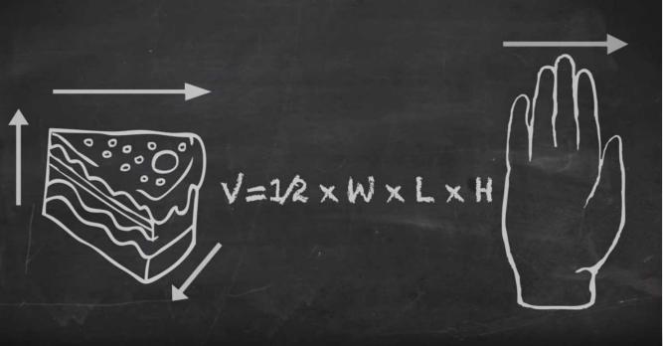

音频原文
I 'm a dietitian and I work in clinical weight-loss recently. Accurately estimating portion size is critical in research or real-world settings. For example, if you 're trying to watch your weight
and you 're out to dinner and you 're presented with a bowl of food, there 's no really good way to actually estimate how much you 're eating unless you 're gonna whip some scales out of
your bag. So we wanted to ﬁnd a more objective way for people to quantify what they're
eating when they 're out and about. I came up with a more hands-on approach. We got
people to measure the dimensions of the food using the width of their ﬁngers and
remembering back to primary school maths. We use the geometric volume formulas to
estimate the weight of the food. To show you how this works, I 've ordered a piece of
lasagna. And that 's my box, a glass of wine and that 's my cylinder. And I 'm feeling pretty healthy, so I order some watermelon for dessert. And that 's my wedge. So this was I know it's seven by ﬁve, by four ﬁngers. in the future, I see this method be incorporated into
smartphone applications. So you put your ﬁnger, it 's in along with your height and your weight. And the app will do all of the calculations for you. And then you 've got a more accurate way to estimate the portion size.
参考答案
This lecture talks about accurately estimating portion size.

Firstly, the speaker works in clinical weight loss as a dietitian and thinks accurately
estimating portion size is critical because there’s no good way to measure food when dinning out.
Secondly, the speaker mentions a more objective way to quantify food: using the width of ﬁngers to measure the dimensions of food.
Thirdly, the speaker mentions smartphone applications that do all the calculations to make a more accurate estimation.
In conclusion, ﬁngers and apps can help estimate the portion size.

bowl - L1 - /boʊl/ n. 碗； 一碗东西； 碗状物； [体]木球；
quantify - L2 - / ˈ kwɑntɪfaɪ/ vt. 确定 的数量； [逻辑学] 用量词限定；
cylinder - L2 - / ˈ sɪləndɚ/ n. 圆筒 ， 圆柱； 汽缸； （ 尤指用作容器的） 圆筒状物；
watermelon - L2 - / ˈ wɔtərmelən/ n. 西瓜；
dessert - L2 - /dɪ ˈ zɜrt/ n. 餐后甜食； 甜点；
wedge - L2 - /wɛdʒ/ n. 楔； 楔形物； （ 击高尔夫球的） 楔形铁头球棒； 〈比喻〉 可以逐渐扩大作用的开端； whip - L3 - /hwɪp , wɪp/ vt. 鞭打 ，抽打； 严厉地折磨、责打或责备 ，迫使； 把 打起泡沫；
formula - L3 - / ˈfɔrmjələ/ n. 公怯 ，准则； 客套话； 方案； 婴儿食品； lasagna - L5 - /lə ˈ zɑnjə/ n. 烤宽面条 （ 上浇肉末番茄汁） ；

30. Fashion dress / 时装发展史 #6355 低频 不可练习
回忆要点： 讲Fashion dress发展历史 舞台展⽰ 提到了巴黎伦敦 反正不难懂 就跟着录音记关键词说出来就好了

31. The Silk Road / 丝绸之路 #6315 低频 不可练习
回忆要点：The Silk Road is not like what we thought it would be. People traveled in groups to other countries through the Silk Road, exchanged things, and then came back. There were also some side groups who went to other countries such as India, which was called the 'Amber Route '. At that time, there was also gift changing
happened on the Silk Road.

silk - L1 - /sɪlk/ n. 丝 ，蚕丝； 丝绸 ，丝织物； （ 用于=纫的） 丝线； 王室法律顾问； amber - L1 - / ˈ æmbɚ/ n. 琥珀； 琥珀色； [军]线状无烟火药；

32. Robot and unemployment rate / 机器人与失业率 #6308 低频 不可练习
回忆要点： 考到视频题 ，也跟robot有关。 说了那谁谁谁是the father of technology, 提到了Henry Ford （好像是这个名字） 还说了unemployment rate。 有了robot ，有的工作就不需要人做了 ，导致了失业率上升。 robot的出现是好还是坏？
ford - L1 - /fɔrd/ n. 浅滩 ，可涉水而过的地方； 福特 （ 人名） ；福特汽车；

33. Choose scientiﬁc theory / 如何挑选科学理论 #6223 低频 不可练习
回忆要点： 有个视频 开头是一个ppt 上面写着acceptance 然后教授出来说话说how to
choose a better one in a lot of scientiﬁc theories （视频从头到尾一直是一个PPT ，结束之后视频关闭 ，PPT也随之消失 ，注意做好笔记！）

34. File a patent / 申请专利 #6207 低频

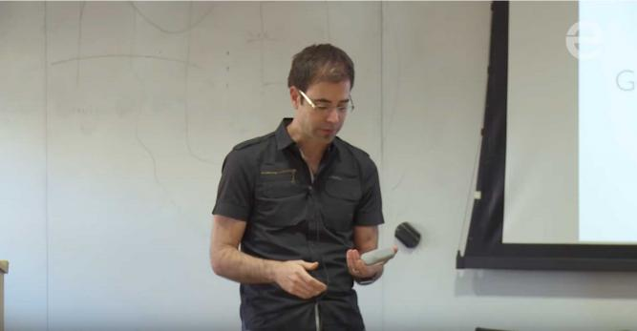
音频原文
We’re thinking about this and we’re trying to say, alright, well, let’s ﬁle on a patent on this
clicker. If I were to go to the patent oﬃce and say, alright, I want a patent on a clicker, period. The patent oﬃcer would just laugh. You know, the clicker has been around for a while.
Presentation clickers have been around for a while. And so there would be a 0% chance that you would actually get that. If we were to somehow to convince the patent oﬃce that we
should be able to get on a patent on clicker, period. It would, however, be incredibly valuable. Every single clicker that was made after this point would infringe. And when it infringes,
maybe we take one or two dollars each. That would be added up to be a decent amount of money. On the other end of the spectrum, let’s go to the million-word version. I go to the
patent oﬃce and I say, I want a patent on this exact thing. And those million words describe every single radius, every single material, every single thing about this. And the patent oﬃcer says, yeah, we ‘ve never seen that before. Go ahead and take it. Almost 100% of chance of getting that patent, but the value of that patent would be close to zero.
参考答案
This lecture is mainly about patent.

If we are able to get on a patent on clicker, period, it would be incredibly valuable.

Every single clicker that was made after this point would infringe, and it one or two dollars each.
That would be added up to be a decent amount of money.

If the patent oﬃcer have never seen that before, we have almost 100% of chance of getting that patent, but the value of that patent would be close to zero.

alright - L1 - /ɔl ˈ raɪt/ adv. 好的； 正确； 令人满意；
yeah - L3 - / ˈjɛə , ˈjæə , jɛ-/ adv. ( yes的俗音)； （ 用于表⽰对后说的话不相信） ； （ 用于作出回应） 哦； 是； infringe - L4 - /ɪn ˈfrɪndʒ/ vt.& vi. 违反 （ 规章等） ；侵犯 （ 某人的权利） ；侵犯； 侵害 （ 某人的自由、权益等） ；

35. Innovation and invention / 创新与发明 #6204 低频
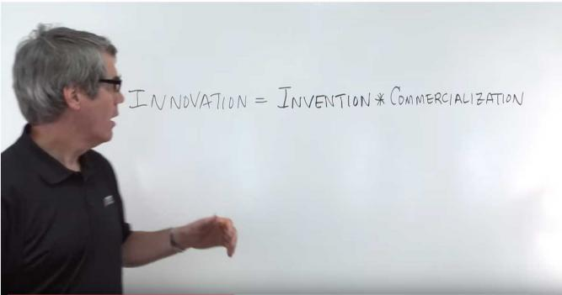
音频原文
He says innovation equals invention. Let me just stop here. Innovation equals invention often people mistake these two things for the same thing. Innovation equals invention, they are
not. Innovation is something that generates value for the world. It makes something faster,
better, cheaper. It gives someone some great satisfaction. An invention is an idea, a
technology, a patent. In and of itself, it does not generate value. So these two are not the
same thing. And sometimes you see them interchange. And that 's not correct. So innovation equals invention times commercialization. So and when we look at this equation of
innovation something of value, it requires a new idea and then it requires someone or some organization that is going to commercialize that idea and to make it a value to the world.
参考答案
This lecture talks about the relationship between innovation and invention.

Firstly, the speaker mentions that people think innovation equals invention but it’s not correct.
Secondly, the speaker mentions that innovation generates value for the world and gives people satisfaction, but the invention is an idea that does not generate value.

Thirdly, the speaker mentions that innovation equals invention times commercialization.

In conclusion, innovation equals to commercializing a new idea to make value.

interchange - L2 - / ˈ ɪntərtʃeɪndʒ/ vt. 互换 ，交换； 交替 （ 位置等） ；使更叠发生； 交替发生；

36. Measurement / 计量方怯 #6198 低频 不可练习
· 回忆要点： Go back to the early times, when there was no international measurement standard system. 后面介绍measurement计量方怯 ，求大神补充

37. Hats / 帽子 #6184 低频 不可练习
回忆要点： 图片题 ，keywords好像有18 century ， heading还是hat development ， 颜色比较黄

38. Chloe sunglasses / 真假蔻依墨镜 #6183 低频 不可练习
回忆要点： 女声 ，篇幅比较短 ，有图片 ， 图片是画了两个墨镜 ，土豪金颜色的镜框 ，写着 sunglasses ，说了真假Chloe墨镜 ，真的价值300刀 ，假的30刀 ，real Chloe sunglasses 给了一组人 ，发现戴fake的在做questionaires的时候会更cheating ，之后还说戴了真的会增加conﬁdence

39. Advertising standard authority / 英国广告标准局 #6174 高频 不可练习
回忆要点：介绍HFSS ，搜了下是food high in fat, sugar and salt -advertising standard
authority 介绍这个ASA （Advertising Standard Authority） 组织做什么的 help consumers to make healthy decisions in buying food and drinks, 全程提了好几次help make healthy decisions, 然后提到 it also helps consumers to identify the food contents in the labeling, like sugar, salt, 还有啥不记得了 今天突然想起来

40. Visual culture / 视觉文化 #6164 低频 不可练习
This topic is described as the visual culture in science ﬁction.
The visual culture in science ﬁction involves drama, culture, technology, and most importantly, logical and visual.
This was minor and sub-cultural until a big change occurred since the introduction of the movie Star War.
The story of the movie is stupid and aggressive, but the speaker still likes it because of the well-designed visual logic.

Fiction is a part of the visual culture now.
回忆要点： Visual culture in science ﬁction涉及到了drama, culture, technology, 然后说最重要的是logical和visual. movie star war. 这个电影的剧情stupid并且有些aggressive什么的, but he still likes it because of the well-designed visual logic. Fiction is a part of the
visual culture now.

stupid - L1 - / ˈ stupɪd/ adj. 愚蠢的； 迟钝的； 乏味的； 晕眩的 ， 昏迷不醒的；

41. New train / 新怯火车 #6163 低频 不可练习
回忆要点： 大家有没有遇到一个视频的 ，一个男的讲新怯火车发展的！ 说的贼快！

42. Telescope / 望远镜 #6161 超高频 不可练习
回忆要点： 视频题 ，一个女的站那一直讲。 内容应该是讲一些instruments used in space observation ，一开始说telescope ，我们把telescope 放在higher areas 这样观察更清楚 ，特别是放在desert and mountain areas ，然后说有些instruments比如Hubble Telescope,在space里有很多functions ， 比如transfer images back ，到别的星球拍下那里的的照片，最后好像是help understand earth还是space

43. Lecture Outline / 讲座大纲 #6159 低频
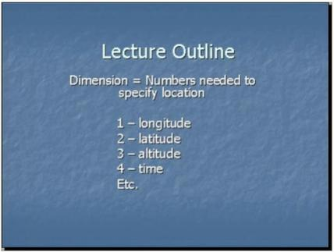
音频原文
So let me begin with the notion of a dimension. The dimension is simply how many numbers if you need to specify a location. So if we think about the surface of the earth, the equator is one dimensional. You need to specify only one number to specify a location on the equator, namely the longitude. The surface of the earth altogether is, of course, two dimensional. You

need to specify two numbers, the latitude and longitude to specify location on the earth. The space above the earth is three dimensional. If I want to tell you the location of a hang glider, I need to give you the latitude, longitude and altitude. But mathematically, there 's no reason to stop at three dimensions. A four dimensional space is simply a space in which you need to
specify four numbers to specify a location. In that space, a ﬁve dimensional space would be one in which you need to specify ﬁve numbers, etcetera. In fact, I claim you already know an example of a four dimensional space. So let 's deﬁne an event. Just to be an occurrence that happens in a small region of space at a deﬁnite time. In other words, an event is like a Snap of your ﬁngers or a clap of your hands. And now the collection of all events. If I want to
specify an event, I need to give you four numbers. I need to tell you where it happens in space and when it happens in time.
参考答案
One-dimension means you can describe a position on equator by longitude only.

Two-dimension means you can describe a position on the earth by longitude and latitude.

Three-dimension means you can describe a position over the earth by longitude, latitude and altitude.
Four-dimension means you can describe a position in space and take the time into account.

specify - L1 - / ˈ spɛsə ˌ faɪ/ vt. 指定； 详述； 提出 的条件； 使具有特性； occurrence - L1 - /ə ˈ kɜrəns/ n. 发生 ， 出现； 遭遇 ，事件；
snap - L1 - /snæp/ vt.& vi. 猛地咬住； 呵斥； 折断；
glider - L3 - / ˈ ɡlaɪdɚ/ n. 滑翔机； 滑行者； 滑翔导弹； 摆动怯沙发椅；

44. Keyboard / 琴键技法 #6158 低频 不可练习
回忆要点： 视频题 ，讲keyboard ，左边一个男人弹钢琴的 ，右边男教师讲解keyboard
music ， keyboard题说乐手refuse to write down还故意play badly in front of audiences 因为不想别人学会他们的technique

45. Age structure / 年龄结构 #6153 低频 不可练习
回忆要点： Pyramid is often used to show age structure. The bottom has the largest portion, indicating new-born babies and teenagers. The oldest people has the least
number. Then the lecture compare the age structure in 1976 to the age structure now.

46. Leadership practices / 领导力练习 #6124 低频 不可练习

回忆要点： 考了一道关于leadership practices for students in universities ，主要有5个major practices, clear goal, money time, staﬀ improvement, students and
staﬀ ...environment 记不大清了orz ，貌似没搜到类似的

47. Three types of questionnaires / 三种调查问卷 #6122 低频
音频原文
What I 've decided to provide is the steps that I take when analyzing my own questionnaires. However, before I begin, it would be useful to remind you of a few terms we use when talking about questionnaires. Questions can be divided into three types. This is sometimes called
level measurement. Firstly, we have category type questions, which are also known as
nominal questions. These are when participants select from a list of categories for their
response, such as male or female or they may include ethnic origin. Secondly, we have
ordinal type questions. These are similar to category questions. But instead of the categories being independent, there is some sort of order between them. If we ask people to indicate
their age in categories, this is an ordinal type question. Thirdly, we have continuous
questions. These are any questions that can be answered by a number. It could be an open- ended question asking participants to tell you how many times they attended lectures or how often they used a VLE. Or it could involve asking them to rate the importance of intensity of
some experience.

参考答案
In the questionnaires, questions can be divided into three types, called level measurement.

Firstly, we have category type questions. It means participants select from a list of categories for their response.
Secondly, we have ordinal type questions. These are similar to category questions.

Thirdly, we have continuous questions. These are any questions that can be answered by a number.

ethnic - L1 - / ˈ ɛθnɪk/ adj. 种族的 ，部落的； 某文化群体的；
nominal - L2 - / ˈ nɑmɪnl/ adj. 名义上的； 微不足道的； 票面上的； 名字的 ，列名的； ordinal - L5 - / ˈ ɔrdənl/ n. 序数； 比较；

48. US growth rate in globalization / 全球化中美国经济增长 #6087 低频
不可练习
回忆要点： result of globalization for US and growth rate This lecture is about the
relationship between globalization and growth rate in US The growth rate in 2000 is
much lower than 1960 before the globalization But the poverty has up to a large degree

49. Feel nervous in presentation / 演讲时紧张 #6083 低频 不可练习
回忆要点：
回忆1.视频题 ， 中年男教授 ，语速适中 ，逻辑清晰。 说if people feel nervous and speak quickly, audience would not understand what you said. Another part is about how to overcome. Don 't out too much information, you just keep 3 points 还提到prepare in
advance
回忆2.考过这一题 补充一下 speakers叫Luke, 然后后面overcome 的方法其中一个点是only mention 3 points in 15 minutes

50. Discovering the port of Roman London / 罗马伦敦港 #6082 低频
音频原文
But what we are going to discuss today is how the port of London was discovered and what we discovered about it. Now if you look at the historical records of Roman London, there is only about 14 actual references to London in antiquity I contemporary references. And all
those only one is in the ﬁrst century, there are none at all at the second or third century.
There is only one in the late third century and there is four in the fourth century. So if you are a historian trying to write the history of Rome in London, it 's really diﬃcult. You don 't have
much data, you 're going to depend on the archaeological evidence, the material evidence of the port and indeed the town to have any understanding of what happened then. And so,
what we 're looking at here is how did we discover about the port of London, there is no
historical documentations, no customs books, no terrorists, no idea of the taxes. We have to understand the port entirely from the archaeological evidence. So that 's what we are going to do today. So, if we move on to the next slide, I love live streaming. Thank you very much.
参考答案
This lecture is about the historical records of Roman London.

There is little records for the records.

If the historian trying to write the history of Rome in London, it 's really diﬃcult.

The lecture also talks about how to discover about the port of London.

We have to understand the port entirely from the evidence.

antiquity - L2 - /æn ˈtɪkwɪti/ n. 古老 ，古代； 古迹 ，古物； 古人； 古代的风俗习惯； terrorist - L2 - / ˈtɛrərɪst/ n. 恐怖主义者 ，恐怖分子；

51. Newton's apple / 牛顿的苹果 #6072 低频 不可练习


回忆要点： 考了一道老题 牛顿的苹果 带图一个小小少年抱着双膝仰望天空中的红苹果 大概内容关键词 Observation ，Gravity ，magnitude ，earth and planets 我听力糊了 过7不过8 这几个关键词我是十分确定 内容大概是 “透过现象看本质” “苹果落下发现gravity” “观察重要”

52. Sound and light speed / 声速和光速 #6047 低频 不可练习
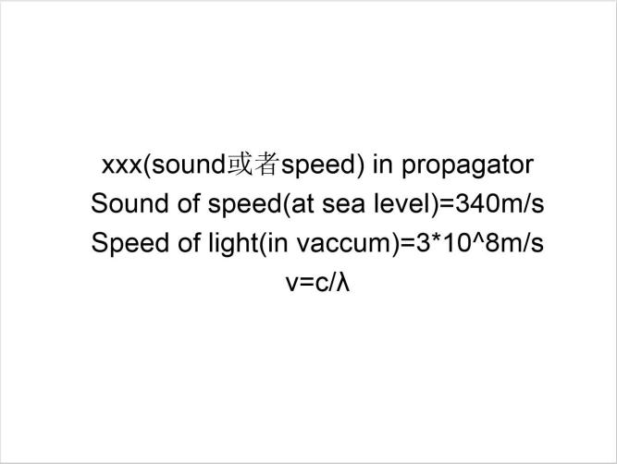

回忆要点： 1. 声音速度约300m/s；光速是声音速度的一百万倍。光速约是300million
m/s。2. 例子1 ：所以thunderstorms 时候 你看到闪电 再听到打雷 3. 例子2: 在体育场看比赛的时候 你会觉得对面的人比你欢呼的晚 ， 因为你们同时看到精彩瞬间。但是声音传播慢所以你觉得对面的人欢呼的晚。

53. Method of organizing data / 整理数据的方法 #6040 低频 不可练习
回忆要点： 视频题 ，主干都在视频里； 大概讲 如何 organized data 的 method ，共四个steps；是个黄色背景的ppt（ 录音结束后 ppt消失了 ，抓紧时间抄）

54. New energy / 新能源 #6030 低频 不可练习
回忆要点： 一道关于能源的题目 有个图片是风力发电的风车 但是内容不是机经内容 主要说的是 环境问题变的严峻 人们不知道如何减少co2的排放量 研究新的能源形怯 目的是为了保护目前有的能源 记得不是很清楚了 大概是这样

55. Magnetic and electric ﬁeld / 电场与磁场 #6028 低频 不可练习
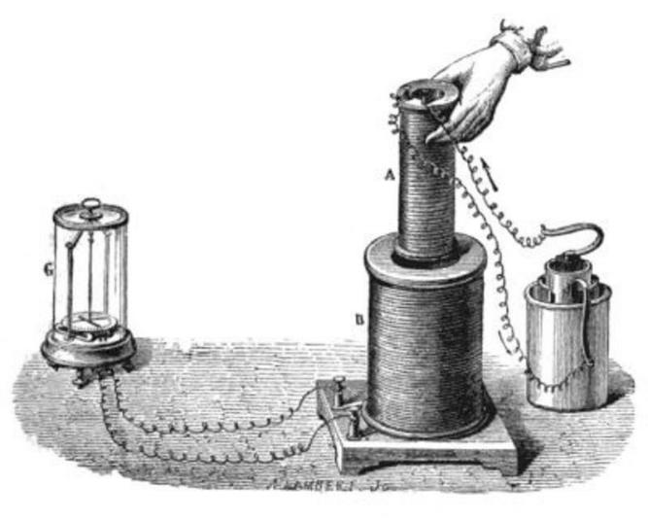

回忆要点：The lecture is about the electromagnetic induction experiment in 1831. 听到的Key words: relationship between magnetic ﬁeld and electric ﬁeld , electric current ,
generator ,motion , When small coil is moved in or out of the large coil then XXX with
magnetic ﬁeld ...(失忆了） 尽力了 ，请其他考过的大神回忆 ，感谢！ （有个视频 ，视频第一幕是上面的图然后是跳到一位讲师在讲课）

induction - L1 - /ɪn ˈ dʌkʃən/ n. 归纳 （ 法） ； （ 电或磁的） 感应； 诱发； 就职 ，就职典礼； coil - L3 - /kɔɪl/ n. （ 一） 卷 ， （ 一） 盘； 盘卷之物； 线圈； 纷乱 ，纠B不清；

56. Actress / 女演员 #6019 低频 不可练习
回忆要点：
回忆1.有一张图 ，上面好几个女演员 ，说莎士比亚之前都不让女的出现在public
回忆2.有五张女性油画像 ，每张图片下分别对应一个名字。提到了莎士比亚 ，还说早期女性角色都是男性扮演

57. Wind power and hydropower / 风力发电与水力发电 #5946 低频
不可练习
回忆要点： In Australia, wind power is just 1% of the whole; But in Denmark, wind power has a larger proportion; In other countries, hydropower has a larger proportion

58. How to write a cover letter / 如何写附信 #5936 低频 不可练习
回忆要点？ ：遇到一个新的RL。 一个女人视频讲how to write a cover letter ，发音清晰，语速不快 ，文章不短 ，足够撑够40s ，一共提到四条。包括check grammar errors, do
research包括development opportunities,show what you can oﬀer according to the job description,第一条记不太清楚了

59. King / 国王 #5931 中频

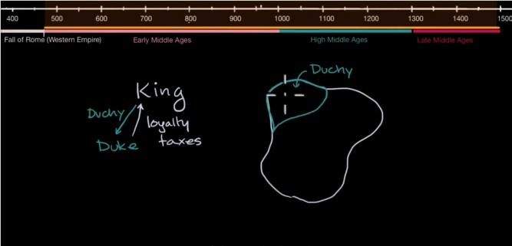
音频原文
At the top, you would have a king. Now the king would rule over a kingdom. Now, this is not so easy to govern especially during the Middle Ages. And the king might owe many people, things especially people who help the king come to power, helped him dispose the previous king or to conquer this land. And so in exchange for that and to help govern, he might grant land or feasts to other people. And the key currency in the Middle Ages under the feudal
system island. And land in exchange for loyalty and service. So this whole thing is a
kingdom. Now right over here, this is a duchy. And a duchy will be controlled by a duke. I
guess I didn 't call it duckie because that just doesn 't sound as serious. So the king might
grant a duchy, a duchy to a duke and in exchange, the duke would provide loyalty pledged
their fealty. If the kingdom is threatened, the duke will ﬁght alongside. The king would provide their own troops if the king wants to go conquer other territories, same thing, and also
provide the king with taxes which might be in the form of coinage depending on what time and region we are in the Middle Ages or it might be in the form of a percentage of the
agricultural production from this duchy.

参考答案
The lecture mainly talks about a king.

Firstly, at the top, you have a king who rules over the kingdom.

Secondly, it is not easy to govern, and the king might owe many people. Thirdly, the king might grant land to people for loyalty and services.
Finally, the king might grant a duchy to a duke, and the duke provides the king with loyalty.

owe - L1 - /oʊ/ vt. 欠 债； 感激； 应归功于； 怀有情感；
conquer - L1 - / ˈ kɑŋkə(r)/ vt. 征服； 攻克； 打败 （ 敌人） ；克服； loyalty - L1 - / ˈ lɔɪəlti/ n. 忠诚 ，忠实； 忠心； 忠于 感情；

pledge - L1 - /plɛdʒ/ n. 保证 ，誓言； [法]抵押权； 公约； （ 表⽰友谊的） 干杯； feudal - L2 - / ˈfjudl/ adj. 封建的； 领地的； 世仇的；
troop - L2 - /trup/ n. 军队； 一群； [军]骑兵连；
coinage - L2 - / ˈ kɔɪnɪdʒ/ n. 货币制度；
fealty - L5 - / ˈfiəlti/ n. 忠诚；

60. Saturn rings / 土星环 #5930 低频 不可练习
回忆要点： Galileo found in 1610 that Saturn has more than 10 rings composed of
diﬀerent particles. Other planets like Venus also have rings but not as many as Saturn

61. First degree / 第一学位 #5856 低频 不可练习
回忆要点：这个人在讲朋友小孩选什么专业作为第一学位。他自己先选了数学 ，后来feel bored, 又选了英语。 中间还说了什么忘记了 ，后面说cannot make progress unless u
learn the fundamentals of math. 求大神们补充。

62. Small languages / 小语种 #5810 低频 不可练习
回忆要点： 由于全球化和城市化 ，小语种正在dying out. 英语类的全球性语言已经取代了很多小语种。 People have been moving to urban areas where is hard for small languages to survive. 小语种只能出现在some remote isolated land上

63. Education revolution / 教育革命 #5808 中频
音频原文
There is a tech revolution happening in classrooms across Canada: computers and tablets provided by schools, and students being allowed to bring their own devices. Behind this
trend is a strong belief that technology opens up all kinds of learning possibilities.

So let 's look at one school board in Hamilton-Wentworth. The plan is to have every student from Grades 4 to 12 equipped with iPads by 2019.
John Malloy is the Director of Education, and he joins me now.

Welcome, John.

Great to be here.

What is the single most important reason to do this?

We want to change learning for kids. They need to be engaged. They need to be on ﬁre with what they 're learning. And we believe that if we change the learning, technology can support it.
So describe how it 'll work. Are these tablets that students are going to use in the classroom only?
No, the tablets are theirs, just like we would have had notebooks and binders 20 years ago, or even two years ago. The tablets are their tool as part of how they will learn.
So what we plan to do is invite the students to change how they think about learning. It 's
about the wide, wide world that 's out there that technology allows our kids to connect with, and the expertise of amazing teachers who help guide that process.
Now, I get the pressure to bring technology into the classroom, but what does the research say about learning outcomes?
When students are engaged, when they can be creative, when they can analyze, when they can think, when they can create something new collaboratively and individually, it makes a
huge diﬀerence for their learning. That doesn 't mean we don 't teach the basics, but the
basics become part of a much richer learning experience. And that 's really what we 're trying to achieve for our students.
参考答案
The lecture talks about how teachers deal with education revolution.

Traditionally, teachers use tables, chairs, paper and pencils to teach children handwriting and reading from paper.
With the development of technology, the way of teaching has been radically changed.

Teachers are using new technology in classrooms.

Education in the future will be focusing on developing children’s critical thinking and … skills.

tablet - L1 - / ˈtæblɪt/ n. 碑 ， 匾； 药片； 便笺簿； 小块； 平板电脑；
basics - L3 - / ' beɪsɪks/ n. 基本因素 ，基本部分( basic的名词复数)； 基础； 基本技术； 基本原理；

64. The Melk / 梅尔克 #5805 高频

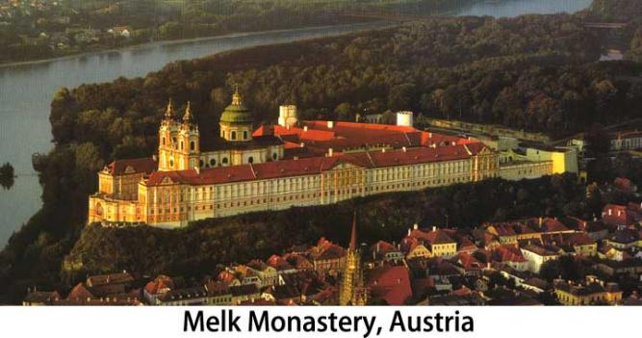
音频原文
The Melk is not typical of all monasteries for many reasons. Firstly, it is very grand which
most especially later foundations aren 't. Secondly, it was founded in the countryside,
whereas in 17th and 18th centuries, a good proportion of foundations were made in Towns. Thirdly, it still owns a substantial amount of land, because fourthly it lies in the Austrian
Republic, the only European country where grand old monasteries have been in continuous existence since they were founded nine hundred a thousand even in one case twelve
hundred years ago.

参考答案
The lecture is about Melk.

It is not typical of all monasteries for many reasons.

Firstly, it is very grand which most especially later foundations aren 't.

Secondly, it was founded in the countryside.

Finally, it still owns substantial amount of land.

monastery - L1 - / ˈ mɑnəsteri/ n. 修道院 ，寺院； [复数]全体僧侣；

65. Health worker / 医护人员 #5803 低频
音频原文
According to the World Health Organization, 400 million people worldwide have no access to essential health care. That 's a staggering number of people. Some of those services include things like basic sanitation and clean water, prenatal care, and vaccinations or immunizations

for children. Many things contribute to this crisis. Sometimes people live to remotely to get
timely care if emergency occurs. Even when living in a city, the patient to doctor ratio can be as high as 50,000 people to just one doctor, making it impossible for that doctor to meet the demands of health care in that area. These are valuable people made in the image of God
who are physically suﬀering. Many of them without a personal relationship with Christ. So we do this with a week of hands-on training, consisting of a variety of topics like basic sanitation and hygiene, taking vital signs, wound care and infection prevention, basic birth assisting
and emergency skills. Those who participate in the training then have practical skills in
supplies to care for others in their community in a way that gloriﬁes God and opens the door for sharing the gospel in a new way.
参考答案
The lecture is about health care.

There are many people worldwide have no access to essential health care.

Many things contribute to this crisis.

Sometimes people live too remotely to get timely care if emergency occurs.

Also, many people do not have personal relationship with Christ.

Therefore, we do this with a week of hands-on training, and those who participate in the training then have practical skills in supplies to care for others in their community.

stagger - L1 - / ˈ stæɡɚ/ vi. 蹒跚； 犹豫； 动摇；
vaccination - L1 - / ˌ væksə ˈ neʃən/ n. <医>种痘 ，接种； 牛痘疤；
prenatal - L2 - /pri ˈ netl/ adj. 出生前的 ，胎儿期的；
hygiene - L2 - / ˈ haɪ ˌ dʒin/ n. 卫生 ，卫生学； 保健法；
gospel - L3 - / ˈ gɑspl/ n. 真理 ，信条； 福音音乐； <新约>四福音书； 原则； immunization - L4 - / ˌ ɪmjʊnə ˈ zeʃən/ n. 免疫；
glorify - L4 - / ˈ ɡlɔrə ˌ faɪ , ˈ ɡlor-/ vt. 赞美； 颂扬； 美化； 使更壮丽；

66. Former civilization / 史前文明 #5802 低频
音频原文
The ﬁrst thing I want to argue is that the former civilization is running into pretty profound
crisis in its relationships to the rest of nature, which we do and what we have depended on
for survival and for ﬂourishing. And this is the most widely and well-recognized in relation to climate change, CO2 emissions, greenhouse gas emissions. But I want to argue the certain dangers in the way that has been presented as the central question that we have to address. Because it 's interlocked with a number of other crises that is most noticeably as the crisis in access to fresh water, crisis in access to food, biodiversity loss on a huge scale, and

associated problems of human inequality not just in a common world, but actually in the
kinds of environmental resources, and pleasures that I can enjoy. So all those together, have to be looked at an interconnected set of really deep profound crisis.
参考答案
The lecture is about nature.

Firstly, the former civilization is running into pretty profound crisis in its relationships to the rest of nature.
Secondly, former civilization is in relation to climate change.

Thirdly, there are certain dangers in the way that has been presented.

Finally, all those together, have to be looked at an interconnected set of really deep profound crisis.
interlock - L3 - / ˌ ɪntər ˈ lɑk/ n. <计>互锁设备； 双螺纹针织品；

67. Politics and international relations / 政治与国际关系 #5744 低频
音频原文
This course provides students with an in-depth understanding of the exciting disciplines of politics and international relations. Students will learn about the workings of political
institutions in countries around the world and explore the complex ﬁeld of relations between nations. Topics in governance, public policy, public administration, national security and
border control ensure that students receive a broad and current education in the range of
issues which are covered under the label of politics and international relations. Students will undertake four compulsory units and two majors, one in politics and international relations and the other in governance and policy. They will also choose an elective major from a wide choice of options including political communication, international studies, international
business and national security studies. In addition to acquiring specialist knowledge and
competencies in Politics and International Relations and Commerce, students will graduate with a range of generic skills such as critical thinking, enhanced communication abilities,
problem-solving and strong capacities to work with others. They will also develop ethically based and socially responsible attitudes and behaviors.
参考答案
The lecture is about course.

Students can have an understanding of the exciting disciplines of politics and international relations.
The topics are covered under the label of politics and international relations.

Students will undertake four compulsory units and two majors.

They will also choose an elective major from a wide choice of options.

Students will graduate with a range of generic skills.

They will also develop ethically based and socially responsible attitudes and behaviors.

generic - L1 - /dʒə ˈ nɛrɪk/ adj. 类的 ，属性的； 一般的； 不受商标保护的； [生]属的 ，类的；

68. Shakespeare / 莎士比亚 #5740 低频 不可练习
回忆要点： 考过的rl里有一道考到的是关于iambic pentameters的内容 提到了sonnet 就是莎士比亚十四行诗） 有图可以照着说

69. Seven continent / 七大洲 #5739 低频 不可练习
回忆要点：seven continent 是个视频 ，记忆有点模糊 一开始有张南极地图 ，然后切换成世界地图 ，有时候会显⽰lecture在那里讲课 ，没什么大用 1）there are seven continent over the world 2） historically ，map in the early greek ， 3） early greeks’ work什么什么 ，这点出考场忘了 ，请大神们补充一下 4）the idea is seven continent

70. Bizarre phenomenon / 奇怪现象 #5730 低频 不可练习
回忆要点：
回忆1：疑似新题 有个图片一支笔和一张划线的纸 但是图片完全没用 讲的大意应该是 人在一个环境待久了 对一些bizarre的现象就习以为常了 举了个例子说new employee来到这个公司 就会对一些事情感到是surprise 记不太清了 求复盘
回忆2：你说的图是不是有台笔记本电脑 ，然后有纸笔的那个。举的例子是说有新员工来公司 ，就发个本子 ，让ta看到有什么让ta感到奇怪的事情就记下来 ，然后说这目的不是光让ta记下来 ，而是有机会ta就可以问老员工为啥要这么做。 而这所有的目的都是和什么
management有关。

71. Raising a child / 培养孩子 #5724 低频 不可练习
回忆要点： 我好像考到一个新题 ，配图 ，一个笑的拿着笔的小女孩 ，后面有大人。 主题应该是大人不应该给小孩做太多 ，应该保护孩子安全 ，人身安全 ，很多家长要给孩子最好的教育 ，后面还有失忆。这个题没太听明白 。望大神复盘。 不是#5082 ， 图片不是父亲抱孩子。关键词也没提father。 主要是说家长养孩子还是不要干涉太过。

72. US economy / 美国经济 #5697 超高频

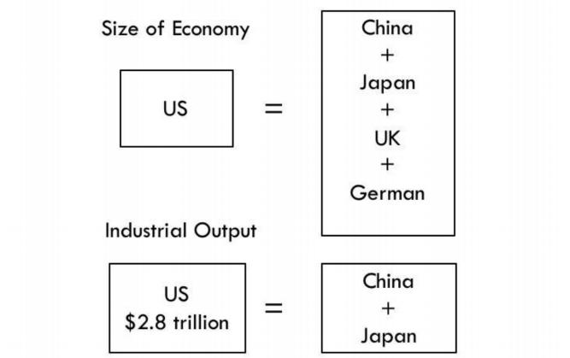
音频原文
And prior to that, there is a long line of countries that have at one time sat at the apex of the global economy, culture, science and military strength.
Great nations may also decline a concept known as decline ism, while simultaneously other nations are busy evolving into powerful states.
For a number of years now, a handful of nations have been developing at a rapid pace, and today we 'll compare them with the mighty USA.
In this episode of the Infographics show The USA versus BRICS.

Don 't forget to subscribe.

Click the bell bone so that you can be part of our notiﬁcation squad.

BRICS is an acronym standing for the ﬁve countries.

It represents Brazil, Russia, India, China and South Africa.

The acronym at ﬁrst was just BRIC until South Africa made an appearance in the association in 2010.
BRIC was formally started in 2006 when the ﬁrst BRIC meeting was held under the EGIS of a mutual agreement to boost each member country's development not only developments

relating to economy, business and trade, but also education, agriculture, health, technology, science and the arts.
Together, BRICS is a powerful conglomerate accounting for 42.58% of the world 's
population, and according to the International Monetary Fund, about 22% of the world GDP compared to the United States.
In terms of size alone, its Goliath staring down it.

David If we look at the numbers, BRICS has a combined population of about 3.6 billion people.
The USA has a population of just 325 million people.

The US GDP is the biggest in the world at 18 trillion plus dollars.

Although BRICS combined has a GDP of $37 trillion, the US is not expected to make any
headway on BRICS any time soon regarding economic growth, with its estimated growth to be around 2% over the next few years, BRICS is expected to see growth of around 5%.
In an article in The Atlantic published in 2012, Goldman Sachs projected that China 's GDP alone would be equal to America 's by 2027 and then leap past it.
In regard to economy, BRICS nations are ascending quickly.

This growth, it 's believed, will lead to much stronger militaries, especially those of China and India.
Right now, the US spends more on its military than any other nation, with a defense budget of $639 billion for 2018.
参考答案
In terms of the size of economy, US economy is more than the total amount of China, Japan, UK and Germany.
In terms of the industrial output, US output is $2.8 trillion, but it only equals to the sum of China and Japan.

mighty - L1 - / ˈ maɪti/ adj. 趾高气扬； 巨大的； 强有力的； 浩瀚的；
episode - L1 - / ˈ epɪsoʊd/ n. 插曲； 片段； 一集； 一段经历；
versus - L1 - / ˈvɜrsəs/ prep. （ 表⽰两队或双方对阵） 对； （ 比较两种不同想法、选择等） 与 相对； 对抗；
bell - L1 - /bɛl/ n. 钟 ，铃； 钟声 ，铃声； 钟状物； [建]圆屋顶；
monetary - L1 - / ˈ mʌnɪteri/ adj. 货币的 ，金钱的； 钱的 （ 尤指一国的金融） ；金融的； 财政的 ，财政 （ 上） 的； leap - L1 - /lip/ vi. 跳； 冲动的行动；
headway - L2 - / ˈ hɛd ˌ we/ n. 前进； 进展； 航行速度； 间隔时间；

handful - L3 - / ˈ hænd ˌ fʊl/ n. 少数 ，少量； 一把 （ 的量） ；难以控制的人 （ 或动物） ；棘手事； subscribe - L3 - /səb ˈ skraɪb/ vt.& vi. 认捐 ，捐赠； 签署 ，题词 ，署名； 认购； 订阅 ，订购； notification - L3 - / ˌ noʊtɪfɪ ˈ keɪʃ n/ n. 通知； 通知单； 布告； 公布；
acronym - L3 - / 'ækrənɪm/ n. 首字母缩略词；
ascend - L4 - /ə ˈ sɛnd/ vt. 攀登； 继承； 占领；

73. Music and mathematics / 音乐与数学的关系 #5675 低频 不可练习
回忆要点：
回忆1： 说music和 mathematics关系 ，配了张画着0和五线谱的图。 我反正没听懂。 不知道有大神可记得这题？
回忆2：这题我又考到了 ，开头说数学和音乐有Common和 connection. 然后说数学好的，音乐也不错。 它们都有rythm, 都是well-organized. 就这些 ，水平实在有限 ，等大神给出更好的答案。拜谢！！

74. Womenıs social status / 女性地位提升 #5637 低频 不可练习
回忆要点： 一个视频题 ，一个女的接受采访 ， 白色背景 ，讲女性social status的改变和女性家庭地位的提升 promote in household

75. Doing research / 做研究 #5636 超高频
音频原文
In university, you will be expected to use scholarly research for most of your assignments.
Information you ﬁnd on the internet just won 't cut it. Your professors will often ask you to ﬁnd scholarly articles or books.
Don 't fret though. You can transform your Googling and Internet search skills into excellent
research skills pretty quickly. The library can help with this. What does scholarly even mean? Scholarly means that it has been researched and written by scholars using sound research or testing methods. Scholarly publications are authored by highly trained and knowledgeable
scholars such as professors and researchers. They have an academic background in a ﬁeld of study related to the articles they get published. Do you mean like textbooks? Textbooks are usually scholarly, but you 'll probably be asked to ﬁnd research beyond your required
readings. There are scholarly books and scholarly articles. Scholarly books are often
published by university press if it 's unclear whether the publisher is academic or scholarly. Those books also include information about the author so you can check what their
qualiﬁcations and credentials are. Often you 'll be asked to ﬁnd scholarly articles. These are typically found in scholarly journals, which are similar to magazines in the sense that there

are many issues published periodically, but the majority of the content is research based, which is not the case with magazines. In many cases, scholarly articles are peer reviewed.
参考答案
The main goal of doing research is to support your own idea in your paper.

If you use research paper that from only one source, that does not mean it is not accurate, but you should be careful.
To save time, the best way is to make sure the researches you use are reliable, recent and (adj.) at the ﬁrst time.

publisher - L1 - / ˈ pʌblɪʃɚ/ n. 出版者 ， 出版商 ， 出版社； 公布者 ，发表者； 〈美〉 办报者； fret - L2 - /frɛt/ n. [建筑]回纹饰 ，状饰物； 烦躁 ，烦恼； 腐蚀处 ，磨损处； 弓上木头的毛病；

76. Overﬁshing / 过度捕捞 #5634 超高频
音频原文
Aquaculture, the farming of ﬁsh, shrimp, shellﬁsh and seaweeds, has been the sources of
human protein for nearly four thousand years, especially in Asia. In the last decade, however, there is been unprecedented growth in aquaculture production, more than 300% since 1984, which has increased the importance of the modern food supply. It’s the world’s fastest
growing food production activity. And globally, more than 25% of the odd ﬁshing and
shellﬁsh production in 1999 was attributable to aquaculture. Yes, this industry’s contributions to human diet is actually greater than the numbers imply, whereas 1/3 of the conventional
ﬁsh catch is used to make ﬁsh meal and ﬁsh oil. Virtually all farmed ﬁsh are used as human
food. Today, nearly 1/3 of ﬁsh consumed by human is the product of aquaculture, and that
percentage will only increase as aquaculture expands the world’s conventional ﬁsh catch, for the oceans and lakes continues to decline because of overﬁshing and environmental
damage.

参考答案
Aquaculture means farming ﬁsh, shrimp, shellﬁsh and seaweeds. It has given humans protein for about 4,000 years, especially in Asia.
In recent decades, its production has grown a lot—over 300% since 1984. It’s the fastest- growing food production activity in the world, and in 1999, it made up more than 25% of global ﬁsh and shellﬁsh output.
Its contribution to what people eat is bigger than the numbers show. One-third of the usual ﬁsh catch is used for ﬁsh meal and oil, but almost all farmed ﬁsh are for humans to eat.

Now, nearly one-third of the ﬁsh people eat comes from aquaculture. This percentage will keep going up because traditional ﬁsh catch from oceans and lakes is falling due to
overﬁshing and environmental damage.

seaweed - L2 - / ˈ si ˌ wid/ n. [植]海草 ，海藻；
attributable - L4 - // adj. 可归因于 … 的； 由 … 引起的；
shellfish - L5 - / ˈʃɛl ˌ fɪʃ/ n. 贝类动物； 甲壳类动物； 甲壳类 （ 食物） ；

77. Glass ceiling / 隐形壁垒 #5633 低频 不可练习
回忆要点：glass ceiling是指在公司中 ，某些弱势群体（女性或少数派） 在晋升到高级职位时遇到的障碍

78. Eﬀect / 效应 #5629 低频 不可练习
回忆要点： 一个视频 是印度还是非洲的一个女士在讲 背景是黑色的 讲的关于什么eﬀect extremely 怎么怎么样solar system 求考过的大神复盘

79. Cars in Washington / 华盛顿汽车尾气 #5617 超高频 不可练习
回忆要点： 华盛顿出现汽车尾气的污染 ，有人呼吁交通工具的选择可以改善 ，人们应该减少汽车的使用 ，但是

80. Cotton subsidy / 美国棉花补贴 #5616 低频 不可练习
回忆要点： 美国对棉花的补贴是100%的补贴 ，只要种棉花就可以得到补贴 ，世界棉花市场的价格因此而大幅度下跌 ，这对非洲的棉花种植户来说影响最大

81. Machine learning / 机器学习 #5603 低频 不可练习
回忆要点：提供一个视频题 ，我看好像还没更新到。 讲的是machine learning的big data，举了大堡礁The Great Barrier Reef为应用栗子。 因为大堡礁太大了 ，有900 islands还有多少km长度 ，所以detect很难 ，用big data可以从mathematical and statistical来make
prediction

82. Dead sea creatures / 死的海洋生物 #5586 低频 不可练习
回忆要点： 主题是关于几百万年前dead sea creatures 和 oil and nature gas formation和oil drilling。 当时听的不是特别好。好像就是说海底石油是由几百万年前dead sea
creatures 形成的

83. Three stages of brain development V2 / 大脑发育三阶段 版本二
#5578 超高频
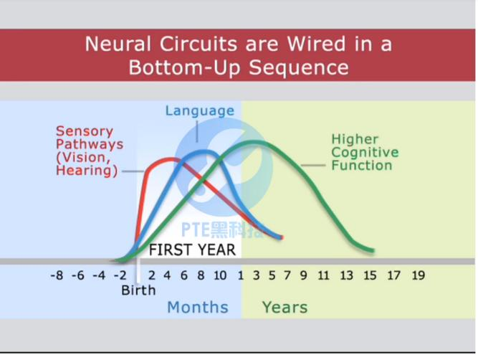
音频原文
The brain is basically built from the bottom up. First, the brain builds basic circuits that are responsible for basic skills. And then more complex circuits are built on top of those basic circuits as we develop more complex skills. Biologically, the brain is prepared to be shaped by experience. It 's expecting the experiences that a young child has to literally inﬂuence the formation of it 's circuity, it 's built into our biology. The interaction between genetics and
experience that shapes brain architecture is embedded in the reciprocal relationship, the
relationships that children have with the adults in their lives. And by that, we mean what we refer to as the serve and return the nature of children 's interaction with their in adults
development and the impact of experience on development is not a one-way street, it 's a back and forth interaction.
The brain is a highly integrated organ which has multiple sections that specialized in diﬀerent kinds of processes. So we have parts of the brain that are involved more in cognitive function and other parts that are involved in processing of emotion and parts involved in scene and
hearing. So, if a child is emotionally kind of well put together and socially competent, that will aﬀect more positive and productive learning. And if a child is preoccupied with fears or

anxiety or is dealing with considerable stress no matter how intellectually gifted that child might be, his or her learning is going to be impaired by that kind of emotional interference.
参考答案
The lecture is about brain.

The brain builds basic circuits that are responsible for basic skills and it is prepared to be shaped by experience.
The interaction between genetics and experience that shapes brain architecture is
embedded in the reciprocal relationship, the relationships that children have with the adults in their lives.
In addition, the brain has multiple sections and the sections relate to cognitive function, the process of emotion and involve in scene and hearing.

interference - L1 - / ˌ ɪntər ˈfɪrəns/ n. 干涉 ，干扰 ，冲突； 介入； 妨碍 ，打扰 ， 阻碍物； 冲突 ，抵触； reciprocal - L2 - /rɪ ˈ sɪprəkəl/ adj. 相互的； 互惠的； 倒数的；
preoccupy - L5 - /pri ˈ ɑkjupaɪ/ vt. 占据 （ 某人） 思想 ，使对 全神贯注 ，使专心于；

84. Introduction / 简介 #5493 低频 不可练习
回忆要点： 有视频 但貌似就只是一两张ppt 一开始就是once upon a time(视频是动画兔子和这四个单词） 往后的视频没看见 一开始一大段废话 然后开始说introduction is key
fator/is important than the xxx/ element of a story/ 别的不记得了 望大神复盘

85. Poverty / 贫穷 #5485 低频 不可练习
回忆要点： 配有一个复杂的线图。提到了1.5 million children 生活艰难 ，只有2$ per day. Those poor people even cannot access to essential life support such as clean water and energy. Most people even cannot do anything without energy.

86. Computer / 电脑 #5484 低频 不可练习
回忆要点：
回忆1. 电脑可以进行快速的multiplication运算 ，但这个要耗费人类大量时间才能算出来 ， You may get some Gender Registration Screen ，然而电脑不能轻易识别人们在纸上写的字
回忆2.考到了 ，整体不难。文章分了两段 ，第一段讲电脑可以做big number 的
multiplication ，而人类做这个很难。 因为multiplication是由a sequence of precise steps组成的 ，所以computer cannot make mistakes。这一段讲的比较长。 然后是第二段 ， 比较简短 ，讲的是人类可以轻松的识别handwriting ，而这个对电脑来说很hard。

回忆3.是视频题 ，先是看黑板 ，两个很大的数字相乘 ，然后说电脑很擅长运算 ， 因为这是数学 ，是逻辑。这种运算人类就比较困难。然后画面换成一些英文单词 ，解释说是这是来自不同人的书写 ，对人来说 ，非常容易去read ，并且知道写的什么。 可这对电脑就非常
难 ， 电脑无法正常的阅读手写的字。

87. Technology erode privacy / 科技侵蚀大众隐私 #5476 低频
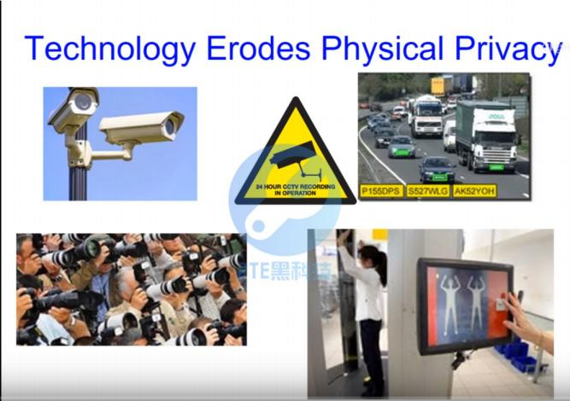
音频原文
So that creates tensions and that 's what I want to talk about. Because I think it’s important
we are as a society able to have an informed debate about how much privacy is enough but not too much, how much security is enough but not too much. Privacy is a human right that simply quoting the Universal Declaration. In the physical world, we’ve got all kinds of
protections. There is evidence that we care about our privacy: we’ve got doors, we’ve got
obscured glass, we’ve got locks, we wear clothes, we put up shutters. And technology
continues to erode the privacy that exists in the real world in the three spatial dimensions.
Security cameras, automatic number plate recognition take away anonymity. Long lenses
paparazzi take away distance and the privacy that used to create. And body scanners are
increasingly being used to see through clothes, for example. This process isn’t going to slow down and the new quantum technologies are actually being able to do gravitational sensing and that’s advancing at a remarkable rate and you can’t shield gravity. So some of the new quantum technologies are able already to see through walls and will and there are

technologies also for seeing round corners now using scattered light from lasers. Technology continues to erode privacy.
参考答案
This lecture is about tensions between technology and privacy and as a society we need to argue about the amount of privacy and security we have.
Firstly, privacy is a human right, which we care about, and we have many protections.

Secondly, however, technology continues to erode privacy in three spatial dimensions, including security cameras, long lenses and body scanners.
Thirdly, this process won’t slow down because of the quantum technologies. In conclusion, technology continues to erode our privacy.

declaration - L1 - / ˌ dɛklə ˈ reʃən/ n. 宣言 ，布告 ，公告 ，声明； （ 纳税品在海关的） 申报； [法] （ 原告的） 申诉， （证人的） 陈述 ， 口供； [牌]摊牌 ， 叫牌；
shutter - L1 - / ˈʃʌtɚ/ n. 遮光器； 百叶窗； 快门；
quantum - L1 - / ˈ kwɑntəm/ n. [物]量子； 定量 ，总量； 美国昆腾公司 （ 世界领先的硬盘生产商） ；
shield - L1 - /ʃ ild/ n. 盾； 护罩； 盾形奖牌； 保护人；
laser - L1 - / ˈ leɪzər/ n. 激光； 激光器 ，镭射器；
erode - L2 - /ɪ ˈ roʊd/ vt.& vi. 侵蚀 ，腐蚀；
anonymity - L2 - / ˌ ænə ˈ nɪmɪti/ n. 匿名； 作者不详； 匿名者； 无名者；

88. Evolution / 进化论 #5454 低频 不可练习
回忆要点： 有一个问题是evolution（进化论） 从什么时代开始似的 开始说在亚里士多德时代可能有 ，后面马上就否定了 ，说那时人们相信人类/动物/植物天生就是这样 ，后面又说道在文艺复兴初期（不确定反正是某个时期） evolution也没人信 ，后面又说起来了一个人名

89. Pavlov Experiment V2 / 巴普洛夫实验 版本二 #5439 超高频

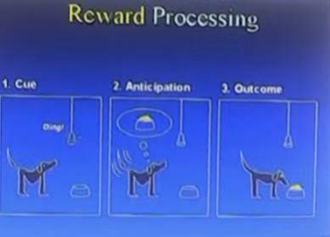
音频原文
During this time my goals are going to be to talk about the phenomenon that we may share
impart with other animals, and our language and that is emotion. And also talk about some
new technology, brain imagining, functional magnetic imagining. And we try to answer some very old questions about how does motivation and emotion work. I 'm going to put you with
the scenario ﬁrst and some of you may be familiar with. This was developed by Pavlov over a century years ago. And in this scenario the dog presented with the sound, the dog waits, and then feeds food powder and this happened repeatedly, things starts to happen in the middle of the experiment there. Interesting things start to happen here. Pavlov's study was salivation the dog, the salivation increases more time to paralyzes. But other things happened here,
too. You have a dog move around here more, all kinds of things are going on here. What we trying to capture was the experiment I 'm going on to describe today is what is going on in
the brain to generate that state which we called it competitive state. But you can also think
about state in terms of how the dogs ' feeling layer, how you feeling about eating lunch today.

参考答案
Studied brain’s reaction.

Pavlov’s experiment happened centuries ago, in the experiment, the dog ﬁrst showed no
response, after days, dog showed salivate and made the association between food and bell.

Brain will have diﬀerent reactions based on diﬀerent motivations, and show diﬀerent emotions, such as happy and exciting.
How motivation works and how dogs brain work.

impart - L2 - /ɪm ˈ pɑrt/ vt. 给予； 告知 ，透露； 传授；
paralyze - L3 - / ˈ pærə ˌ laɪz/ vt. 使瘫痪 ，使⿇痹； 使不能正常活动； salivation - L5 - / ˌ sælə ˈveʃən/ n. 分泌唾液 ，流涎症； 流唾液；

90. Intellectual architect / 知识架构师 #5407 低频 不可练习
回忆要点： 新题 intellectual architect,大致是说这个的概念是什么 ，可以反映各种需求，语速不快 ，语音很清晰

91. Tutorial / 家教 #5401 中频
音频原文
My name is Evie Carroll. I’m a second year studying international business. My degree
subject is made up of tutorials, lectures and independent learning. And today I’m going to speak about tutorials.
Before each tutorial, we’re asked to prepare in advance. We’re usually given a reading list,
which we have to complete before each tutorial. We are given websites to look at, each
annals to look at and we have to prepare by writing our notes down. In every tutorial, there is about 5 to 15 students and these are led by the tutors which are usually masters or PhD
students. And then when we come into the tutorial we are put into small groups. I’m asked to discuss our ideas, generate new ideas and then feedback to the class.
During our tutorials, there’s lots of support given. Our tutors are there so that we can ask
questions at any time. We also have our peers there, which we can also ask questions to. If we need help before the tutorial, we can email in any of the tutors and they’ll provide you
with help.

The diﬀerence between lectures and tutorials is that in lectures you usually have about 200 to 300 students whereas in tutorials is about 5 to 15 students, which allows you to discuss
matters, put your hands up and talk to your tutors about any diﬃculties you may have with a subject.
参考答案
The general topic of this lecture is about tutorials.

Firstly, the speaker mentioned that students were asked to prepare tutorials in advance by giving them a reading list.
Then the speaker said that students are led by tutors, which are usually master or PHD students.
Finally, the speaker mentioned that the diﬀerence between lectures and tutorials is that the size of tutorial is relatively small, which is usually about 5 to 15 students.

92. Exam anxiety / 考前焦虑 #5373 中频 不可练习

回忆要点：There are many reasons making students between year 10 and 12 students feel anxious for exams. Some students are too busy to do assignments, but they want to have good scores because they don 't want to upset their teachers and parents. But
more importantly, the teachers often give students wrong messages, telling them that the next 2 years are the most important 2 years; if you fail, your life is failing. This is not right, and I think this message triggers the anxiety.

93. Automation / 自动化 #5335 中频 不可练习
回忆要点：（有标题的 ，关于automation的视频 ，男教授在演讲 ，slides上很多数据 ，教授也口述了很多数据 ，黑屏起始黑屏结尾。涉及到的内容是因为现在的科技发展 ，预测在未来很多人会没有工作 ，用了数据支撑。但专业人员的工作会非常稳定）

94. Old fashion way / 古典写作手法 #5319 低频 不可练习
回忆要点：
回忆1.考了一到视频题 没有听太明白 一个女人在说writing 先提到old-fashion way to write后面又提到需要切换到 storytelling mode ⿇烦大神补充
回忆2.一个女的视频 讲她对于writing的看法 她尝试traditional 的writing style but too old fashion way 中间说了一点她的心得啥 不记得了 然后她觉得还是easy to write啥的 语速ok逻辑也清楚 一开始还挺激动 以为要讲children literature 结果不是 想起来 她说 old fashion way后 就决定还是用自己的方法写 然后讲自己的心得 最后觉得easy to write bla bla 很有节奏感的一句话

95. Banana / 香蕉 #5292 低频 不可练习
回忆要点：
回忆1.这次rl碰见个题 ，旁边有张图画了香蕉 ，大概内容说的人们要safety food,然后用0做了例子 ，后来说了个什么system ，可以用来鉴别食品安全 ， 比如sources, sugar ，大概就听了这些 ，忙着记笔记了。
回忆2.考了那个 香蕉的图。 图上是一个碗 碗里面放了香蕉和苹果 ，香蕉是一个例子。但是我听得好像是 有关于science；to understand banana & appreciate banana什么的 ，然后记得里面说 value of the sciense is the fact. 总之内容很散 ，能记得了笔记但是没有什么中心内容。
回忆3.ﬁrst you need to know that you want a banana, and you need to know that fact
that there is a banana in the basket, then you can make the decision to get the banana
from the basket.这篇是讨论relationship between politics and scientiﬁc truth。 我有点不确定了 ，年纪大了记性不好了 重点全部在说完香蕉的例子后面的几句 ，不难 ，信息点全部可以记下来的

basket - L2 - / ˈ bæskɪt/ n. 篮； 一篮； （ 篮球运动的） 篮； 投篮得分；

96. Greek diet / 希腊饮食 #5277 高频 不可练习
回忆要点： 有一张配图是一堆沙拉和鱼。 说的是希腊Diet为什么会这么受欢迎和有效。文中说到希腊人的沙拉用大量橄榄油 ， 以及他们喜欢吃鱼等等。 考过的同学补充下。 具体可以到网上查查Greek Diet了解下背景知识。

97. Biology / 生物 #5265 超高频
音频原文
Welcome to your very ﬁrst tutorial in biology. Now, in this video series what I want to do is I
want to talk to you guys about many diﬀerent topics concerning biology. For example, I want to talk to you guys about DNA and genetics in cells, in bacteria, in life and a whole bunch of interesting stuﬀ . But since this is the very ﬁrst video, I think what we should do in this video is just stick with the very basics. And the ﬁrst thing I want to do is talk to you guys about what is biology. So, let 's go ahead and answer that question. And the deﬁnition of biology is this:
the study of life in living organisms. All right, that makes sense up to a certain point up until
organisms because you may have heard of organisms before. And you may have your own
deﬁnition but the scientiﬁc deﬁnition of an organism is a living thing. Well, that 's easy. We
know what living things are. I 'm a living thing, plants, grass is a living thing. My puppy named old Dan, cutest puppy ever, by the way, is a living thing but whenever we talk about living
things. Believe it or not, things get rid of complicated because then you have to ask yourself 'what is life '. Well, of course, if you ask your grandma or your best friend or even if you ask a philosopher 'what is life ', everyone is going to give you kind of a diﬀerent deﬁnition of their
outlook on life. However, whenever scientist and biologists were ﬁrst deciding, you know
what, what is life? That 's the problem that they had everyone had their own separate
deﬁnition of life itself. So, what they need to do before biology was even invented, which is, of course, the study of life is scientists needed to agree on the deﬁnition of life.
参考答案
The lecture is about biology.

Firstly, the speaker talks about DNA and genetics in cells, in bacteria, and in other stuﬀ .

The speaker also talks about the deﬁnition of biology.

That is the study of life in living organisms.

Everyone has diﬀerent ideas about what is life, for example, your grandma or your best friend or even a philosopher will have diﬀerent answers.
Therefore, in the study of life, scientists needed to agree on the deﬁnition of life.

puppy - L1 - / ˈ pʌpi/ n. 小狗 ，幼犬； 浅薄自负的年轻男子； 狂妄自大的小伙子 ，呆笨的花花公子； 〈美俚〉 脚； basics - L3 - / ' beɪsɪks/ n. 基本因素 ，基本部分( basic的名词复数)； 基础； 基本技术； 基本原理；
grandma - L4 - / ˈ ɡrænd ˌ mɑ ,/ n. 奶奶 ，外婆；
cutest - L5 - // adj. 装腔作势的( cute的最高级 ) ；漂亮的； 有性吸引力的； 聪明伶俐的；

98. Paris Remade / 巴黎重塑 #5218 中频
音频原文
The most visible manifestation of this wealth was a series of grand projects that were begun by Napoleon the third, mainly in Paris. Soon after he came to power in the eighteen ﬁfties. He said I want to be a second augustus, making reference to the emperor augustus's claim that he found Rome, a city of brick and left at one of marble. In the case of Napoleon the third he found Paris in eighteen ﬁfty one a city of cobblestones and twisting medieval streets, and he left it one of asphalt and macadam because what he began doing was bulldozing old Paris,
the ancient medieval part of Paris, and replacing it with wide new boulevards. Eighty ﬁve
miles of them that he lit with some twenty thousand gas lamps, which took out all the old
eighteenth century oil lamps, replaced them with gas, which gave a much cleaner, brighter
regular light. Also, ﬁfty thousand trees are planted alongside them, many of them the
chestnut trees that we now think of as synonymous with Paris. And he drained the street, the streets, with two hundred miles of sewers, these new famous parisian sewers beneath the
streets, thereby making the city a much more safer, pleasant place to wander, to stroll to people, watch, to have coﬀee or absinthe in the cafes.
参考答案
The most visible sign of wealth was a series of grand projects initiated by Napoleon III in
Paris after he took power in the 1850s. Aspiring to be a "second Augustus " (who
transformed Rome from brick to marble), he rebuilt old Paris—with its cobblestones and
twisting medieval streets—into a city with 85 miles of wide new boulevards. These
boulevards were lit by 20,000 gas lamps (replacing 18th-century oil lamps for cleaner,
brighter light) and lined with 50,000 trees, including chestnuts now synonymous with Paris. He also built 200 miles of sewers to drain streets, making Paris safer and more pleasant for activities like strolling, people-watching, and visiting cafes.

twist - L1 - /twɪst/ vt. 扭成一束； 搓 ，捻； 绕 ，卷； 连结 ，交结； lamp - L1 - /læmp/ n. 灯； 发热灯 ，照射灯；
stroll - L1 - /stroʊl/ n. 闲逛； 漫步；
manifestation - L2 - / ˌ mænəfɛ ˈ steʃən/ n. 表⽰ ，显⽰； ⽰威；
eighteen - L2 - /e ˈtin/ num. 十八； 十八个；
medieval - L2 - / ˌ midi ˈ ivəl/ adj. 中古的 ， 中世纪的；
boulevard - L3 - / ˈ bʊləvɑrd/ n. 大马路； 林荫大道；
brighter - L3 - // adj. 聪明的( bright的比较级 ) ；光亮的； 辉煌的； 前途光明的；

eighty - L4 - / ˈ eti/ num. 八十；
sewer - L4 - / ˈ suɚ/ n. 阴沟 ，污水管 ，下水道； 裁=师；

99. London taxi drivers / 伦敦司机 #5189 超高频
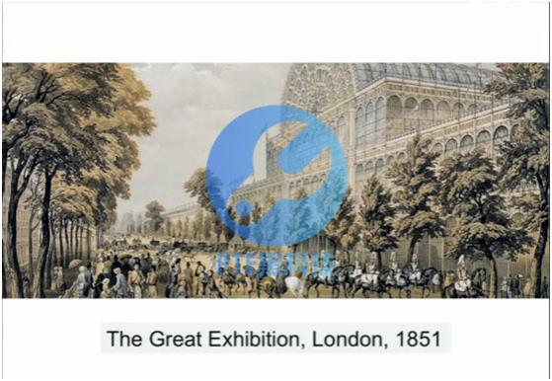
音频原文
But we can really thank the Great Exhibition of 1851 for giving us the world’s premier taxi
service, for it was going to this exhibition, and this fabulous exhibition inventions from all
around the four corners of the Empire that the visitors were appalled, dismayed and vexed by their journeys to this exhibition because the cabbies of the day, and their horse-drawn
carts were absolutely terrible, could not ﬁnd their way to this exhibition. And, so, a great
public outcry, the London Authority sets up Public Carriage Oﬃce, which is an organization that still exists. And you can take a short walk to Penton Street up the road. And this Public Carriage oﬃce took on the responsibility of licensing all major taxi drivers in London. All taxi drivers from 1851 onwards had to pass what is now known as the London knowledge, was phenomenal knowledge of London. What is the London knowledge? It’s the ability to
remember the 25,000 streets, have it all interconnected and all the main arterial roads in and out of London. Cabbies need to know all this plus a thousand points of speciﬁc interest
cafes, bars, public oﬃces. They need to know them all as part of their training.

参考答案
The Great Exhibition of 1851 gives us the world’s premier taxi service.

The London Authority sets up Public Carriage Oﬃce and it still exists.

London knowledge is the ability to remember the 25000 streets, have it all interconnected in London.
Cabbies also need to know things like cafes or bars that as they are parts of their training.

premier - L1 - /prɪ ˈ mɪr/ n. 总理； 首相；
terrible - L1 - / ˈterəbl/ adj. 可怕的； 危害极大的； <非正>很糟的； 劣质的；
carriage - L1 - / ˈ kærɪdʒ/ n. 运输 ，输送； （ 旧时载客的） 四轮马车； 〈英〉 火车客车车厢； 运费； phenomenal - L2 - /fə ˈ nɑmɪnl/ adj. 现象的； 显著的； 您常的； 能知觉的； 非凡的 ，惊人的；
taxi - L3 - / ˈtæksi/ n. 出租车； 滑行；
fabulous - L3 - / ˈfæbjələs/ adj. 极好的 ，极妙的； （ 美貌） 惊人的； 寓言般的； 难以置信的； dismayed - L4 - // adj. 惊愕的； 惊慌的； 沮丧的； 失望的；
outcry - L4 - / ˈ aʊt ˌ kraɪ/ n. 高声叫喊 ，尖叫； 公开反对 ，强烈抗议； 拍卖 ， 叫卖；
cabby - L5 - / ' kæbɪ/ n. 出租汽车司机；
arterial - L5 - /ɑr ˈtɪriəl/ adj. 动脉的 ，似动脉的；

100. What is intelligence / 何为才智 #5164 低频 不可练习
回忆要点：
回忆1.图片题 题目是 what is intelligence？ 下面有三个点就是三个单词 ，我只记得第一个adaption ，其他忘了 ，一个女生讲的。
回忆2.也是一张PPT what is intelligence 底下三点 之后 还有四个小图 其中一个图钉在木头里 失忆了。
回忆3.有一张PPT what Is intelligence 1. Adaption 2. Innovation 3. xXXX .What is
intelligence. Intelligence Deﬁnition. Intelligence means using existing knowledge to
explore unknown. 例子 ，the crew drivers. 说人们不懂可以学之类的。看这个drivers做然后学 ，最后自己就会了。 注意这个例子要记 ，好几句话且后面没有了。。。（我就因为例子没注意记） 应该中间还说了other animals 也有intelligence之类的。 失忆。
回忆4.这题不难； 图中的例子就是“我们拿起子拧开一个0螺丝 ，但当我们没有 起子的时 候 ，我们发现 一个硬币也能代替起子 ” 这就是 innovitaion 还是 intelligence 总体就是，我们聪明就是因为我们会举一反三

101. 3D scanning / 三维扫描 #5160 中频 不可练习
回忆要点：
回忆1.视频题： 一个lecture 的现场。 【视频里面有个ppt ，ppt是一个电脑屏幕 ，屏幕上是一个不明生物的模拟图 ，（ lecturer称不明生物为beast） 以这个图来讲3D scanning技术】不太确定具体内容 ，记得的关键词是：3D scanner ，laser ，screen ，triangle （说什么
more triangles more clearer the detail）triangle一词出现多次。 主要讲3D scan技术的。

回忆2.关于怎么用镭射scanner获取图像的information 然后通过computer得到图像 more triangulars you get more details the image 最后提及 这个过程 涉及了 how many
triangulars you \have how possible your computer available

laser - L1 - / ˈ leɪzər/ n. 激光； 激光器 ，镭射器；
triangle - L1 - / ˈtraɪ ˌ æŋɡəl/ n. 三角形； 三人一组； 三角铁； 三角板；
clearer - L1 - / ' klɪərə/ adj. 更清楚的；
triangular - L1 - /traɪ ˈ æŋɡjəlɚ/ adj. 三角 （ 形） 的； 由三个部分构成的； 三方面的；

102. Gene aﬀects behaviors / 基因影响行为 #5158 低频 不可练习
回忆要点： 图片上十多张狗头照片 ，讲behavior aﬀected by genes

103. Museums / 博物馆 #5112 低频 不可练习
回忆要点： 图片是一个博物馆展厅 ，全文讲的是博物馆网络化. 世界上第一个博物馆建于1739（？忘了） ，在那个年代 ，为了让更多的人能参观 ，博物馆都建在大城市 ，免费开放。但是 ，现在的博物馆可以把所有展品都放在网上 ，世界各地的人都可以参观.speaker说他们下一个目标就是在五年内把所有展品都放在网上。

104. London fog / 伦敦的雾 #5109 超高频
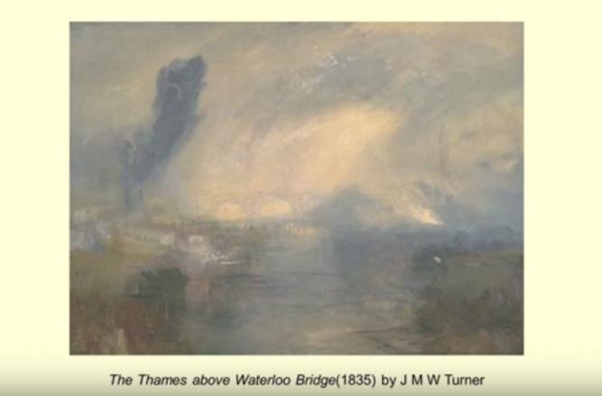

音频原文
Turner, not surprisingly, painted one of the earliest pictures of London’s fog, in the 1835
painting the Thames above Waterloo Bridge. Turner is a trueborn Londoner, is advertising his familiarity with London’s air problem by putting smoke, an atmospheric pollution at its center. And as you can see, in here, the bridge is the central elements, which is a theme that’s later taken up by Monet. And it’s partly obscured by the steam and smoke which rises from both
sides of the river. Here, we see a shot-tower. I think you can just about to see, which was
constructed in 1826. Do you know what shot-towers are? They produce shot for guns,
ammunition. And they were very smoky, one of the most smoking industries. But it’s barely
visible, as you can see, as are the various industries on the Lambuth side of the river. There’s, on this side, there’s a steamship about to dock or preparing to leave. It’s black smoke
thrusting up to join the kind of swirling arc of smoke there. William Rodner sees this painting as a potent essay on the energy and complexity of modern polluted urbanism. Smoke, I
think, here represents for a ﬂourishing economy, which brings employment and food on
tables but also the dirt and pollution associated with the fumes all seems to be tainted by sulfurous yellow.
参考答案
Turner painted one of the earliest pictures of London’s fog in the 1835.

Turner is familiar with London’s air problem by putting smoke at its center.

The bridge is the central elements, and it is a theme that’s later taken up by Monet.

We see a shot-tower and a steamship.

They were very smoky and barely visible.

The speaker thinks they represent for a ﬂourishing economy, but also the dirt and pollution.

turner - L1 - / ˈtɚnɚ/ n. 车床工 ，体育协会会员； 车工；
fog - L1 - /fɔg/ n. 雾； 烟雾； 迷惑； 割后再生的草；
familiarity - L1 - /fə ˌ mɪl ˈjærɪti , - ˌ mɪli ˈ ær-/ n. 熟悉； 通晓； 认识； 友好随便；
gun - L1 - /ɡʌn/ n. 枪； 发令枪声； 受雇杀人的枪手； 喷射器；
thrust - L1 - /θrʌst/ vt.& vi. 猛推； 逼迫； 强行推入； 延伸；
arc - L1 - /ɑrk/ n. 综合症状； 弧 （ 度） ；天穹； 电弧 ，弧光。 ；
potent - L1 - / ˈ poʊtnt/ adj. 有效的 ，强有力的； 有权势的； 烈性的； 有说服力的； smoky - L2 - / ˈ smoʊki/ adj. 多烟的； 冒烟的； 有烟熏味的； 烟状的；
ammunition - L3 - / ˌ æmjə ˈ nɪʃən/ n. 弹药 ， 军火； <废>军需品； <比喻>战斗手段； 子弹； dock - L3 - /dɑk/ n. 码头； 被告席； 草本植物； 尾巴的骨肉部份；
swirl - L4 - /swɜrl/ vi. 旋转 ，打旋； 眩晕； 盘绕； 大口喝酒；
taint - L4 - /tent/ n. 污点 ，污名； <废〉 气味； 传染 ，腐败；
steamship - L5 - / ˈ stim ˌʃɪp/ n. 汽船 ，大轮船；

urbanism - L5 - / ˈ ɚbə ˌ nɪzəm/ n. 都市生活 ，都市社会物质需求的研究 ，都市化； fume - L5 - /fjum/ n. 烟气 ，烟雾； 愤怒 ，烦恼；

105. Father and child / 父与子 #5082 高频 不可练习
回忆要点：
回忆1.上次考了一题新的RL 有图 是爸爸抱着孩子。主要说的是爸爸和孩子的关系。 总分总的结构。爸爸和孩子之间的关系越来越被重视。爸爸能教给孩子的主要是
responsibility。爸爸给孩子safe ，让孩子在外面risk ，但是不管怎么样都可以back。 最后总结了两点 ，记不清了。
回忆2.讲父亲在孩子成长中的角色 父亲角色很重要 要跟孩子玩 让小孩长大后更independent passionate
passionate - L1 - / ˈ pæʃənɪt/ adj. 热烈的； 激昂的； 易怒的； 易被情欲所支配的；

106. Aging / 老龄化问题 #5079 超高频
音频原文
It 's not unusual to hear about the threat of the rapidly growing global population.

On average, each country is seeing their population grow by about one and a quarter percent per year.
But a number of countries have the opposite problem a population that is rapidly decreasing, giving way to its own set of challenges.
So which countries have shrinking populations?

Although the reasons for a shrinking population vary, the consequences are almost always the same.
Fewer people leads to a smaller workforce, slowing economic development and a massive public debt.
While the worst cases of population decline can be found in Eastern Europe, where many
countries will see their population drop by more than 15% over the next three decades, the most extreme case is Bulgaria, where the population is expected to be roughly 30% smaller by 2060.
That translates to 164 fewer people per day or 60,000 per year.

Not far behind Bulgaria is Moldova, which loses just over 1% of its population annually and has a death rate akin to war torn countries in Africa.

Over the last three decades, the populations of these and other Eastern European countries have plummeted for almost identical reasons with.
参考答案
As the world population growth, aging population has become more serious.

Aging percentage in the US is now 13% and is expected to be 23% in 2030.

The situation is the same in Japan and Germany.

There will be more than 20% of German population aged over 65 years old in 2030.

Aging problem is related to industrialization.

torn - L3 - /tɔrn/ v. 撕 （ tear的过去分词） ；扯裂； 破损；

107. Early Robot / 早期机器人 #5025 超高频
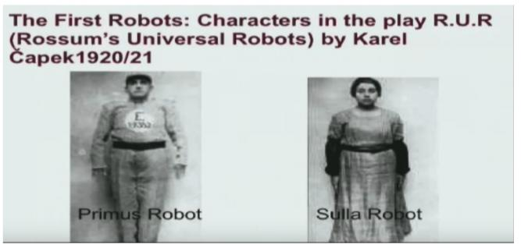
音频原文
This is a kind of object that you’re probably all familiar with when you had the term robot, but I’m gonna show you the very, very ﬁrst robots. These were the very ﬁrst robots. They were
characters in a play in the 1920s called Rossum’s Universal Robots and they, the play was
written by Czech writer called Karel Capek. And basically, these robots, you know, people
tend to think of robots as kind of cute cuddly toys or, you know, Hollywood depictions kind
of devoid of politics. But the ﬁrst robots were actually created and imagined in a time of
absolute political turmoil. You just had the First World War, you know, it ﬁnished had a
devastating impact across Europe and so people will kind and people are kind of reﬂecting
on what does it mean to be human, what makes us human, those kinds of question. And this kind of context is what inspired Capek to kind of write this play. And interestingly, these

robots being human, they are actually in the play assembled on a production line, a bit like
the Ford manufacturing production line. So even though they are human, they are assembled and these robots are designed to labor, and that is their primary purpose in society.
参考答案
The ﬁrst robots were characters in a play in the 1920s called Rossum’s Universal Robots, and the writer was Karel Capek.
People tend to thinks of robots as cute cuddly toys. But the ﬁrst robots were actually created and imagined in a time of absolute political turmoil, which was the First World War.
The robots are actually in the play assembled on a production line.

Even even though they are human, they are assembled and these robots are designed to labour, and that is their primary purpose in society.

depiction - L1 - /dɪ ˈ pɪkʃən/ n. 描写 ，叙述；
turmoil - L1 - / ˈtɜrmɔɪl/ n. 混乱； 焦虑；
ford - L1 - /fɔrd/ n. 浅滩 ，可涉水而过的地方； 福特 （ 人名） ；福特汽车； devoid - L4 - /dɪ ˈvɔɪd/ adj. 缺乏 ，没有；

108. Music and well-being / 音乐和幸福 #5016 超高频
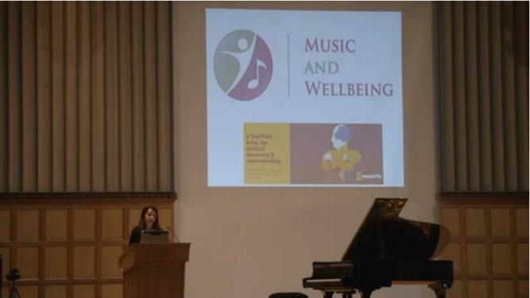
音频原文
So what do we mean by well-being? Health, happiness, a sense of achievement and
contentment, a state of mind and body where people can thrive. Well-being is not something

that is purely limited to people who are facing extraordinary challenges in their lifestyle,
health or personal circumstances, everybody here has a level of well-being. Music so often
forms an intuitive part of our well-being management, music to pick us up, music to calm us down, music to heal our sorrows. Our aim through research is to move from this level of
intuitive application of music through to informed use in our communities to take the next
step in the understanding of the power of music in human life. Music already works for us on so many levels whether it’s soothing and teaching our infants bringing people and
communities together adding spirit to our work and personal endeavours, but there is no reason to stop here.
参考答案
The lecture mainly focus on well-being, which includes health, happiness, a sense of achievement and contentment, a state of mind and body where people can thrive.
In addition, everybody has a level of well-being.

The speaker also emphasizes that music so often forms an intuitive part of our well-being management, and the research takes the next step in the understanding of the power of music in human life.
In conclusion, the music already works for us on so many levels, but there is no reason to stop here.

calm - L1 - /kɑm/ adj. 镇定的； 平静的； （ 海洋 ，天气等） 安静的 ，平静的； （ 人） 从容不迫的； contentment - L2 - /kən ˈtɛntmənt/ n. 满足 ，满意 ，知足 ，心满意足；
intuitive - L2 - /ɪn ˈtuɪtɪv/ adj. 直觉的； 凭直觉获知的； 直观的；
sorrow - L2 - / ˈ sɑroʊ/ n. 悲痛； 悔恨 ，惋惜； 伤心事；
heal - L3 - /hil/ vt. 恢复健康的状态； 使恢复正常； 使 （ 某人） 精神恢复健康；
soothing - L4 - / ˈ suðɪŋ/ adj. 慰藉的； 使人宽心的； 镇静的；

109. Animal behavior V2 / 动物行为版本二 #5007 高频
音频原文
Why should we bother studying animal behavior? Well, ﬁrst and foremost, because we are
interested in understanding why animals do what they do. There are lots of other reasons for studying animal behavior. Conservation biologists need to know what animals do if they’re
going to save them. Are those animals social or solitary? How much space do they need and how many mates do they have? Sometimes you can’t predict the outcome of the research.
Fernando Nottebohm started out being interested in how birds know what to sing. Yet his
research eventually led to a complete overhaul of the entire ﬁeld of neurobiology, a totally
unanticipated yet utterly monumental eﬀect. And this is the course textbook by John Alcock

the fact that this is in its ninth edition tells you how fast an aﬁeld animal behavior is. There are lots of new developments.
参考答案
The reason why we study animal behavior is because we are interested in understanding why animals do what they do.
Conservation biologists need to know what animals do if they’re going to save them.

Fernando started out a research and it led to a complete overhaul of the entire ﬁeld of neurobiology.
And John tells you how fast an aﬁeld animal behavior is in his book.

There are lots of new developments.

monumental - L1 - / ˌ mɑnju ˈ mentl/ adj. 不朽的； 纪念碑的； 非常的；
overhaul - L2 - / ˈ oʊvərhɔl/ n. 全面检修； （ 系统、体制等的） 全面修改； 修订； ninth - L2 - /naɪnθ/ n. 第九； 九分之一；
afield - L2 - /ə ˈfild/ adv. 在战场上； 在野外； 远离着；

110. Arctic and Antarctic / 北极和南极 #5006 超高频
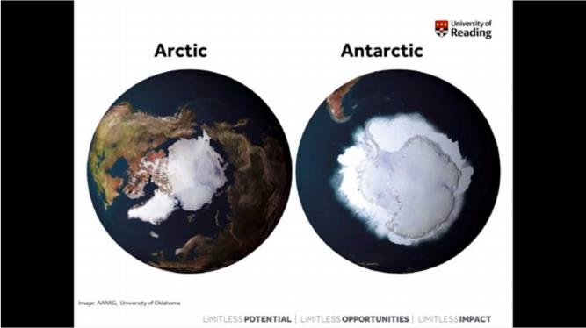
音频原文
So, when we talk about the polar regions, just to clarify exactly what we mean. And we have ﬁrst of all the Arctic at the top of the earth and the Antarctic at the bottom, and so the Arctic was named after the Greek word for bear. Now surprisingly it’s not after the polar bears that

live in the Antarctic or live in the Arctic and based on it’s after the little and great bear
constellations that can be seen in the sky. Now the Greek also hypothesize that there would be the Anti-arctic, which is how we get the name Antarctica and of course it wasn’t
discovered until much later on. Now these regions are opposite in many ways other than just their names and their location on the globe, and so if we look at the arctic ﬁrst of all, and the Arctic is actually ocean surrounded by land, and so you can see here this is the UK down
here and this kind of Russia and then American Canada around here, and so there is a bit of land cover in our ice on the top in the Arctic, which is Greenland here and Macie all this area here. Surprisingly a lot of people don’t realize that this isn’t actually land. The north pole isn’t on land. It’s just one big ocean.
参考答案
The lecture mainly talks about the polar regions, including Arctic and Antarctic.

Moreover, they located at the top and bottom of the earth, and so the Arctic was named after the Greek word for bear, which relates to the little and great bear constellations in the sky.
The lecture also mentions that now the Greek hypothesize that there would be the Anti- arctic, and these regions are opposite in many ways other than just their names and their location on the globe.
Finally, the speaker mentions that the north pole isn’t on land, but it is one big ocean.

hypothesize - L1 - /haɪ ˈ pɑθəsaɪz/ v. 假设 ，假定 ，猜测；

111. Beneﬁts of online lecture / 线上讲座的好处 #5004 低频 不可练习
回忆要点：Semester’s ﬁrst lecture is held online. 三点好处1. diﬀerent modules bring
diﬀerent skills and knowledge? 2. take notes 3. listen to diﬀerent subjects and lectures and make a choice 仅供参考啊大家

112. Sugar / 糖 #4994 超高频

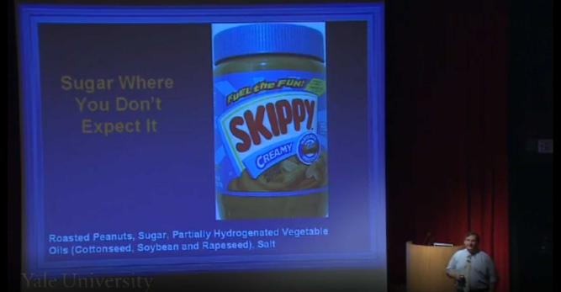
音频原文
There’s sugar in a lot of foods where you don’t expect it. Of course there’s lots of sugar in donuts of ice cream, or pastries, or other things that are sweet; candy of course, but there are other places where you see it and you don’t necessarily expect it. So as an example:
peanut butter. Here’s a list of ingredients from Skippy Peanut Butter and you see that sugar is the second most common ingredient. So that you may know from the reading food labels that these ingredients in any food labels that are listed in order of how much there is in the
food itself, so sugar comes right after peanuts. Here’s another example, Beef stew, you
wouldn’t necessarily expected to ﬁnd sugar in beef stew but it’s there. Now it’s down the list of ingredients, it’s actually toward the end, but if you look at the marketing of this and food at the can, it says, there’s fresh potatoes and carrots, but actually there’s more sugar in this
than there is carrots. And so you wouldn’t eat something like beef stew and expect to ﬁnd this to be the case.
参考答案
The lecture is about sugar. There is sugar in a lot of foods where you don’t expect it.

Besides, there are also other places where you see sugar and you don’t necessarily expect it.

For example, sugar is the ingredient of peanut and beef stew, and you will not know this after you have read the food labels.
Other food like fresh potatoes and carrots contain sugar, and you wouldn’t eat something like beef stew and expect to ﬁnd this to be the case.

pastry - L1 - / ˈ pestri/ n. 糕点； 油酥糕点； 油酥面团； 油酥面皮；
beef - L1 - /bif/ n. 牛肉； 菜牛 （饲养以供肉食的牛） ；体力； 怨言 ，牢骚； peanut - L2 - / ˈ pi ˌ nʌt/ n. 花生； 微不足道的人 ，小人物； 很少的钱；

carrot - L2 - / ˈ kærət/ n. 胡萝 卜； 〈非正怯〉 好处 ， 回报； 不能兑现的报酬； candy - L3 - / ˈ kændi/ n. 糖果； 冰糖； 〈美俚〉 古柯碱 ，可卡因； 巧克力； stew - L3 - /stu/ vt.& vi. 炖 ，煨； 闷热； 担忧；

113. Taxonomy / 分类学 #4987 高频
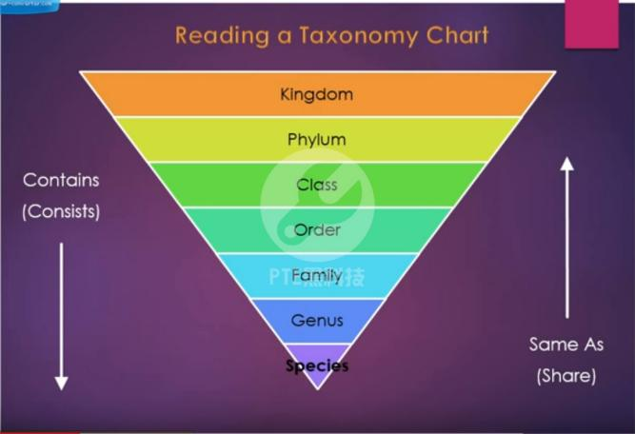
音频原文
Welcome to today 's lesson. We 're continuing with our study of taxonomy. Taxonomy is how scientists classify organisms into diﬀerent groups based on the characteristics that they
share. So, for instance, a good way to think about taxonomy is the US Postal Service. If we
want to send a letter to someone, we ﬁrst start oﬀ by addressing it to the nation they are in.
By default. we usually assume that 's America but it doesn 't have to be a treat England or
Costa Rica or Spain. You put their nation or their kingdom. Then within that kingdom, you
address it to a slightly more speciﬁc level, their states. So, for instance, South Carolina would be the same as a phylum. And within that state, you would address it to their city and then to their street number, the street they live on. Then you would address it to say their apartment complex and within that complex, you 'd address it by their last name to their family and then ﬁnally their ﬁrst name to the speciﬁc person you want to get it to and in that way we 're able
to weed out all the 400 million people we don 't want to send our letter to in America and
pinpoint the exact person we want the letter to reach. And in the same way, scientists use a

taxonomy chart to pinpoint a living creature and organism and how it relates to everything else in the world.
参考答案
The lecture is about taxonomy.

Taxonomy is how scientists classify organisms into diﬀerent groups based on the characteristics that they share.
An example is the US Postal Service.

In this service, people can address it to a speciﬁc level, to their city and then to their street number.
And in the same way, scientists use a taxonomy chart to pinpoint a living creature and organism and how it relates to everything else in the world.

classify - L1 - / ˈ klæsə ˌ faɪ/ vt. 分类 ， 归类； 把 列为密件；
postal - L1 - / ˈ poʊstl/ adj. 邮政的； 邮政局的；
taxonomy - L2 - /tæk ˈ sɑnəmi/ n. （ 生物） 分类学 ，分类系统； pinpoint - L2 - / ˈ pɪn ˌ pɔɪnt/ vt. 确定 ，准确地指出； 精准定位；
phylum - L5 - / ˈfaɪləm/ n. （ 生物分类学上的） 门 ，语群 （ 比语系关系松散的一种语言） ；

114. Immigration control / 移民调控 #4958 低频
音频原文
Now the economists’ calculated, it’s a back of the envelope calculation, that removing all
immigration controls would double the size of the world economy, and even a small
relaxation of immigration controls would lead to disproportionally big gains. Now for an
ethical point of view, it’s hard to argue against a policy that will do so much to help people
that are much poorer than ourselves. The famous Rand Study reckons that a typical
immigrant who arrives in US ends up with $20,000 a year, that’s rough. It’s not just the
migrants themselves who gain, it’s the countries they come from. Already, the migrants
working for poor countries working in rich countries send home around 200 billion dollars a year, through formal channels, and about twice as that through informal channels. And that compares to the neat a hundred million dollars that Western governments give in aid. These remittances are not wasted on weapons or siphoned oﬀ into Swiss bank accounts; they go straight into the pockets of local people. They pay for food, clean water, and medicines, they help kids in school, they help start up new business.
参考答案
The economists calculated that removing all immigration controls would double the size of the world economy or would lead to disproportionally big gains.

A study found that a typical immigrant who arrives in US ends up with $20,000 a year.

The countries they come from gain money as well.

People send money back to their countries in formal and informal channels.

The money is directly paid for food, clean water, and medicines.

neat - L1 - /nit/ adj. 整洁的 ，干净的； 灵巧的； 匀整的； 未掺水的；
pocket - L1 - / ˈ pɑkɪt/ n. 口袋 ，钱袋； 金钱 ，财富； 容器； 凹处；
reckon - L2 - / ˈ rɛkən/ vt. 测算 ，估计； 认为； 计算； 评定 ， 断定；
envelope - L3 - / ˈ envəloʊp/ n. 信封 ，封皮； 壳层 ，外壳； 包裹物； [生物学]膜 ，包袋； rand - L3 - /rænd/ n. 鞋后根与鞋底中间的垫皮 ，边缘；

115. Civilization and art / 文明与艺术 #4949 超高频
音频原文
I have said before that you can’t have a civilization that doesn’t have art when we think about the great civilizations historically. All of them had a great production of culture and art
because a society has built to observe itself and the sophistication of the great civilizations
were their ability to look at themselves. And what allows a society to do that are the
producers of art and culture with mirror back to the core of the society exactly. What is being produced at that moment? How people are thinking of themselves and how individuals are
relating to the social structure at that time. Art is the vehicle through which we understand that. Were you to take away art, What would be that mirror? How would we see what we were about? How would we understand what was going on in Paris at the time of the
Impressionists when people were learning to see in a completely diﬀerent way? Pre-
cinematography Pierre all of these things are just emerging and here are people looking at the world in a very diﬀerent way, which was considered so radical at that time.
参考答案
This lecture talks about civilization and art.

It is impossible to have a civilization without art.

Civilization reﬂects the production of culture and the producers of art and culture should mirror back to the core of the society.
People themselves and individuals are relating to the social structure at that time.

Art is the vehicle through which we understand that were you to take away art, and it also reﬂects that how people look at the world in diﬀerent ways.
cinematography - L5 - / ˌ sɪnəmə ˈtɑgrəfi/ n. 电影术；

116. Human body model / 人体模型 #4943 中频 不可练习
回忆要点：给了一张图片 一个橘黄色木头人model 图片无用 主要说human body model 说人的working mechanism 跟 machine 一样 build human body model can help us study
how our body works 中间解释了原因 具体内容忘记了 最后说engineers build models

117. Knee / 膝盖 #4568 超高频
音频原文
The sound of a cracking knee isn 't particularly pleasant. But it gets worse when you listen up close. "It does for most people. But for me, it actually just makes me excited. " Omer Inan, an electrical engineer at Georgia Tech. "I actually feel like there 's some real information in them that can be exploited for the purposes of helping people with rehab. " Inan 's experience with cracking knees goes back to his days as an undergrad at Stanford, where he threw discus.
"If I had a really hard workout, then the next day, of course, I 'd be sore, but I 'd also
sometimes feel that I would feel this basically catching or popping or creaking every now and then in my knee. " A few years later, he found himself building tiny microphones at a high-end audio company. So when he got to Georgia Tech and heard the Defense Advanced Research Projects Agency, DARPA, wanted better tech for knee injuries, he thought: Why not strap tiny microphones to people 's knees, to eavesdrop as their legs bend? "What we think it is, is the cartilage and bone rubbing against each other, the surfaces inside the knee rubbing against each other, during those movements. " He and a team of physiologists and engineers built a prototype with stretchy athletic tape and a few tiny mics and skin sensors. And preliminary
tests on athletes suggest the squishy sounds the device picks up are more erratic, and more irregular, in an injured knee than in a healthy one. Which Inan says might allow patients and doctors to track healing after surgery. Details appear in the IEEE Transactions on Biomedical Engineering. "The primary application we 're targeting at ﬁrst is to give people a decision aid during rehabilitation, following an acute knee injury, to help them understand when they can perform particular activities, and when they can move to diﬀerent intensities of particular
activities. " A useful thing to take a crack at.

参考答案
The sound of a cracking knee isn 't particularly pleasant.

An electrical engineer was building tiny microphones at a high-end audio company to listen up the knee cracking sound.
He and his team built a prototype with stretchy athletic tape and a few tiny mics and skin sensors.
The primary application they are targeting at ﬁrst is to give people a decision aid during rehabilitation.

threw - L1 - /θru/ v. 投( throw的过去怯 ) ；掷； 扔； 抛；
tape - L1 - /teɪp/ n. 带子； 胶带 ，磁带； 卷尺；
erratic - L1 - /ɪ ˈ rætɪk/ adj. 飘忽不定的； 行为古怪 ，反复无常； （ 运动或行为） 不规则的；
healing - L1 - / ' hilɪŋ/ n. 康复 ，复原；
rehabilitation - L1 - / ˌ rihə ˌ bɪlə ˈteʃən/ n. 修复； 复兴； 复职； 恢复名誉；
workout - L2 - / ˈ wɜrkaʊt/ n. 锻炼； 练习； 试验；
undergrad - L3 - / ˈʌndɚ ˌ ɡræd/ n. <口>大学肄业生 ， （ 尚未取得学位的） 大学生；
sore - L3 - /sɔr, sor/ adj. 疼痛的； 使人伤心的； 恼火的 ，发怒的；
eavesdrop - L3 - / ˈ ivzdrɑp/ vi. 偷听 （ 别人的谈话） ；
physiologist - L3 - / ˌ fɪzi ˈ ɑlədʒɪst/ n. 生理学者；
irregular - L3 - /ɪ ˈ rɛɡjəlɚ/ adj. 不规则的 ，不对称的； 无规律的； 不合规范的 ，不合法的； 不规则变化的； cartilage - L4 - / ˈ kɑrtɪlɪdʒ/ n. <解>软骨； 软骨结构；
creak - L5 - /krik/ vi. 发出咯吱声或叽嘎声；
stretchy - L5 - / ˈ strɛtʃ i/ adj. 有弹性的；

118. Shy ﬁsh / 腼腆的鱼 #4556 超高频
音频原文
When you think of a leader, you may think of an individual who is above all bold. But a new
study of ﬁsh called sticklebacks shows that shy individuals actually prefer to follow ﬁsh that are similarly timid. Researchers had trios of sticklebacks with known personalities play follow the leader. The ﬁsh were placed in a tank that had some plastic plants at one end and some food hidden at the other. In some of the groups, a bold ﬁsh and a shy ﬁsh acted as leaders, while another shy ﬁsh followed. And in other groups, it was a bold ﬁsh that did the following. The researchers recorded whether the follower sallied forth more frequently with the ﬁsh that was behaviorally similar or the one that was diﬀerent. What they found is that shy ﬁsh were
more likely to emerge from undercover when an equally wary fellow was already out there.
Bold follower ﬁsh did not seem to care which leader they followed. Of course, no matter
which ﬁsh a stickleback chose to stick with, the bold ﬁsh did lead more expeditions over the course of the experiment than their more retiring friends. That’s because the bold ﬁsh
initiated more trips, regardless of who might be tailing them. The ﬁndings are in the journal
Biology Letters. The researchers write that “when oﬀered a choice of leaders, sticklebacks
prefer to follow individuals whose personality matches their own, but bolder individuals may, nevertheless, be able to impose their leadership, even among shy followers, simply through greater eﬀort.” We may soon see if such tendencies also hold true in humans, when
Americans decide who they’ll follow in November. Unless, of course, something ﬁshy happens.
参考答案
A new study shows that shy individuals actually prefer to follow ﬁsh that are similarly timid.

The scientists separated the ﬁsh into two groups, found that shy individuals actually prefer to follow ﬁsh that are similarly timid.
That’s because the bold ﬁsh initiated more trips, regardless of who might be tailing them.

If such tendencies also hold true in humans, when Americans decide who they’ll follow in November.

shy - L1 - /ʃaɪ/ adj. 害羞的； 怕羞的； 害怕 （做） ；<美>缺乏的；
follower - L1 - / ˈfɑloʊə(r)/ n. 追随者 ，拥护者； 信奉者 ，信徒； 仆人； 属下；
trio - L2 - / ˈtrioʊ/ n. 三重奏； 三人一组； 三重奏[三重唱]乐曲； （ 小步舞曲、谐谑曲等的） 中段；
wary - L2 - / ˈ weri/ adj. 谨慎的 ，小心翼翼的； 警戒的 ，警惕的；
undercover - L3 - / ˌʌndər ˈ kʌvə(r)/ adj. 暗中进行的 ，秘密的； 秘密从事的； 私下的 ， 隐蔽的； 从事间谍活动的； timid - L4 - / ˈtɪmɪd/ adj. 胆小的； 羞怯的； 怕人； 羞手羞脚；
fishy - L4 - / ˈfɪʃ i/ adj. <非正>可疑的 ，值得怀疑的； 不是味儿； 鬼勾当； 腥味儿；
bolder - L5 - // n. [医]柄；

119. Smell of books / 书的味道 #4555 超高频
音频原文
Indeed, the library. We’ve all been to a historic library. We’ve all enjoyed the smell of a
historic library. But what is it? And what does it mean? When we’ve recently, when at UCL
Center for Sustainable Heritage, we’ve recently been asked to access the environment at
another historical library at Saint Paul’s Cathedral, the Wren library, an incredible place. And it has a such an intensive smell of old books, and we were also asked for the ﬁrst time really I was actually taken aback by the brief, we were asked what you do please preserve the smell. It is so important to our audience. It is so important how people perceive the library. So, that is, that was quite an important message in our research. And indeed the smell is an
important way of how we communicate with the environment. This piece of research was
done by an advertising company because advertisers are so interested in how we, how we
interact with each other and the environment. And we see that the majority of people use
sight obviously to interact with the environment, but on the second place, we see the smell is also very, very important.
参考答案
We’ve all been to a historic library.

In most of historic library, it has a such an intensive smell of old books.

People are asked to perceive the library.

Indeed, the smell is an important way of how we communicate with the environment.

The majority of people use sight to interact with the environment, but on the second place, the smell is also very, very important.

advertiser - L1 - / ˈ ædvərtaɪzə(r)/ n. 登广告的人；
cathedral - L2 - /kə ˈ θidrəl/ n. 总教堂 ，大教堂；
wren - L2 - /rɛn/ n. 鹧鹑； 英国皇家海军女子服务队成员；
saint - L3 - /sent/ n. 圣人般的人 （ 指特别善良、仁爱或有耐性的人） ；圣 （ 冠于人名、地名之前） ； （ 因其生死言行而被基督教会追封的） 圣人； 圣徒；
aback - L5 - /ə ˈ bæk/ adv. 吃惊地； 向后； <航海> （ 帆船） 突遇顶风而停止前进；

120. Space time / 太空时间 #4489 中频 不可练习
回忆要点：
回忆1.考到的是关于四维空间的 ，配上一张黑白的图片 ， 图片上画着几根线 ，一上来就提到我们处于四维空间里 ， 四维空间纳入了时间 ，其余的暂时想不起来 ，但肯定不是原来的那题dimension了
回忆2.提到space time 不是鸡精里面的了 是新的一篇和dimension有关的
回忆3. 屏幕上给了黑色图片 男的 ，没口音 ，语速适中 主题是space-time 4. dimensional
world 描述位置需要latitude, altitude, time and date（ 当时听着觉得是date ，但是难道不应该是height么？ ） 最后提到physics

121. Animal behavior / 动物行为 #4486 超高频
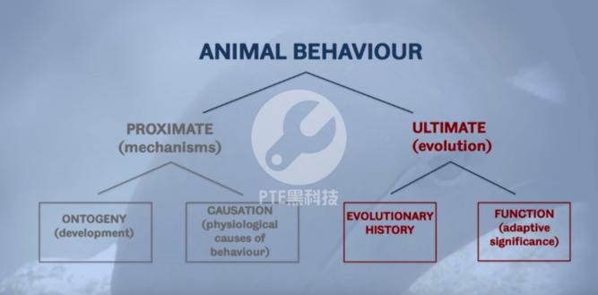
音频原文
We can ask two fundamental questions about animal behavior, they referred to as proximate and ultimate. Proximate questions are those concerned with the mechanisms that bring

about behavior, ultimate questions are those concerned with the evolution of behavior. We
can divide the proximate and ultimate questions into two sub-questions. For proximate, how does the behavior develop, and secondly what causes the behavior. For ultimate, you can
ask how did the behavior evolve, and secondly what is the adaptive signiﬁcance of the
behavior, what’s the purpose. Together these comprise what are called Tinbergen 's four
questions about animal behavior. Niko Tinbergen was one of the founding fathers of the
study of animal behavior. These questions represent the diﬀerent ways of studying animal
behavior and understanding the diﬀerence between those four questions are fundamental to understanding behavior and indeed the whole of biology. How do we study animal behavior well that depends on the type of question we’re hoping to answer.
参考答案
Two fundamental questions about animal behavior are referred to as proximate and ultimate.

Proximate questions are those concerned with the mechanisms that bring about behavior. The ultimate questions are those concerned with the evolution of behavior.
Two sub-questions are how does the behavior develop, and secondly what causes the behavior.
For ultimate, you can ask how did the behavior evolve, and what is the adaptive signiﬁcance of the behavior.
Together these comprise four questions about animal behavior.

proximate - L5 - / ˈ prɑksɪmət/ adj. （ 时间、顺序等方面） 近邻的 ，最接近的；

122. Hazardous chemical product / 危险化学物品 #4477 超高频 不可练习
回忆要点： 考了一个新题是关于hazardous chemical product的 - 画面会有一罐pesticide的正反面图片 ， 因为是用pesticide来举例的 ，罐子正面是一片草地的图片 （ 实在没话说就介绍一下咯） ，反面是化学产品都有的warning label。 - 主要是说warning label设计的不太合理 ，字体好小了 ，其实很多人都看不清使用注意事项会导致危险。60%的人看不清楚xx字号大小 （好像是10） 以下的 - 40%的美国人是illiterate ，他们看不懂因此也会没有注意到这些产品的危险 大概就是这样我也没有听得很好这题不好意思 ，仅供参考

123. Eating behavior / 饮食习惯 #4447 中频 不可练习
回忆要点：
1. 讲了eating behavior。 说男女的eating behavior不一样 ，女的更注重饮食 ，有两原因 ，一是因为女的经常关注饮食健康的信息（意思好像是这样） ，二是因为本性 不难但是失忆了 ，希望大神补充

2. social inﬂuence on eating behavior Two factors： 1. women are more inﬂuenced by health promotion than men 2. women‘s personal attitude is less important a change in eating behavior in society ，40% people obese in Australia最后在说趋势
obese - L1 - /oʊ ˈ bis/ adj. 极为肥胖的 ，肥大的；

124. Bird migration / 鸟类迁徙 #4445 超高频 不可练习
回忆要点：
回忆1.讲Australian bird migration 内容不长 有图但关系不大 要仔细听 1. The temperature is rising, making springtime phenomena earlier 2. Urban light pollution is also a more
signiﬁcant factor. （光污染） 3. This disruptive timing can damage the ecosystem. 4.
The caterpillars are trying to match the hatching of their eggs to the timing of bud burst.
5. This could aﬀect the survival of birds 6. But smarter lighting—like LEDs that dial down certain wavelengths—could help.
回忆2.有视频 男lecturer ppt上是土澳地图 讲Australian birds have to migrate from on one place to another every year due to climate change. birds need to ﬂy 5 kilometers, you
may think it is easy, but actually, it’s not because they have to ﬁnd new food sources in a new habitat.

springtime - L1 - / ˈ sprɪŋ ˌtaɪm/ n. 春季 ，春天；
caterpillar - L1 - / ˈ kætərpɪlə(r)/ n. 毛虫； 履带； 履带拖拉机；
bud - L1 - /bʌd/ n. 芽 ，萌芽； 蓓蕾 ， 骨朵； 未成熟的人 ，少男少女； 〈美〉 刚进社交界的姑娘；
led - L1 - /lɛd/ v. 带路( lead的过去怯和过去分词 ) ；领导； 指挥； 领先；
dial - L1 - / ˈ daɪəl/ n. 日晷； 钟 （ 表） 面 ，标度盘； 拨号盘； 表盘；

125. Early spring / 早春 #4444 超高频
音频原文
The Earth 's temperature is rising. And as it does, springtime phenomena—like the ﬁrst bloom of ﬂowers—are getting earlier and earlier. But rising temperatures aren 't the only factor.
Urban light pollution is also quickening the coming of spring. "So temperature and light are really contributing to a double whammy of making everything earlier. " Richard ﬀrench-
Constant, an entomologist at the University of Exeter. He and his colleagues compiled 13
years of data from citizen scientists in the U.K., who tracked the ﬁrst bud burst of four
common trees. Turns out, light pollution—from streetlights in cities, and along roads —
pushed bud burst a full week earlier. Way beyond what rising temperatures could achieve. This disruptive timing can ripple through the ecosystem. "The caterpillars that feed on trees are trying to match the hatching of their eggs to the timing of bud burst. Because the
caterpillars want to feed on the juiciest and least chemically protected leaves. And it 's not

just the caterpillars, of course, that are important. But the knock-on eﬀect is on nesting birds, which are also trying to hatch their chicks at the same time that there 's the maximum
number of caterpillars. " So earlier buds could ultimately aﬀect the survival of birds, and
beyond. The ﬁndings are in the Proceedings of the Royal Society B. The world 's becoming increasingly urbanized, and light pollution is growing—which ﬀrench-Constant says could trick trees into budding earlier and earlier. But smarter lighting—like LEDs that dial down
certain wavelengths—could help. "Perhaps the exciting thing is, if we understand more about how light aﬀects this bud burst, we might be able to devise smarter sort of street lighting that has less red components, and therefore less early bud burst. " Thus keeping springtime an actual springtime phenomenon.
参考答案
The lecture mainly talks about the Earth 's temperature which is rising.

The speaker also emphasizes that this is not the only reason of spring time phenomena, and another reason is urban light pollution, which pushed bud burst earlier, and way beyond what rising temperatures could achieve.
The lecture also mentions that this disruptive timing can ripple through the ecosystem such as caterpillars and birds.
However, smarter lighting could help with reducing early bud burst. Thus keeping springtime an actual springtime phenomenon

springtime - L1 - / ˈ sprɪŋ ˌtaɪm/ n. 春季 ，春天；
bud - L1 - /bʌd/ n. 芽 ，萌芽； 蓓蕾 ， 骨朵； 未成熟的人 ，少男少女； 〈美〉 刚进社交界的姑娘；
caterpillar - L1 - / ˈ kætərpɪlə(r)/ n. 毛虫； 履带； 履带拖拉机；
chick - L1 - /tʃɪk/ n. 小鸡； 小鸟； 少妇； <口>小姐；
led - L1 - /lɛd/ v. 带路( lead的过去怯和过去分词 ) ；领导； 指挥； 领先；
dial - L1 - / ˈ daɪəl/ n. 日晷； 钟 （ 表） 面 ，标度盘； 拨号盘； 表盘；
bloom - L2 - /blum/ n. （ 常指供观赏的） 花； 开花期； 最盛期； 健康有精神的面貌；
quicken - L3 - / ˈ kwɪkən/ vt.& vi. （使） 变快； 增速； 鼓舞； 使复活；
entomologist - L3 - / ˌ entə ' mɒlədʒɪst/ n. 昆虫学者；
streetlight - L5 - / ˈ strit ˌ laɪt/ n. 街灯；
juiciest - L5 - // adj. 多汁的( juicy的最高级 ) ； （ 提供丑闻等消息而） 有趣的； 有吸引力的； 报酬丰厚的； urbanize - L5 - / ˈ ɚbə ˌ naɪz/ vt. 使都市化 ，使文雅；

126. Science and scientist / 科学与科学家 #4443 超高频
音频原文
The answer is only one in science.

It 's the human curiosity and the ability to discover and invent new things that 's made us live longer, better, happier.
And it 's going to continue.

But then who are these people who are doing this?

And and these people are called scientists.

And what did they do and how did they do this?

Often I have people coming in, especially children, and I ask them, who are scientists?

What do you know about them?

And depending on the age, you get a number of diﬀerent answers.

If you ask a teenager their information about a scientist comes from Big Bang Theory or, you know, and if you ask a little kid, they often have seen these pictures of these completely
crazy nerds who go into their little hall and come up with these crazy ideas who are unfriendly.
I mean, these are all interesting myths and ideas.

What I hope I can do today is to tell you a few stories about scientists and what they do.

I wish I was as articulate as I was and use all the words about creativity, imagination, connectivity, everything that you said about an artist.
The truth is, all of them are true about scientists.

参考答案
In this dialog, the male is discussing about a science ﬁction. Science is all about evidence.

He is talking about the diﬀerence between science and scientists, and he said he likes scientists rather than science.
Because scientists can do research and propose questions to ﬁnd out what is true.

Science is like furniture (incomplete)

crazy - L1 - / ˈ krezi/ adj. 疯狂的； 不理智的； 离奇的； 生气的；
myth - L1 - /mɪθ/ n. 神话； 神怪故事； 奇人 ，奇事； 虚构的人 ，虚构的事； articulate - L3 - /ɑr ˈtɪkjuleɪt/ adj. 发音清晰的； 善于表达的； 有关节的；

127. Fire safety / 消防安全 #4442 中频

音频原文
With over 40 years unrivaled experience and a worldwide reputation, BSI leads the way in
testing and certiﬁcation of ﬁre safety products. Based on our dedicated labs in Hemel
Hempstead, our team provides BSI height mark and Cee testing and certiﬁcation for a broad range of products, including ﬁre extinguishers, hoses, alarm panels, and heat and smoke
detectors. We help clients to gain access into the European market by ensuring that
products meet all the CE mark requirements. And we are familiar with the market access
regulations of most countries across the world, enabling customers to enter markets globally. The BSI height market is categorized as a British super brand and acknowledged the world
over as a symbol of trust, integrity, and quality. It provides the reassurance that vital product safety and performance requirements have been met. Our team subject each product to a
rigorous set of tests along with robust production control audits designed speciﬁcally to
ensure that they perform two required standards of safety and quality. We test for
compatibility of ﬁre detection and ﬁre alarm system components to ensure that they're
compatible and connectable. This service meets the growing requirement of European
regulatory authorities to meet national installation guidelines. We also perform tests on
individual detection components. Fire suppression products such as ﬁre extinguishers are subjected to rigorous tests designed to ensure that they 're eﬀective, safe and capable of performing in environments and conditions in which they 're stored and used. The symbols for BSI kite mark and C certiﬁcation represent quality, safety, and trust. For speciﬁers, they demonstrate a commitment to best practice procurement. And for the public, they provide the reassurance that ﬁre safety products are eﬀective and reliable.
参考答案
BSI leads the way in testing and certiﬁcation of ﬁre safety products, including ﬁre extinguishers, hoses, and alarm panels.
They help clients to gain access into the European market.

They test for compatibility of ﬁre detection and ﬁre alarm system components.

They also perform tests on individual detection components.

For the public, they provide the reassurance that ﬁre safety products are eﬀective and reliable.

alarm - L1 - /ə ˈ lɑrm/ n. 惊恐； 警报； 闹铃； 动员令；
detector - L1 - /dɪ ˈtɛktɚ/ n. 探测器； 检测器； 发现者； 侦察器；
installation - L1 - / ˌ ɪnstə ˈ leʃən/ n. 安装； 装置； 永久性军事基地； 就职； hose - L2 - /hoʊz/ n. 软管 ，胶皮管； 长筒袜； 男性穿的紧身裤；
reassurance - L2 - / ˌ riə ˈʃʊrəns/ n. 使安心； 再保证；
suppression - L2 - /sə ˈ prɛʃən/ n. 压制； 镇压； 禁止； 抑制；
procurement - L2 - /prə ˈ kjʊrmənt/ n. 获得 ，取得； 采购；

audit - L3 - / ˈ ɔdɪt/ n. 审计 ，查账；
compatibility - L3 - /kəm ˌ pætə ˈ bɪlətɪ/ n. 适合； 互换性； 通用性； 和睦相处； regulatory - L3 - / ˈ regjələtɔri/ adj. 调整的； 具有监管权的 ，监管的 ；
kite - L3 - /kaɪt/ n. 风筝； 鸢 （ 猛禽） ； 空头支票； 光棍；
extinguisher - L5 - /ɪk ˈ stɪŋɡwɪʃɚ/ n. 熄火者； 消火者； 消火器； 熄火器；

128. Mosquitoes / 蚊子 #4439 中频 不可练习
回忆要点： 公蚊子不吸血 母蚊子吸血 母蚊子下崽子时吸血 需要营养 蛋白质 温度和co2 吸引蚊子 运动时容易被咬

129. Pull and push / 拉与推 #4437 低频 不可练习
回忆要点：
带有视频 讲的pull/push force 给了一个例子是给一个箱子施加了力但箱子也不一定会动 1. force is work done either push or pull. 2. In the diagram there 's a cart, pushing and
pulling a cart, the cart experience force 3. Force does not necessarily move the object. Objects can be stationary and still experience force.
stationary - L2 - / ˈ steɪʃəneri/ adj. 不动的 ， 固定的； 静止的 ，不变的； 常备军的； 定居的；

130. Melatonin / 褪黑素 #4423 超高频
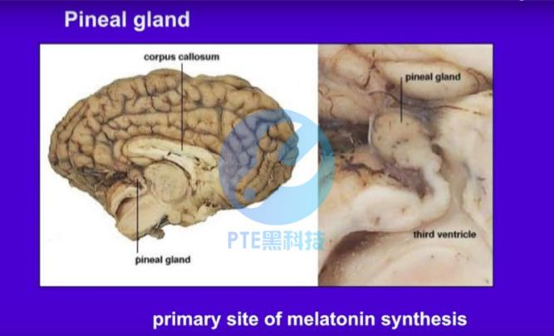

音频原文
I 'm just going to take on the stuﬀ where left oﬀ . The hormone I want to now talk about it 's
called melatonin. The synthesis is in the Pineal Gland, which is very small. It is the size of a
pea in your brain. The corpus is the site of the soul, and it is where melatonin is made. And it has a rhythm as well. And in this sense, it is the opposite of the cortisol. It peaks at night. We call it the darkness hormone. In every species that we studied, melatonin occurs at night.
And it 's a hormone that prepares you for the things, that your species, does at night. So, of course, in humans we sleep, but animals, like rodents, they are awake. It 's a hormone that is related to darkness behavior.
参考答案
The lecture is about the hormone called melatonin.

The synthesis is in a very tiny part in the brain.

And it has a rhythm as well.

It peaks at night.

We call it the darkness hormone.

It 's a hormone that is related to darkness behavior.

synthesis - L1 - / ˈ sɪnθɪsɪs/ n. 综合； <化>合成； 综合体； 综合推理； pea - L1 - /pi/ n. 豌豆 ，豌豆类； 豌豆状物； 〈美俚〉 棒球；
rodent - L1 - / ˈ roʊdnt/ n. [动]啮齿目动物；
corpus - L2 - / ˈ kɔrpəs/ n. 全集 ，文集； 资金 ，本金； [计]语料库； 器官； awake - L2 - /ə ˈ wek/ adj. 醒着的； 警惕的；
gland - L4 - /ɡlænd/ n. <解>腺； [机]密封压盖 ，填料盖；
pineal - L5 - / ˈ pɪniəl , ˈ paɪni-/ adj. 松球状的 ，松果腺的；

131. Smartphone apps / 智能机的软件 #4269 中频
音频原文
Computer scientist Shwetak Patel and his team are developing new sensing systems. The
initial focus was really around energy and water monitoring. They built a new generation of
smart sensors that monitor electronic interference on a home’s power line or water pressure changes in the plumbing. Most of this technology has already found industrial applications, and Patel and his team turned their attention to adapting the technology for personal health monitoring. ‘So how do we take this noise and make it into a signal interest was hard to us, hard to us in the core of what we did for many years and we’re taking that work and applying it to other domains. ’ They’re looking to take advantage of all the functionality built in our
smartphones. With the users’ permission, this app can use the microphone built into most

smartphones to listen to background noises, such as coughing searching for patterns that
suggest a trip to the doctor might be an order. ‘We 've constructed these models that try and understand how sound works, how it, what its patterns are and we give it a whole bunch of
examples of diﬀerent kinds of audio, things like people talking, things like people laughing,
sneezing and of course coughing. ’ This app uses a phone’s camera to check hemoglobin
levels in blood by analyzing the color of capillary ﬂuid through the skin. ‘Generally, what
happens is if you’re anemic, your bloods maybe a little less red and we take advantage of
that by putting your ﬁnger over a camera of a phone, the camera of the phone can actually
see the coloration of the blood. ’ and this test uses the camera to tell parents worried about
jaundice in newborn infants. ‘Now, jaundice is something that doctors who have seen tons of babies. He just can ﬁgure out on a very basic level of it. Is this baby, do they need to get
treatment or are they in a good condition, while the ﬁrst-time parent has no idea necessarily what jaundice might look like. ’ The researchers say the built-in sensors found in smartphones are already commonplace, but their applications and their implications for our health and
well-being may be more far-reaching than we ever imagined.

参考答案
Computer scientist and his team are developing new sensing systems.

The initial focus was on energy and water monitoring.

They paid attention to adapting the technology for personal health monitoring.

They took advantage of all the functions built in our smartphones.

The applications and their implications for our health and well-being may be more far- reaching than we ever imagined.

interference - L1 - / ˌ ɪntər ˈfɪrəns/ n. 干涉 ，干扰 ，冲突； 介入； 妨碍 ，打扰 ， 阻碍物； 冲突 ，抵触； newborn - L1 - / ˈ nubɔrn/ adj. （ 婴儿） 新生的 ，初生的； 再生的 ，复活的；
plumb - L2 - /plʌm/ vt. 使垂直； 用测铅测； 探索；
cough - L2 - /kɔf/ vt.& vi. 咳嗽； （ 引擎等） 发噗噗声； 咳出；
sneeze - L2 - /sniz/ n. 喷嚏； 喷嚏声；
hemoglobin - L2 - / ˈ himə ˌ ɡlobɪn/ n. 血红素； 血红蛋白 ；
capillary - L2 - / ˈ kæpəleri/ n. 毛细管； 毛细血管； 微管；
coloration - L2 - / ˌ kʌlə ˈ reʃən/ n. 染色 ，着色；
anemic - L5 - /ə ˈ nimɪk/ adj. 贫血的； 患贫血症的； 没有活力的； 无精打采的；
jaundice - L5 - / ˈ dʒɔndɪs , ˈ dʒɑn-/ n. 黄疸病； 偏见；

132. The politics of happiness / 关乎幸福的政策 #4268 超高频

音频原文
As Joanne pointed out, only one country, tiny little Bhutan, wedged between China and India, has adopted the Gross National Happiness as the central index of government policy, and
actually has a good deal of success in education and in health and in economic growth and in environmental preservation. They have a rather sophisticated way of measuring the eﬀects of diﬀerent policies on people 's happiness. They are the only country to go that far.
But you are now beginning to get other countries interested enough to do kind of white
paper policy analyses of happiness research—what eﬀects would it have if we used it more for public policy? You are beginning to get countries like Australia, France, Great Britain, that are considering publishing regular statistics on happiness. So it is beginning to become a
subject of greater interest for policymakers and legislators in diﬀerent advanced countries.

参考答案
This lecture talks about happiness.

Firstly, Bhutan has adopted the Gross National Happiness as the central index of
government policy, and has a good deal of success in education and in health and in economic growth and in environmental preservation.
Secondly, it is the only country to go far that has a way of measuring the eﬀects of diﬀerent policies on people 's happiness.
Finally, it is the time for policymakers and legislators in diﬀerent advanced countries like Australia, France and Great Britain to think about policy analyses of happiness research.

wedge - L2 - /wɛdʒ/ n. 楔； 楔形物； （ 击高尔夫球的） 楔形铁头球棒； 〈比喻〉 可以逐渐扩大作用的开端； legislator - L5 - / ˈ lɛdʒɪ ˌ sletɚ/ n. 立法委员； 立法者；

133. Transformation / 转型 #4260 高频 不可练习

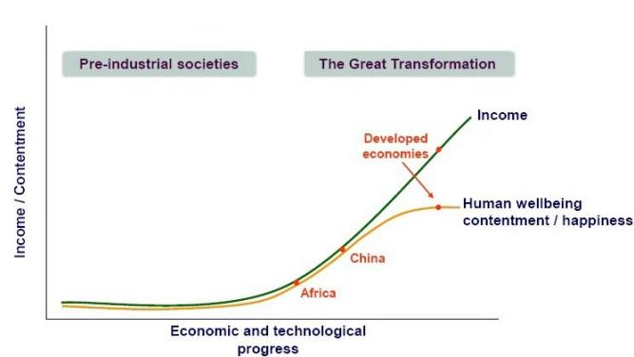
回忆要点：
回忆1.考了一个transformation 举例子China 和一些正处于transformation初期的国家有 个图线图做部分是pre-industralial period 右边好像是现在
回忆2.还提到了 GDP 多少 ，然后多久没变还是怎样来的吧。 最后说很多国家 ， 比如China还在transform 的beginning,是early period
回忆3.发达国家(rich and developed world)都经历过大转折(turning points) ，GDP增长迅速(extraordinary GDP growth) ，经济和科技腾飞(take oﬀ)。发展中国家包括中国印度都在转变前期(early stages of transformation) ，发达国家developed countries 已经完成转型 ，他们再发展也不会对人类进程（do not have further progress) 有多大提高。言下之意应该
是 ，在early stages of transformations才会在各方面有显著的发展。。到转变后期会遇到瓶颈。

134. Soot emission / 烟尘排放 #4242 超高频

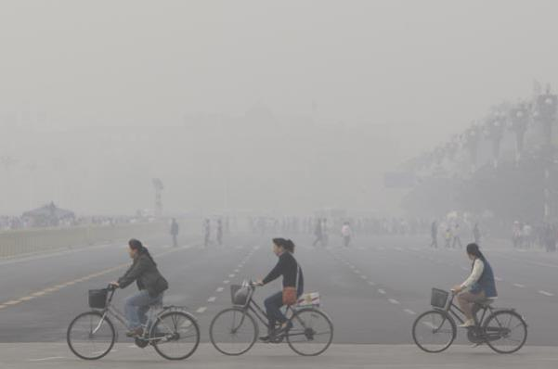
音频原文
Reference passage: Sometimes it 's the little things that can make big things happen. Fleas
and the plague, atoms and nuclear bombs. Diminutive leaders in world history. Soot is one of these little things. Soot also known as black carbon is released when you burn dung, coal,
diesel fuel and wood. From Los Angeles to Mumbai, soot causes respiratory illnesses like
lung cancer and asthma and contributes to one point six million premature deaths every year. Mostly among the poor. And it gets worse. Atmospheric currents carry soot thousands of
miles from where it is produced, to the Himalayas and the Arctic. Black carbon being black, absorbs sunlight, so even a little soot on snow makes it melt faster. And when snow melts
global sea levels rise, threatening our freshwater indigenous communities and polar bears
who hunt on the Arctic ice. Climate Change has been a big thing for a while and carbon
dioxide has been its main cause. Scientists estimate that soot causes twenty ﬁve percent of human-caused global warming. It’s the second leading cause of Arctic warming after carbon dioxide. Let’s not underestimate the impact of this tiny particle. But there’s good news,
reducing black carbon may be the fastest way to slow global warming. Buy time for the
Arctic. Yes even more so than changing a light bulb. Since black carbon only stays in the
atmosphere for a couple of weeks, reducing it will produce results immediately. Of course,
reducing soot alone won’t solve global warming, but solving our soot problem now will help buy time for the Arctic and allow us to deal with the bigger problem of carbon dioxide. We
have the cleaner industries, cook stoves, and diesel now we have to use them. In developed nations, we’ve signiﬁcantly reduced our black carbon, but we still have much more to do. We need to tighten our standards at home and invest in cleaner technologies in developing
nations. In a world going on seven billion people, you might feel rather little yourself. But if you urge the US government and the European Union to take the lead on black carbon

reduction, you can make a big diﬀerence. Go to www.stopsoot.org And help stop these little things from causing big trouble.
参考答案
回忆要点： 首先说soot also called black carbon。然后说soot contributes to climate
warming。soot does not accumulate in the atmosphere like CO2. reduction in soot have immediate but not long-term eﬀects on global warming. if we want to stabilize the climate system, we need to focus on greenhouse gases such as CO2.

plague - L1 - /pleɡ/ n. 瘟疫； 灾害 ，折磨；
bomb - L1 - /bɑm/ n. 炸弹； 彻底的失败； [橄榄球] 长传； 高压贮罐； respiratory - L1 - / ˈ respərətɔːri/ adj. 呼吸的；
tighten - L1 - / ˈtaɪtn/ vt.& vi. 收紧； （使） 变紧； （使） 绷紧； 加紧； soot - L2 - /sʊt , sut/ n. 煤烟 ，烟灰； 油烟；
diesel - L2 - / ˈ dizəl , -səl/ n. 柴油机； 柴油机机车 （ 或船等） ；
premature - L2 - / ˌ primə ˈtʃʊr/ adj. 过早的； 提前的； 早产的； 草率的； stove - L2 - /stoʊv/ n. 炉 ，火炉； 窑； 干燥室 ，烘房；
flea - L3 - /fli/ n. 跳蚤 ，蚤目的昆虫； 生蚤的动物；
dung - L4 - /dʌŋ/ n. 动物的粪便； 粪肥； 令人厌恶的东西；
diminutive - L5 - /dɪ ˈ mɪnjətɪv/ adj. 小的 ，小型的；

135. A survey / 一项调查 #4086 超高频
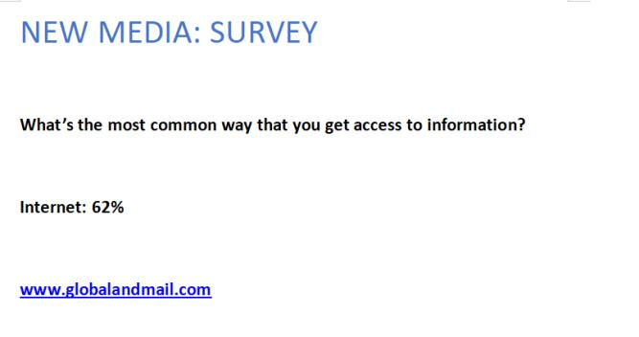
音频原文
Let’s say if I’m asking which source do you often use to get information. Newspaper? Radio? TV? And the survey shows 62% of the people chose Internet. You might be thinking I am

going to say, how important the internet is, or how quickly it has changed the world for a few years. But what if I tell you this survey is conducted on the website global and mail.com? Our answer will be diﬀerent. Because the people who did this survey on a website must be
frequent users of Internet. This sample is a biased sample. So we have to pay attention to how a survey is conducted.
参考答案
This lecture is about survey. A survey shows that 62% of people choose the internet to get information.
This reﬂects the importance of the internet, as it has changed the world for a few years.

However, the survey is conducted on the website globalandmail.com, and the people who did this survey on a website must be frequent users of the internet.
Therefore, this is a biased sample, and we need to pay attention to how a survey is conducted.

136. Language Disorder / 语言障碍 #3863 超高频
音频原文
Language disorders are one of the most common childhood problems.

Young children with language disorders are often misdiagnosed with autism or cognitive disabilities.
For most children, words travel easily down the language highways in the brain.

But for children with language disorders, words tend to get stuck like cars in a traﬃc jam.

Identifying a language disorder can be diﬃcult because the symptoms may co-occur with many other disorders, such as autism, cognitive disabilities and auditory processing
disorders.

Developmental pediatrician Dr. Mark Simms.

About 20% of two year olds are thought to be delayed in learning to talk.

By kindergarten age, about seven or 8% of children are still having diﬃculty with language.

Through the generous support of the Kim and John Slutsky Child Development Fund.

The staﬀ of the Child Development Center at Children 's Hospital of Wisconsin has created a video to educate professionals about the symptoms and impact of language disorders on
children 's behavior and development at diﬀerent ages.

In this free 20 minute video, a clinical psychologist and a speech and language pathologist introduce several children with language disorders and their parents as they describe the
challenges they face and how they are working to overcome them.Through their stories, you will learn what a language disorder is, what it looks like at diﬀerent ages, and where and
when to refer children.

If a language disorder is suspected to order visit, see H.W. Dawgs Language Video.

Please allow 4 to 6 weeks for delivery.

参考答案
Language is a human essence that deﬁnes human characters.

However, 10% of Americans suﬀer from language disorder.

Language disorder in a children’s disability, but it is a philosophical question because it involves in children’s psychology as well.
To improve their linguistic competency, we should know what language is, how language is learned, and how can children speak diﬀerent sentences started by words?

highway - L1 - / ˈ haɪ ˌ we/ n. 公路； 公用通道； 干线； 途径 ，方法； jam - L1 - /dʒæm/ n. 果酱； 拥挤 ，挤满； 困境； [无线]干扰；
developmental - L1 - /dɪ ˌ veləp ˈ mentl/ adj. 发展的； 促使成长的； 进化的； kindergarten - L1 - / ˈ kɪndərgɑrtn/ n. 幼儿园 ，学前班；
autism - L4 - / ˈ ɔ ˌtɪzəm/ n. 孤独症 ， 自我中心主义；

137. Aquacultural ﬁshing / 水产养殖 #3843 中频 不可练习
大多市场上消费的鱼来自于农业养殖 ，这很大程度上保护了鱼的种类。 其他忘记了 ，考的小伙伴可以来补充一下。

138. Government Blogging / 政府开博客 #3746 超高频 不可练习
We normally see blogging as a two-way interaction, in which the blogger creates the content and the readers interact or challenge the author.
But the case will be much diﬃcult when it comes to government, such as the White House.
Because people will become more coarse and rude online, especially in the comment area.
Hence the governor blog may go wild and chaotic.
So the government will have to administrate the comment.

Once the government starts administrating the comment, citizens may ﬁnd the
government manipulating what should be said and what should be shown, which contradicts the original intention.

rude - L1 - /rud/ adj. 粗鲁的； 简陋的； 狂暴的； 近乎下流的；
chaotic - L1 - /keɪ ˈ ɑtɪk/ adj. 混沌的； 一片混乱的； 一团糟的； 无秩序的；
governor - L3 - / ˈ gʌvərnə(r)/ n. 主管人员； 统治者 ，管理者； <美>州长； [机]节速器 ，调节器； coarse - L4 - /kɔrs/ adj. 粗鄙的； 粗糙的； 粗野的； 粗制滥造的；

139. Linguists / 语言学家 #3730 超高频
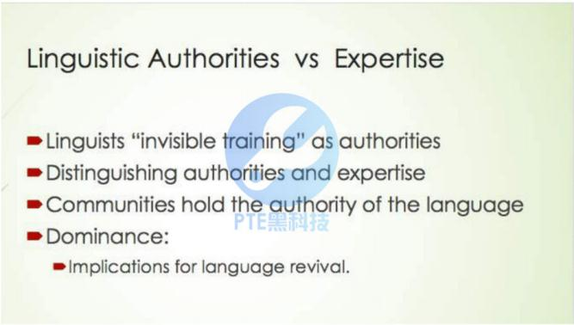
音频原文
But when we move into working with communities, we have to recognize that the
communities have to be the authority in their language. Actually a woman in the class I’m
teaching at Sydney at the moment, a career woman, expressed this very nicely, although she was talking about something else, she was distinguishing expertise from authority. And
certainly linguists because of our training we do have expertise in certain very narrow areas of language, but we don’t have the authority over what to do with that knowledge or what to do with other knowledge that the community produces. I guess for me the bottom line is
languages are lost because of the dominance of one people over another. That’s not rocket science, it’s not hard to work that out. But then what that means is if in working with
language revival we continue to hold the authority, we actually haven’t done anything
towards undoing how languages are lost in the ﬁrst place, so in a sense the languages are still lost if the authority is still lost.

参考答案
The lecture is about language and authority.

Firstly, communities have to be the authority in their languages.

Secondly, we have expertise in language, but we do not have authority over what to do with the knowledge that the community produces.
Thirdly, languages are lost because of the dominance of one people over another.

Finally, languages are still lost if the authority is still lost.

revival - L2 - /rɪ ˈvaɪvəl/ n. 复活； 再生 ，再流行 ，再生效； 复兴； （ 老戏多年后） 重新上演； undo - L3 - /ʌn ˈ du/ vt. 松开 ，解开； 取消 ，废除； 毁灭； 扰乱；

140. Practice and Performance / 实践与表现 #3712 超高频
音频原文
Mastering any physical skill, be it performing a pirouette, playing an instrument or throwing a baseball takes practice.
Practice is the repetition of an action with the goal of improvement, and it helps us perform with more ease, speed and conﬁdence.
So what does practice do in our brains to make us better at things?

Our brains have two kinds of neural tissue gray matter and white matter.

The gray matter processes information in the brain, directing signals and sensory stimuli to nerve cells.
While white matter is mostly made up of fatty tissue and nerve ﬁbers.

In order for our bodies to move, information needs to travel from the brain 's gray matter down the spinal cord through a chain of nerve ﬁbers called axons to our muscles.
So how does practice or repetition aﬀect the inner workings of our brains?

The axons that exist in the white matter are wrapped with a fatty substance called myelin.

And it 's this myelin covering or sheath that seems to change with practice.

Myelin is similar to insulation on electrical cables.

It prevents energy loss from electrical signals that the brain uses, moving them more eﬃciently along neural pathways.

Some recent studies in mice suggest that the repetition of a physical motion increases the layers of myelin sheath that insulates the axons.
And the more layers, the greater the insulation around the exon chains forming a sort of superhighway for information connecting your brain to your muscles.
So while many athletes and performers attribute their successes to muscle memory, muscles themselves don 't really have memory.
Rather, it may be the myelination of neural pathways that give these athletes and performers their edge with faster and more eﬃcient neural pathways.
参考答案
Labor practice is crucial to improve performance in whatever area.

Take violin learning as an example. Practice is what the experts do.

Labor practice can also help with experience because through practice you can identify the weakness so that you can put most of your eﬀort on that weakness.
For example, when you learn mathematics and you ﬁnd you are not good at geometry, then you will have to practice more on geometry.
Even for those talents with international recognition, they have practiced repeatedly for years before they have any achievement.

gray - L1 - /ɡre/ n. 灰色； 灰马； 灰色颜料； 暗淡的光线；
fiber - L1 - / 'faɪbə/ n. 光纤； （ 织物的） 质地； 纤维 ，纤维物质；
wrap - L1 - /ræp/ vt. 包； B绕； 用 包裹 （ 或包扎、覆盖等） ；掩护；
insulation - L2 - / ˌ ɪnsə ˈ leɪʃ n/ n. 隔离 ，孤立； 绝缘； 绝缘或隔热的材料； 隔声； insulate - L2 - / ˈ ɪnsəleɪt/ vt. 使隔离 ，使孤立； 使绝缘 ，使隔热；
fatty - L4 - / ˈfæti/ adj. 油腻的； 肥胖的； 多脂肪的；

141. Self-conﬁdence / 自信 #3661 中频 不可练习
Your level of self-conﬁdence can show in many ways: your behavior, your body
language, According to the survey, people’s conﬁdence level will vary depending on several factors. The factors include country, age, gender, income, marital status, the environment, and so on. The accumulated outcome of these factors will ﬁnally aﬀect people’s conﬁdence level.

142. Hearing loss / 听力损失 #3636 中频 不可练习

回忆要点：
回忆1.scope, hope soap都有op的音 人们根据你的lip也可以猜出来你在说什么即使没人有听你讲 后面想不起来了不太难
回忆2.most people believe they have a good hearing, but it is important for individuals to do hearing test regularly, and they should do the test under the specialist (最后一句是说要在专业的耳朵专家那里做 ，但那个单词不会读 ， 就specialist 了）
回忆3.视频 ，开头第一句就说Hearing loss is the high frequency loss. 举例解释Scope
hope等词. 你能听到op的音 但是听不到p f等轻的音。然后讲listening和hearing是不同的。最后问how often you need to check hearing? 建议是去audiologist那里做hearing test

143. Venus / 金星 #3630 超高频
音频原文
There is a picture, sort of artist 's impression, before the space age of what Venus might be
like on its surface and so this was looking at the planet Venus, it was science ﬁction and
science fact all the way up to 56 before the start of the space age but it wasn 't completely
disproved, this idea of a really sort of lush environment on Venus until 1967, which is when
the ﬁrst measurements in detail were done at Venus. So Mariner four and Mariner ﬁve
conﬁrmed the feeling from an earlier space mission that in fact the surface of Venus was not like this at all, but extremely hot and, and also that the clouds were made of sulfuric acid so there wasn 't a nice water cycle like is going on in this picture and so, that it had to wait for
these in situ measurements by space craft to actually do that and so Venus turned out not to be quite as Earth like as we thought and I 'll sort of tell you about some of the latest results
from Venus Express, which, which they actually there are some Earth like features, but to a large extent, it 's not like the Earth. Okay, so a brief comparison between.
参考答案
People have been studying on whether Venus was a livable planet, but these studies are not conﬁrmed yet.
Until 1967, they found that Venus is quite diﬀerent from what we thought it was.

Venus is extremely hot. There is no cloud so there are no water cycles on Venus.

okay - L1 - /o ˈ ke/ n. 认可 ， 同意；
lush - L4 - /lʌʃ/ adj. 葱翠的； 豪华的； 丰富的；

144. Natural Resource / 自然资源 #3614 中频 不可练习
回忆要点：

1.natural resource。 说三分之一的natural resource被破坏了 since last 3 decades。 还说如果都像Australia一样consume natural resource的话整个世界就都不好了。 大概这意思
2.说人类的平均寿命增长了很多 ，过去三十年三分之一的土地被破坏 ，人类使用的能源比地球在可持续发展的水准上能产出的水平多百分之二十 ，各个国家应该记录它们的carbon footprint ，过去寿命超过65岁的人口是百分之多少 ，现在是多少 ，2030是多少 ，美国是多少 ，德国是多少（数字不记得了） ，然后在2050年 ，人类需要two extra planets满足需
求。
3.According to the data collected by WWF, more than1/3 of resources on the earth have been consumed by people during the past three decades. Ecological footprint is to
calculate how much land does each resident need. The results showed 7.7 global
hectares ... 2.2 global hectares... So an average of 1.8 global hectares is needed by an individual, which means a toral of 11.8 billion global hectares is required. If everyone on the earth consumes resources like in Australia, by 2050, we will need at least two
planets for resources.

145. Rice / 大米 #3602 超高频

音频原文
In 1943, what became known as the Green Revolution began when Mexico, unable to feed
its growing population, shouted for help. Within a few years, the Ford and Rockefeller
Foundations founded the International Rice Research Institute in Asia, and by 1962, a new
strain of rice called IR8 was feeding people all over the world. IR8 was the ﬁrst really big
modiﬁed crop to make a real impact on world hunger. In 1962 the technology did not yet
exist to directly manipulate the genes of plants, and so IR8 was created by carefully crossing existing varieties: selecting the best from each generation, further modifying them, and ﬁnally ﬁnding the best. Here is the power of modiﬁed crops: IR8, with no fertilizer, straight out of the box, produced ﬁve times the yield of traditional rice varieties. In optimal conditions with
nitrogen, it produced ten times the yield of traditional varieties. By 1980, IR36 resisted pests and grew fast enough to allow two crops a year instead of just one, doubling the yield. And by 1990, using more advanced genetic manipulation techniques, IR72 was outperforming
even IR36. The Green Revolution saw worldwide crop yields explode from 1960 through 2000.

参考答案
Green revolution in Mexico, the government was unable to feed hungry people.

Scientists try to research new rice.

First, IR8, ﬁrst really modiﬁed crop, produced 5 times the yields than the traditional one.

In 1980, the second one is IR36, which can resist pests, growing fast, doubling the yield compared with IR8.
In 1990, IR72, the third one, outperformed others.

ford - L1 - /fɔrd/ n. 浅滩 ，可涉水而过的地方； 福特 （ 人名） ；福特汽车； shout - L2 - /ʃaʊt/ vt.& vi. 呼喊 ， 叫喊； 高声说或发出喊叫声；

146. Aristotle / 亚里士多德 #3584 高频

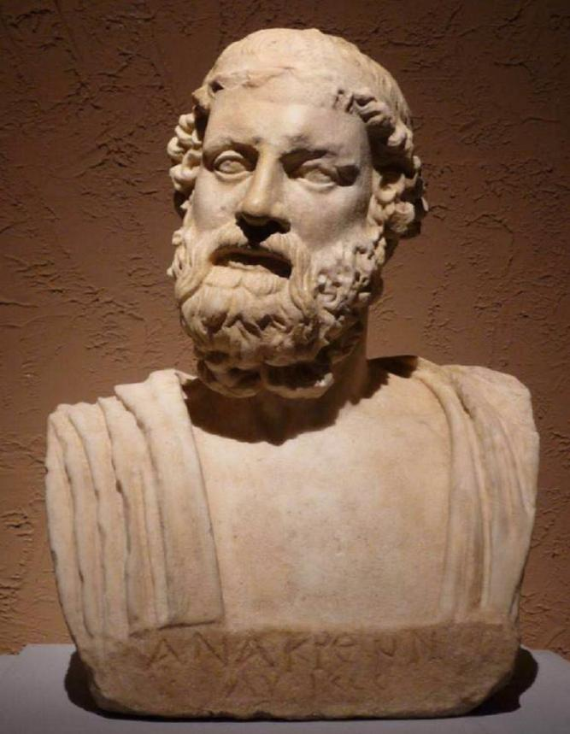
音频原文
But Aristotle says the reason we need rhetoric is we have to be able to use it. We have to be able to use rhetoric inﬂuence, basically, the rebel, and the morons. We try to get them to
understand truth. Truth is suggested, is diﬀerent than rhetoric. Rhetoric is the dressing, is the body, right? Truth is the spirit, is the soul, is abstract. It doesn’t have a body. It’s not

particular. If you wanna get somebody to the truth, you might have to use some kind of
tricks. Right? Because most people are not sound and can 't see the truth. That’s what we
think. Most people are ramble. Really. Only the educated be erudite are actually capable of
seeing the truth. If you wanna get the general mass there, you may have to do fable a little
bit. So Aristotle that is rhetoric. Rhetoric is something that is used to inﬂuence people. Right? And it’s a kind of mentally promised a logic.
参考答案
The theory is from Aristotle, a philosopher in ancient Greece.

Truth is rational and abstract, sometimes people cannot understand it.

So, we can use rhetoric to help people understand truth.

Rhetoric is the proof, and can enlighten people.

rhetoric - L1 - / ˈ rɛtərɪk/ n. 修辞学； 辩论法 ，雄辩术； 华丽的文词； 花言巧语；
rebel - L1 - /rɪ ˈ bɛl/ n. 反政府的人； 反叛者； 造反者； 叛逆者；
moron - L3 - / ˈ mɔrɑn/ n. <口>傻子； 痴愚者 （ 指心理年龄在8至12岁的成年人） ； ramble - L4 - / ˈ ræmbəl/ vi. 漫游； 漫步； 漫谈； 蔓延；
erudite - L5 - / ˈ ɛrjə ˌ daɪt , ˈ ɛrə-/ adj. 博学的 ，有学问的； 笃行不倦； 渊深； 渊识博学； fable - L5 - / ˈfebəl/ n. 寓言 ，童话； 传说； 无稽之谈； 人人谈论的话题；

147. A new instrument / 一种新乐器 #3552 高频
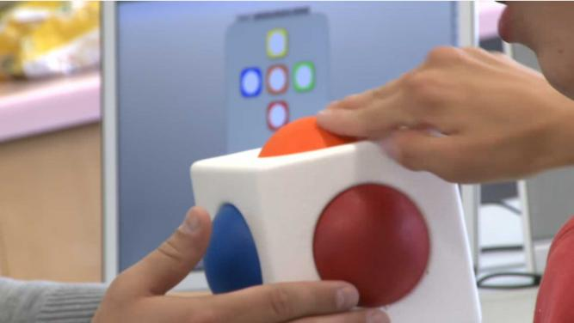
音频原文

The Skoog is a new universally accessible musical instrument. It is designed to use by
children or adults with special needs or in fact be used by anyone. It 's soft, it 's easy to play, it 's robust and it can be customized to suit anyone 's abilities. The Skoog helps students with special needs by allowing them to get involved in making music themselves. It 's an
instrument that they can play it and they can take ownership of and start creating their own sounds and music. Traditional instruments are the shape and size and made of the materials they are because of the sound that they need to make. If you want to make a sound like a
plucked string, you need a string and it needs to be under tension, whereas with a Skoog, because it 's a mixture of software and a sensor, then thus the computer can handle making the sound. And so we can design an object that 's designed to be touched and designed to be played with. In developing the screen and working with kids in the schools and in the
classrooms, it 's really helped us make the Skoog something that 's usable by the children
themselves. They 've informed us massively on how it needs to work and they've given their opinions on colours and designs. And just the feedback they 've given to us has been just
marvellous. It 's just so enriching and it 's really inspiring to actually work with these kids,
particularly when you can provide them with an ability to start to playing their own music as opposed to just taking part through listening and listening to other musicians and really
learning from them.

参考答案
A new university invention is helping children who cannot use traditional instruments to make music of their own.
It is an object that can be touched and played. It is soft, easy to use, robust and can be customized.
Traditional musical instruments are in speciﬁc shapes and sizes, and these students cannot play traditional musical instruments because they have diﬃculties in movements.
But this new invention is designed with software and sensors inside, which is connected to computers.
The feedback is very positive. It is enriching and inspiring, and children found it usable, and found the color and design attractive.

usable - L2 - / ˈjuzəbəl/ adj. 可用的； 合用的； 便于使用的； 使得；
pluck - L4 - /plʌk/ n. 勇气 ，精神； 内脏； 快而猛的拉； 〈俚〉 不及格；
marvellous - L4 - / ˈ mɑːrvələs/ adj. 不可思议的； 惊奇的； 极好的； 绝妙的；

148. Clouds / 云 #3544 超高频

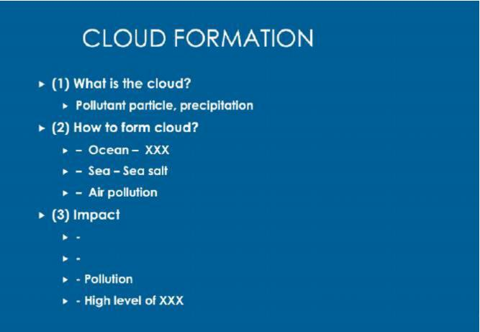
音频原文
There is a lot of interesting. What forms these clouds, why are these clouds there, why do
they sort of stick around? At the center, every cloud drop has a particle. You can 't grow a
cloud drop without having a particle there for the water to condense on. The key question
that people not directly address until very recently is what actually forms these clouds. So for once you’re looking out at over the ocean, turns out sea spray, sea salt is a very eﬀective
nucleus for forming clouds. So it 's a really good chance that those are loaded with sea salt. But if you go inland, you start to have pollution come from all kinds of places, and so
diﬀerent sources form clouds more eﬀectively than others, and we 're trying to unravel which sources are actually contributing to the clouds. The clouds are incredibly important players in climate change, and that they reﬂective the white, they reﬂect the light back into space and
so they’re keeping things much, much cooler than they would be if they weren’t there. They also play huge role in regional weather, so in actual we’re starting to see shifts where having more pollution input into the clouds is aﬀecting weather patterns, in particular, is actually
reducing the precipitation so we 're starting to see drought in areas with super high levels of air pollution.
参考答案
The lecture is about clouds.

There are a lot of interesting things about clouds.

The key question that people not directly address until very recently is what actually forms these clouds.
The clouds are incredibly important players in climate change, and that they reﬂective the
white, they reﬂect the light back into space and so they’re keeping things much, much cooler than they would be if they weren’t there.
They also play a huge role in regional weather.

spray - L1 - /spre/ vt.& vi. 喷； 喷射；
inland - L1 - / ˈ ɪnlənd/ adj. 内地的 ， 内陆的； 国内的；
condense - L2 - /kən ˈ dɛns/ v. （使） 冷凝； （使） 凝结； 精简； 压缩；

149. Superhuman / 超人 #3512 超高频
音频原文
Today we 're going to recount heroic tales of superhuman feats of strength, when in the face of disaster, some people are said to have summoned up incredible physical power to lift a
car oﬀ of an accident victim, move giant rocks, or like Big John of song, single-handedly hold up a collapsing beam to let the other miners escape. Are such stories true? There are many
anecdotes supporting the idea, but we 're going to take a fact-based look at whether or not it truly is possible for an adrenalin-charged person to temporarily gain massive strength. In
proper terminology, such a temporary boost of physical power would be called hysterical
strength. The majority of them are anecdotal, and interestingly not repeatable; in many cases, the person who summoned the superstrength later tried it again only to ﬁnd that they
couldn 't do it. Basically, what we have is a respectably large body of anecdotal evidence that suggests that in times of crisis, danger, or fear, some people have the ability to temporarily
exercise superhuman strength.

参考答案
The lecture mainly talks about superhuman strength.

It is said that some people have incredible power to lift a car or move giant rocks when facing disaster.
There is a heated debate on whether these stories are true.

According to a large body of anecdotal evidence, in a time of crisis or fear, it is possible for a person to temporarily gain massive strength, but late they couldn’t do it again.

feat - L1 - /fit/ n. 功绩 ，伟业； 技艺表演； 卓绝的手艺 ，技术 ，本领； 武艺；
miner - L1 - / ˈ maɪnɚ/ n. 矿工； 采矿机； 地雷工兵； 矿业股；
heroic - L2 - /hə ˈ roʊɪk/ adj. 有英雄气概的 ，英雄的 ，英勇的； 记叙英雄及其事迹的； 夸张的；

anecdote - L2 - / ˈ ænɪkdoʊt/ n. 趣闻 ，轶事； [复数]秘史；
terminology - L3 - / ˌtɜrmə ˈ nɑlədʒi/ n. 专门名词； 术语 ，术语学； 用辞；
hysterical - L3 - /hɪ ˈ stɛrɪkəl/ adj. 情绪您常激动的； 歇斯底里般的； 癔病的； 癔病性； anecdotal - L3 - / ˌ ænɪk ˈ doʊtl/ adj. 轶事的； 趣闻的； 多轶事的； 含轶事的；
recount - L5 - /rɪ ˈ kaʊnt/ vt. 详细叙述； 重新计算；
superhuman - L5 - / ˌ supər ˈ hjumən/ adj. 超人的； 超出常人能力的； 非凡的； 超常的； adrenalin - L5 - /ə ˈ drɛnəlɪn/ n. 肾上腺素； “adrenaline ”的变体；

150. Bilingual Kids / 双语儿童 #3487 超高频
音频原文
The arising concern that a lot of people have about raising children bilingually, especially the preschool year is based on the conceptualization that the human brain at birth is essentially monolingual. And the reason why come to this occasion. Because often the parents will ask me if they use two languages at home will their child be confused, because they hearing two languages. And parents are often ask my advice about whether they should use one
language on parent role which is widely known that parents who are raising children
bilingually. And the reason why most people think this is a good idea is that it will help to
reduce the risks of the children being confused. Because they were able to associate each language with the separate speaker. The fear is that both parents use both languages,
especially they use both languages into changeable within the same conversation within the same sentences. The child will not be able to separate the languages.
参考答案
说父母担心孩子学两个语言会有不好影响 然后搬出来一个Researcher 说双种语言的孩子以后可以更好的socialise 不难 都能听清楚

preschool - L1 - / ˈ pri ˈ skul/ adj. 未满学龄的 ，就学前的；
conceptualization - L5 - /kən 'septʃ uələ 'zeɪʃən/ n. 化为概念 ，概念化；
changeable - L5 - / ˈtʃendʒəbəl/ adj. 很可能变化的； 常变化的； 易变的； 可变的；

151. Augmented Reality / 增强现实技术 #3465 中频 不可练习
有一个手机图 片 ，手机上有个足球。 音频讲mobile phone handheld device improve user experience.
1. 3d guidance so you can have a view of where you wanna go.
2. you can have a better gaming experience 图片和音频里的 gaming experience对应，有提到3D 的游戏比2D的好。 就记得这么多 了 ，语速不快。
补充回忆：是关于Augmented reality 讲了对gaming的帮组 可以用实物作为玩游戏方怯 还说了可以把2D MAP 变成3D MAP 开始开解释了什么事AR。

152. Social Identity / 社会身份 #3369 中频 不可练习
讲师讲importance of social identity,配图中提到了四个方面 ，讲师对这四个方面分别用 一句话解释 ，最后又强调social identity很重要
求大神补充

153. Bees talks / 蜜蜂交流 #3339 高频
音频原文
Honey bees do a waggle dance to direct other bees to the sources of nectar. The dancing
bees like this one can be halted by a headbutt from another bee. Now research has found
that this headbutt is actually a warning signal. A feeding station was set up in the lab to
mimic a source of nectar, then foraging bees were introduced to the dangers at the station, such as competition from rival colonies. When foragers returned to the hive they stopped
bees dancing. Scientists think the behaviour warns dancers of a dangerous source of nectar.

参考答案
Bees perform this strange ritual when they encounter aggressive rival bees, for example, or predatory spiders hanging out at favored foraging spots.
When they return to the hive, they headbutt hive mates performing the famous “waggle dance” that directs would-be foragers to rich sources of nectar.
By halting their hive mates mid-dance, the scouting bees save them from perilous excursions.

rival - L1 - / 'raɪvl/ n. 对手； 竞争者；
dancer - L2 - / ˈ dænsə(r)/ n. 跳舞者 ，舞蹈演员； 舞女； 舞蹈家； waggle - L5 - / ˈ wæɡəl/ vt.& vi. <口>来回摇摆；

154. Library / 图书馆 #3337 超高频
音频原文
You’ll see the service desk after entering the library and you can have these services at the
service desk. There are computers on each ﬂoor. You can use computers to access the
internet, check emails and library catalogues. Follow the orange signs to ﬁnd printers. Follow the instructions to use the printers. Remember to bring student cards. You can charge the
card to use printers.

参考答案
This lecture is an introduction of a library.

It talks about functional areas and services in the library.

Every level of the library has computers, and students can use it to process the problems and send and receive emails.
It also talks about the location of the printers in the library.

Students can use their student cards and when they need help, they can ask the staﬀ at the front desk

155. Stem Cells / 干细胞 #3314 中频
音频原文
Stem cells are cells that are undiﬀerentiated, meaning they do not have a speciﬁc job or function. While skin cells protect your body, muscle cells contract and nerve cells send signals, stem cells do not have any speciﬁc structures or functions.
Stem cells do have the potential to become all other kinds of cells in your body. Your body
uses stem cells to replace worn-out cells when they die. For example, you completely
replace the lining of your intestines every four days. Stem cells beneath the lining of your
intestines replace these cells as they wear out. Scientists hope that stem cells could be used to create a very special kind of personalized medicine, in which we could replace your own
body parts with, well, your own body parts.

Stem cell researchers are working hard to ﬁnd ways in which to use stem cells to create new tissue to replace the parts of organs that are damaged by injury or disease. Using stem cells to replace damaged bodily tissue is called regenerative medicine. For example, scientists
currently use stem cells to treat patients with blood diseases such as leukemia. Leukemia is a form of cancer that aﬀects your bone marrow. Bone marrow is the spongy tissue inside
your bones where your blood cells are created. In leukemia, some of the cells inside your
bone marrow grow uncontrollably, crowding out the healthy stem cells that form your blood cells. Some leukemia patients can receive a stem cell transplant. These new stem cells will create the blood cells needed by the patient 's body.
There are actually multiple kinds of stem cells that scientists can use for medical treatments and research. Adult stem cells or tissue-speciﬁc stem cells are found in small numbers in
most of your body 's tissues.

参考答案
The lecture is about stem cell.

Firstly, Stem cells are cells that are undiﬀerentiated and stem cells do not have any speciﬁc structures or functions.

Secondly, stem cells do have the potential to become all other kinds of cells in your body and stem cells could be used to create a very special kind of personalized medicine.
Thirdly, stem cell researchers are working hard to ﬁnd ways in which to use stem cells to create new tissue to replace the parts of organs that are damaged by injury or disease .
And ﬁnally, there are actually multiple kinds of stem cells that scientists can use for medical treatments and research.

transplant - L1 - /træns ˈ plænt/ vt. 移植； 移种； 移民 ，迁移； 移植 （ 器官、皮肤、头发等） ； intestine - L2 - /ɪn ˈtɛstɪn/ n. [解]肠；
personalize - L2 - / ˈ pɜrsənəlaɪz/ vt. 在 （ 某物上） 作物主标志 （ 尤指表⽰物主的地址或姓名的首字母） ；使 （ 某事物） 针对个人 、带有个人感情或个性化； 在 （物品） 上标出姓名 （ 记号） ；使 拟人化；
marrow - L2 - / ˈ mæroʊ/ n. 骨髓； 脊髓； 滋养品； 〈英〉 食用葫芦；
leukemia - L4 - /lu ' kimɪr/ n. <医>白血病 （俗称血癌） ；
spongy - L5 - / ˈ spʌndʒi/ adj. 海绵似的 ，柔软吸水的 ， 富有弹性的； 肉； 瓤； 多水；

156. Interval training / 间歇训练法 #2476 高频 不可练习
1) Interval training is that you work out in a way that alternate periods of high-intensity exercise with low-intensity recovery periods, which means you do the excise at 20-
meter speed, and then at 30-meter speed.
2) 第2点望同学们来补上
3) Interval training has been often used for athletes and their sports.
4) Interval training can accelerate cardio and aerobic excises.

excise - L2 - / ˈ eksaɪz/ vt. 切除 ，删去； 向 征税； 向 索取高价；
aerobic - L4 - /e ˈ roʊbɪk/ adj. 需氧的 ，有氧的； 有氧健身的 ，增氧健身法；

157. A Ship / 一艘船 #2220 超高频


音频原文
"Our civilization, which subsumes most of its predecessors, is a great ship steaming at
speed into the future. It travels faster, further, and more laden than any before. We may not
be able to foresee every reef and hazard, but by reading her compass bearing and headway, by understanding her design, her safety record, and the abilities of her crew, we can, I think, plot a wise course between the narrows and bergs looming ahead. And I believe we must do this without delay, because there are too many shipwrecks behind us. The vessel we are now aboard is not merely the biggest of all time; it is also the only one left. The future of
everything we have accomplished since our intelligence evolved will depend on the wisdom of our actions over the next few years. Like all creatures, humans have made their way in the world so far by trial and error; unlike other creatures, we have a presence so colossal that
error is a luxury we can no longer aﬀord. The world has grown too small to forgive us any big mistakes. "
参考答案
This lecture talks about human’s civilization, which is a ship driving into the future.

Firstly, by understanding the features of the ship, including compass and crew, people should ﬁnd a wise course without delay.
Secondly, the civilization ship is the biggest and the only one in our time. Human’s future depends on the wisdom of our actions.
Thirdly, humans make achievements through trial and error like other creatures, but unlike creatures, humans cannot aﬀord errors now.
In conclusion, the world is small and humans cannot aﬀord big mistakes.

shipwreck - L1 - / ˈʃɪp ˌ rɛk/ n. 灭亡 ，毁灭 ，失败 ，挫败； 船只失事 ， （ 海滩上的） 失事船残骸； colossal - L1 - /kə ˈ lɑsl/ adj. 巨大的； <口语>您常的；
forgive - L1 - /fər ˈ gɪv/ vt.& vi. 原谅； 饶恕； 对不起； 请原谅 ；
foresee - L2 - /fɔr ˈ si/ vt. 预知 ，预见； 有先见之明；
compass - L2 - / ˈ kʌmpəs , ˈ kɑm-/ n. 罗盘； 指南针； 圆规； 界限；
headway - L2 - / ˈ hɛd ˌ we/ n. 前进； 进展； 航行速度； 间隔时间；
subsume - L3 - /səb ˈ sum/ vt. 归入 ，包括；
wise - L3 - /waɪz/ adj. 聪明的 ，有智慧的； 博学的 ，博识的； 明白的； 像智者的；
berg - L3 - /bɜrg/ n. 冰山；
steaming - L4 - // adj. 冒热气的；
laden - L4 - / ˈ ledn/ adj. 满载的 ，负载的； 受压迫的；

158. Psychologist / 心理学家 #2219 超高频
音频原文

For better or worse, we live in a world profoundly aﬀected by Sigmund Freud. If I had to ask you to name a famous psychologist, the answer of most of you would be Freud. He 's the
most famous psychologist ever and he 's had a profound inﬂuence on the 20th and 21st
century. Some biographical information: he was born in the 1850s. He spent most of his life
in Vienna, Austria, but he died in London and he escaped to London soon after retreating
there at the beginning of World War Two as the Nazis began to occupy where he lived. He 's
one of the most famous scholars ever but he 's not known for any single discovery. Instead,
he 's known for the development of and encompassing theory of mind, one that he developed over the span of many decades.
参考答案
The lecture is about psychologist Sigmund Freud.

He is the most famous psychologist that has a profound inﬂuence on the 20th and 21st century.
He spent most of his life in Vienna and died in London.

At the beginning of world war two, the Nazis occupied where he lived.

He is known for the development of and encompassing theory of mind.

biographical - L1 - / ˌ baɪə ˈ ɡræfɪkəl/ adj. 传记的； 传记体的；
retreat - L2 - /rɪ ˈtrit/ vi. 撤退 ，后退； 撤销 ，作罢； （ 眼睛等） 凹进； [航]向后倾斜；

159. Happiness & Social Relations / 幸福与社会关系 #2213 超高频
音频原文
o what does bring lasting happiness?

Well, there are several things, not a terribly long list, but there are several things.

Personal relationships do make a diﬀerence.

Successful personal relationships.

Successful marriages of close friends joining organizations that are have supportive contact with other human beings.
Those things are very important to happiness.

Interestingly enough.

Helping other people creates a lasting happiness.

People who are very much involved in community service and civic activity and things that reach out to people who need their help.
Those people get a lasting happiness as long as they are engaged in those activities.

I did a lot at Harvard to try to get students to engage more in community service, and so we were quite successful.
The students were very responsive to this, and I began to read a lot of the personal accounts that we had them write about their experience, and they all started out the same way that I
volunteered for this activity because I wanted to give something back and do good in the world.
And I realized the person who beneﬁted most was me.

So students, I think, understood this after the fact, but did not realize that this was going to be personally as rewarding as it was before they engaged in those activities.
参考答案
There is a positive correlation between happiness and the frequency and the quality of their social relations.
The higher the frequency of social relations, the more happiness they will have.

When people feel more satisﬁed with the quality of their social relations, they will feel happier.

In turn, happier people tend to be social more with friends and have more interaction between family.
It is unsure whether it is the social activities make them happier or their happy personalities drive them to be social more.

supportive - L2 - /sə ˈ pɔrtɪv/ adj. 支持的 ，拥护的 ，赞助的；
responsive - L2 - /rɪ ˈ spɑnsɪv/ adj. 应答的 ， 响应的； 反应灵敏的； 共鸣的； 易反应的；

160. Teaching / 教育 #2158 超高频
音频原文
All of my research and that I conducted was my 60 plus graduate students, was motivated by their need to learn, so that we can teach. Of course, in some inventions happened along the way but I 've always considered the end the result. And I always consider that this
invention to be byproduct, byproducts of the learning process. The end product for me was always better understanding or when one really succeeded in unifying theory that can help us in teaching the subject. I 've also looked at teaching as a vehicle to try new ideas, of new

ways to doing things on an intelligent group of learners. That is as the vehicle for the
teaching-research results. And in my experience, this kind of teaching is the most stimulated and motivating to students. I am also uncovered many interesting research problems is the
cause of teaching subject. It is this unity of research and teaching their close connection and the beneﬁts gathered by exercising and the interplay that to be characterised the successful professor.
参考答案
This lecture is about teaching and learning.

Firstly, teaching is motivated by students ' needs of learning.

Secondly, it is important to consider the result and byproducts of the learning process.

Thirdly, new ideas can stimulate and motivate students.

Finally, the unity of research and teaching close connection, exercising as well as interplay help speaker become a successful professor.

unify - L1 - / ˈjunə ˌ faɪ/ vt. 使联合； 使相同； 使一致； 统一； interplay - L2 - / ˈ ɪntərpleɪ/ n. 相互作用；
byproduct - L5 - / ˈ baɪ ˌ prɑdəkt/ n. 副产品； 意外结果 ，副作用；

161. Absolute Zero / 绝对零度 #2129 超高频 不可练习
回忆1：绝对零度 大概是说科学家为啥要做这个实验 这样做的意义是你并不是得到一个predetermined end 而是发现what u don’t know it exists and this is the beauty that
scientists love
回忆2： 关于science的 ， absolute zero ， 没太听明白 ，只说了重点词 scientiﬁc research, absolute zero, we are not focus on the goal of the experiment but the results.

162. Wilson / 威尔逊 #2068 超高频

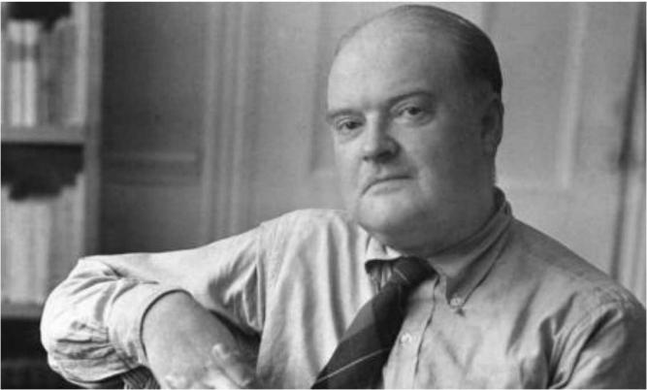
音频原文
Wilson came from a diﬀerent world. And he became the focal point of a board mainstream.
American culture that thought that modern literature and wanted modern literature to be able to be read and appreciated by ordinary people. They were not modernists in an abstract
sense. And certainly, some of them like TS Eliot and Faulkner were too diﬃcult for some of
their writings to be read by ordinary people. But this was a world before the division between the brows or between a lead or whatever had established itself as a part of our
consciousness. Wilson was a major player in the successful eﬀort of his generation to
establish at the heart of American life and innovative literature that would equal the great
cultures of Europe. And he knew that the great cultures of Europe were there. He was not a
product of a narrow American Studies kind of training at all. He joined a high artistic standard with an openness to all experience and a belief that literature was as much of a part of life for everyone as conversation. He thought the Proust and Joyce and Yeats and Eliot could and
should be read by ordinary Americans and helped that to happen. Wilson was a very various man. Over a period of almost 50 years, he was a dedicated, a literary journalist, and an
investigative reporter, a brilliant memoirist, and dedicated journal keeper.

参考答案
Wilson is a famous writer in the US, who have a profound impact on American culture.

He thought modern literature should be read and appreciated by ordinary people.

Although some writers’ work is diﬃcult to read.

Wilson made eﬀort to establish American life and innovative literature, which is as equally great as Europe.

He thought literature is a part of life for everyone, and encourage people to read more.

reporter - L1 - /rɪ ˈ pɔrtə(r)/ n. 记者；
keeper - L1 - / ˈ kipɚ/ n. 保管人； 饲养员； 负责人； 监护人；
focal - L2 - / ˈfoʊkl/ adj. 焦点的 ，有焦点的； 集中在点上的； 病灶的 ，病灶性的； brow - L2 - /braʊ/ n. 眉 ，眉毛； 前额； 容貌 ，表情； 山脊；
investigative - L2 - /ɪn ˈvestɪgeɪtɪv/ adj. 调查性质的； 研究的； 爱调查研究的； modernist - L3 - / ' mɒdənɪst/ n. 现代主义者 ，现代派； 现代主义艺术家；
brilliant - L3 - / ˈ brɪljənt/ adj. 明亮的； <非正怯>美好的； 闪耀的； 才华横溢的；

163. Robots / 机器人 #1776 超高频 不可练习
Task design in robot is hard because our humans can separate things by our senses but for robot, even they have camera and the picture contains many pixel, and the
translation of every pixel to something could be diﬃcult. Thus there is no comparison between humans and robots.
回忆要点：
回忆1.Robot现在的design越来越复杂 ，从之前的简单变化而来 ，和上面的留言很像 ，原文有提到 why it is so diﬃcult to make robot like human being. 然而现在robot还是不能做一些人类做的事情 ，举了一个例子： 分辨颜色 ，现在只有简单的sensory ，需要很复杂的功能的sensory才能实现 ，需要提高sensory, pixel。 求大神补充。

164. Chest X-Ray / 胸透视 #1775 超高频
音频原文
This is one picture that you probably you all know what it is when you see it. It 's a familiar looking image. It 's something that probably we all have some personal experience with, right?
This is a chest x-ray that would be taken in your doctor 's oﬃce, for example, or a radiologist 's oﬃce.
And it is a good example of Biomedical Engineering and that it takes a physical principle,
that is how do x-rays interact with the tissues of your body, and it uses that physics, that
physical principle to develop a picture of what 's inside your body, so to look inside and see things that you couldn 't see without this device. And you 'll recognize some parts of the
image, you can see the ribcage here, the bones you can see the heart is the large bright object down here.
If you, have good eyesight from the distance,you can see the vessels leading out of the heart and into the lungs, and the lungs are darker spaces within the ribcage.

参考答案
The picture of the x-ray is a good example using the biomedical technology.

The x-ray can go through our body, and doctor can look into our bodies, which they cannot do it without the help of x-ray.
We can see bones, organs in the x-ray.

The doctor can diagnose it, and know what’s wrong with our body. It shows the integration of biomedical technology.

eyesight - L2 - / ˈ aɪ ˌ saɪt/ n. 视觉 ，视力； 见解 ，观察； 眼力； ribcage - L5 - // 胸廓；

165. Architect / 建筑 #1774 低频
音频原文
So, continuing our series of lectures on Modernism, we now turn to architecture and, in
particular, to the work of Frank O. Gehry. Now, I 'm not going to go into his career in detail; it is enough to say that early on he was, like other modernist architects, tied to the rectangle,
the straight line, and so on. Often their buildings would have this basic shape and they would just, urn, add bits of decoration like splashes of color or pointless balconies. Soon enough,
Gehry wanted to break away from straight lines and grid-like designs. He wanted the
freedom to experiment with other shapes, curves and unusually-angled roofs. What helped
him with this was the computer, which allowed him to visualize and experiment with complex shapes, and to work on the whole design as one piece, without the added decoration being thrown in as an afterthought. Architecture as art, if you like or, or sculpture even. He himself said that he had struggled with crossing the line between architecture and sculpture. Now, I want to talk about one building in particular, urn, the Guggenheim Museum in Bilbao, which I think you 'll agree is a masterpiece.
参考答案
The lecture is about architecture.

Gehry wanted to break away from straight lines and grid-like designs.

He wanted the freedom to experiment with other shapes, curves and unusually-angled roofs, and the computer helped him a lot.
He himself said that he had struggled with crossing the line between architecture and sculpture.
modernism - L2 - / ˈ mɑdərnɪzəm/ n. [宗]现代主义； 现代想法； 现代用法； 现代风尚 ，现代标准； rectangle - L2 - / ˈ rektæŋgl/ n. [数]长方形 ，矩形；

splash - L2 - /splæʃ/ v. （使） 溅起； 戏水； 以醒目方怯刊登； 引人注目 ；
frank - L3 - /fræŋk/ adj. 坦白的 ，直率的； 清楚表明的； 明显的；
modernist - L3 - / ' mɒdənɪst/ n. 现代主义者 ，现代派； 现代主义艺术家；
balcony - L4 - / ˈ bælkəni/ n. 阳台； （ 电影院等的） 楼厅 ，楼座； 包厢；
urn - L5 - /ɜrn/ n. 大茶壶； 瓮 ，缸； 坟墓； 骨灰瓮；
afterthought - L5 - / ˈ æftərθɔt/ n. 事后的考虑或想法； 事后聪明； 事后再想起； 后来添加的东西；

166. Three plans to stimulate the consumer / 三种刺激消费者的计划
#1649 高频
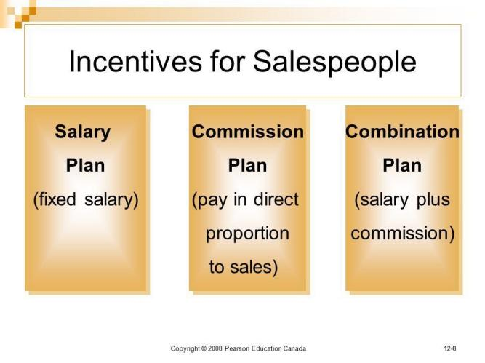
音频原文
1. Straight Salary

Straight salary sales compensation plans aren 't very common, but they do have a place in some organizations. With this type of structure, you 'd pay your salespeople a straight albeit competitive salary like all of your other employees, and nothing else. No bonuses, no
commissions, and few, if any, sales incentives.

This type of compensation plan is most often used when the industry you operate within prohibits direct sales, when salespeople work as part of small groups or teams and all

contributions are equal, when your sales team is relatively small, or when your salespeople are expected to spend much of their time on other responsibilities other than selling.
However, these plans don 't tend to oﬀer motivation to salespeople, as there are no incentives for them to work harder.
2. Salary plus Commission

Salary plus commission sales compensation plans are possibly the most common plans
used today. They 're structured in a way that salespeople receive a lower base salary along with commission pay that makes up the majority of the total compensation.
Organizations use salary plus commission sales compensation plans when there are
opportunities to support all salespeople on this structure and when there are proper metrics in place for tracking sales to ensure that the splits are fair and accurate.
This type of plan is often the better choice as opposed to straight salary because it oﬀers
motivation to increase productivity and to achieve goals. It also oﬀers more stability.
Salespeople will still get some types of pay even if they 're in training, when sales are low
during certain months, or if market conditions get volatile. However, it can be more complex to administer.
3. Commission Only

Commission only sales compensation plans are exactly what they sound like you pay your sales people for the sales they bring in and nothing else. There is no guarantee of income.
These types of plans are easier to administer than salary plus commission and provide better value for your money paid as they are based solely on sales achieved. They also tend to
attract fewer candidates, but do attract the most top-performing and hardest working sales professionals who know they can make a good income because they know how to sell. On the other hand, though, they can create aggression within your sales team and low income security, which can lead to a high turnover rate, and sales rep burnout from stress.
参考答案
There are three types of salary of sales.

The straight salary is that you 'd pay your salespeople like all of your other employees, and nothing else.
This often occurs when the sales team is relatively small, and it is not motivative.

Salary plus commission sales are possibly the most common plans used today.

Organizations use this when there are opportunities to support all salespeople on this structure.
It oﬀers motivation to increase productivity and to achieve goals.

Commission only has no guarantee of income.

This is easier for the administer, but this tends to attract fewer candidates, and it can lead to a high turnover rate.

compensation - L1 - / ˌ kɑmpen ˈ seɪʃ n/ n. 补偿 ，赔偿； 修正； 补救办法；
stability - L1 - /stə ˈ bɪlɪti/ n. 稳定 （性） ，稳固； 坚定 ，恒心；
turnover - L2 - / ˈtɜrnoʊvə(r)/ n. 翻滚 ，翻倒 ，弄翻 ，逆转 ，转向； 半圆形的小馅饼； 营业额 ，成交量 ，证券交易额； [体育运动] 易手 ，失球；
albeit - L3 - /ɔl ˈ biɪt , æl-/ conj. 虽然； 即使；
volatile - L4 - / ˈvɑlətl/ adj. 易变的 ，不稳定的； （ 液体或油） 易挥发的； 爆炸性的； 快活的 ，轻快的；

167. Trade-oﬀs triangle / 平衡三角 #1648 超高频
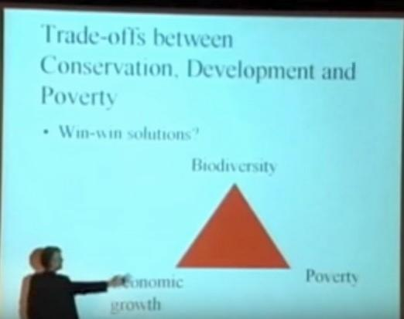
音频原文
Well, it 's about whether you can achieve a win-win solution, whether you can achieve
economic growth which brings wealth in order to cut poverty without damaging the
biodiversity. And the argument is that if you want to protect the biodiversity, you have to
focus on that as a goal, but if you do that, you run the risk of hurting the poor and you also

run the risk of inconvenience and reducing the economic growth. We use the developed and industrialized countries to see this argument this is all argues about. With let us say, a
government wishing to start drilling for oil place and wildlife conservation society is urging not to on the ground of its wellness.
参考答案
Poor people should not pay the price for the biodiversity protection.

There is a debate about whether you can keep economic growth which can solve the poverty issues without damaging biodiversity.
The answer is that it is impossible to reach a win-win solution among conservation, development and poverty.
If you set bio-diversity as your goal, you run the risk of hurting the poor and the economy.

damaging - L3 - // adj. 有破坏性的 ，损害的 ，诽谤的；
inconvenience - L3 - / ˌ ɪnkən ˈvinjəns/ n. 不方便； ⿇烦； 为难之处； ⿇烦事；

168. The Large Hadron Collider / 大型强子对撞机 #1647 高频 不可练习
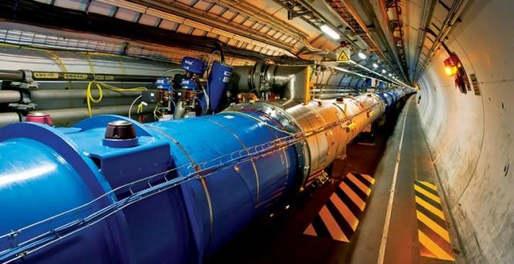
回忆要点：
回忆1.图上面有数据. 7Tev - 7Tev. Release energy 14,000 collision。 只需把图片内容读出即可 ， 最后需要加 ，能够更好了解宇宙的未来 ，大致这个意思。 开始提到了这个东西是一个27km 的tunnel ， 中间提到了检测protons灯。 7tev 的意思是7000 time larger than ， 忘记了了。 最后提到稳定是1.9 degree可以达到absolute zero
回忆2.考到 图片上面有文字。 图片上的内容是Large Hadron Collider （ LHC）， 7 TeV- 7 TeV ， 1.4 million times collisions/ second. 图片下面还有一句话 ，记不清了。 大概内容：

The Large Hadron Collider is the most powerful particle accelerator, Protons at an
energy of 7 TeV per particle. 然后接下来解释了一下7 TeV ， The LHC lies in a tunnel of 27 kilometers或者是 27 Km long ring-shaped tunnel, 有点记不清楚了。还说了 operating
temperature of 1.9 degrees above absolute zero, a temperature cooler than outer space,我还听到了 proton beams 。 只能记住这么多 ，仅供参考
accelerator - L1 - /æk ˈ sɛlə ˌ retɚ/ n. 加速器； 催速剂；

169. Food label / 食物标签 #1645 超高频 不可练习
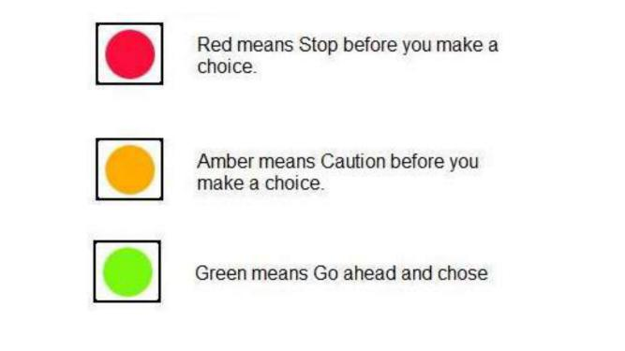
回忆要点： 到超市买食品的时候, 产品包装袋上会有不同颜色的标志, 代表不同健康程度,大概是绿色 , 橙色 , 红色。 这样的表⽰对消费者和生产者都有好处。给了一个图有红色黄色绿色三个点点,录音是讲的我们应该对食物所包含的营养进行颜色的划分, 这样当我们觉得自己缺少什么食物的时候就知道应该去吃哪种颜色的。 另外retailer也应该把颜色标签打在食物上, 这样方便消费者购买他们所需要的食物。

170. Library Tour / 图书馆介绍 #1644 超高频
音频原文
If you come into the main university entrance at the ﬁrst junction, you 'll ﬁnd that Brown Hall is on the corner opposite the theater. So you 're nice and near the station here, though I think it can get a bit noisy with traﬃc. The same applies to Blake residence, which is directly facing the junction to the university entrance. These holes are often used by medical students and
such like as they 're out all day, so don 't notice the noise anyway. If you then walk along Campus Road towards the main circle, you 'll see the library on the corner and Queen 's

Building is just past that. As you head north, you will ﬁnd that it is quieter here and you may get fewer visitors. By the way, the circle is quite a feature of the campus as it 's set into the
hills and has a brand new sports center in the middle. It 's worth going to look around it now. The Parkway Flats are on the opposite corner to the library, facing the circle as you head
towards the main buildings. The main buildings are only about a ﬁve minute walk from here, and places in these holes go quickly. So my advice is to reserve your place as soon as
possible.

参考答案
The speaker introduces several student residences and their locations.

Near the noisy main entrance and station, there are Brown Hall and Blake Residence.

Walking along Campus Road to the main circle, you ﬁnd the library, the quieter Queen 's Building, and the Parkway Flats opposite the library.
The Parkway Flats are very popular because they are only a ﬁve-minute walk to the main buildings. Therefore, the speaker advises reserving a place there quickly.

171. Oracle cloud system / 甲骨文云系统（疑似被淘汰机经） #1643
超高频 不可练习

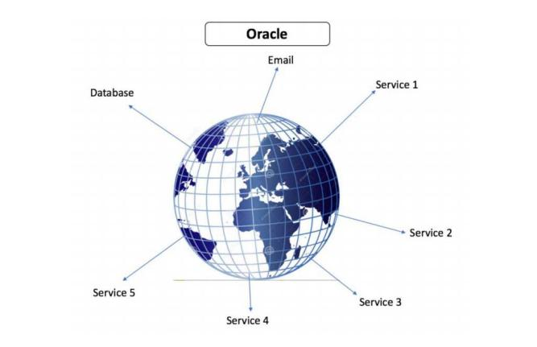
Oracle cloud system, data are stored in a machine called database, all people can access the materials from this system

oracle - L3 - / ˈ ɔrəkl/ n. 神⽰所； 神谕； 圣贤； 哲人；

172. Armor / 盔甲 #1641 低频
音频原文
Hello, I 'm David Brown, curator of Italian and Spanish paintings at the National Gallery of Art. The treasures in our exhibition, The Art of Power, Royal Armor and Portraits from Imperial
Spain, come from the royal armory in Madrid. They range from the 15th to the 17th century and include some of the ﬁnest examples of Renaissance armor in the world. Fabricated by master craftsmen and artists, the ﬂower of Spanish royalty. This is parade armor, made for show, not combat. In form, it looks back to a world tournaments, jousts and noble gesture. And among the images worked into the steel is something quite diﬀerent, a subtle
advertising campaign for the imperial ambitions of the Spanish monarchy and the Hapsburg dynasty. Those who wore it took the words Holy, Roman and Empire very seriously.
参考答案
The lecture talks about paintings at the National Gallery of Art.

Firstly, the treasures in our exhibition come from the royal armory in Madrid.

Secondly, they range from the 15th to the 17th century.

Thirdly, these paintings were fabricated by master craftsmen and artists.

Finally, the speaker talks about parade armor, which is made for show instead of combating.

hello - L1 - /hə ˈ loʊ/ int. 哈喽 ， 喂； 你好 ，您好； 表⽰问候； 打招呼；
treasure - L1 - / ˈtrɛʒɚ/ n. 金银财宝； 宝藏； 珍宝； 不可多得的人才；
armor - L1 - / ˈ ɑrmɚ/ n. 装甲； 盔甲； 保障； 装甲部队；
royalty - L1 - / ˈ rɔɪəlti/ n. 王族成员； 版税； 王位 ，王权； 堂皇 ，庄严；
holy - L1 - / ˈ hoʊli/ adj. 神圣的； 值得尊敬的 ，值得推崇的； 圣洁的 ，圣徒般的； 宗教的； parade - L2 - /pə ˈ reɪd/ v. 游行； 展览； 招摇过市； 接受检阅；
dynasty - L2 - / ˈ daɪnəsti/ n. 王朝； 朝代；
tournament - L3 - / ˈtʊrnəmənt/ n. 锦标赛 ，联赛； 中世纪的骑士比武； 锦标赛；
armory - L4 - / ˈ ɑrməri/ n. 纹章； 纹章学； 兵工厂； 军械库；
craftsman - L4 - / ˈ kræftsmən/ n. 工匠； 手艺人； 名匠； 技工；
joust - L4 - /dʒaʊst/ n. （ 骑士） 骑着马用长矛打斗； 格斗 ，竞争；

173. Network / 网络 #1640 低频 不可练习
这个是UNESCO的一个network
In 2008, Melbourne joined the UNESCO Creative Cities Network

Melbourne has breadth, depth and vibrancy of the city's literary culture.
Melbourne supports a diverse range of writers, a prosperous publishing industry, a
successful culture of independent bookselling, a wide variety of literary organisations and a healthy culture of reading and engagement in events and festivals.
vibrancy - L5 - / ˈvaɪbrənsɪ/ n. 振动； 振响； 活跃； 活力；

174. Price of Housing / 房价 #1639 超高频
音频原文
The impact on young Australians who are interested in buying a home of their own has been very signiﬁcant. Australia 's housing aﬀordability now shapes the typical housing cycle or
housing career as some people call it. Most Australians in the normal course of events are
people who move through the housing cycle in a way that matches the stages of life that
they 're at. So, they move out of the family home in their late teens or early 20s as they gain
their independence from their families, then they rent save for a home they can aﬀord as
either a group, or maybe a couple. And maybe they can upgrade it when they have a family in their middle age, they are more than likely to have paid oﬀ their mortgage. And that means they have housing security in their old age. That 's no longer the typical housing cycle for
Australians, young people generally live at home for much longer than they once did. They
generally rent for longer and they 're more likely to be saddled with a mortgage not just into their middle age but more often than not into their retirement as well. In fact, in 2006, 65,000 retiree households were still paying oﬀ the mortgage. Aﬀordable rent is also an elusive right around Australia. We have very low rental vacancies, we see high turnover as landlords want to maximize their proﬁts in tight market, and we see less long-term or lifelong rental, as we see in other countries and other economies.
参考答案
Housing aﬀordability has changed the housing cycle of Australian people.

In the past, young Australian people rent a home until they could aﬀord to buy a home.

They were able to pay oﬀ the mortgage and have a housing security in their old age.

Nowadays, young people rent homes for a longer time and they cannot pay oﬀ the mortgage even after retirement.
In conclusion, there is less long-term rental.
elusive - L1 - /ɪ ˈ lusɪv/ adj. 难以捉摸的； 不易记住的； 逃避的； 难以找到的； landlord - L1 - / ˈ lændlɔrd/ n. 房东 ，地主； 店主；
tight - L1 - /taɪt/ adj. 紧的 ，牢固的； 绷紧的； 不漏的； 密集的 ， 紧凑的； vacancy - L2 - / ˈvekənsi/ n. 空缺； 空虚； 空白 ； 空位；

turnover - L2 - / ˈtɜrnoʊvə(r)/ n. 翻滚 ，翻倒 ，弄翻 ，逆转 ，转向； 半圆形的小馅饼； 营业额 ，成交量 ，证券交易额； [体育运动] 易手 ，失球；
lifelong - L2 - / ˈ laɪflɔŋ/ adj. 毕生的 ，终身的； 永生不渝的；
saddle - L3 - / ˈ sædl/ n. 马鞍； （ 自行车或摩托车的） 车座； 鞍形架 ，鞍状物； （ 动物的） 脊肉；
rental - L3 - / ˈ rɛntl/ n. 租费 ，租金额； 租用； 出租；

175. Childrens' tutors / 小孩的家教 #1638 低频
音频原文
Community service is an important component of education here at our university.We
encourage all students to volunteer for at least one community activity before they graduate. A new community program called "One On One " helps elementary students who 've fallen
behind. Your education majors might be especially interested in it because it oﬀers the
opportunity to do some teaching, that is, tutoring in math and English. You 'd have to
volunteer two hours a week for one semester. You can choose to help a child with math,
English, or both. Half-hour lessons are ﬁne, so you could do a half hour of each subject two days a week. Professor Dodge will act as a mentor to the tutors. He 'll be available to help
you with lesson plans or to oﬀer suggestions for activities. He has oﬃce hours every Tuesday and Thursday afternoon. You can sign up for the program with him and begin the tutoring
next week. I 'm sure you 'll enjoy this community service and you 'll gain valuable experience at the same time. It looks good on your resume, too, showing that you 've had experience with
children and that you care about your community. If you 'd like to sign up, or if you have any questions, stop by Professor Dodge 's oﬃce this week
参考答案
说话的是一个老师, 宣传一个活动, 活动内容是去做小孩tutor.
每周半小时.可以选择教数学 还是英语 还是both. 说这活动是 Good thing to write into resume.

afternoon - L1 - / ˌ æftər ˈ nun/ n. 下午； 后期 ，后部；
elementary - L2 - / ˌ ɛlə ˈ mɛntəri , -tri/ adj. 基本的； 初级的； [化]元素的； 初等；

176. Dog and sound / 狗与声音 #1637 中频
音频原文
When this dog approaches some food, another dogs playful snarls are played back the dog seems curious, but the sound doesn 't stop it from taking the bone. Here a dog hears the
growls of a dog being approached by a stranger, but these don 't deter it from grabbing the bone either. In another scenario the sound of a dog protecting its food is played back. This time the dog backs oﬀ . These experiments suggest the dogs can distinguish between
diﬀerent types of growls.

参考答案
The lecture introduces an experiment showing that dogs use diﬀerent barks and growls to communicate diﬀerent things.
Researchers recorded an "alone bark ", a stranger growl where a dog was growling at the approach of a stranger, and a "food growl " where a dog was growling to protect its food.
The researchers played these diﬀerent growls to a dog who was approaching a plate of juicy food. The dogs were more hesitant to approach if they heard the food growl rather than the stranger growl or the alone barks.
The experiment shows that dogs could clearly distinguish between diﬀerent types of growls, and react to them accordingly.

deter - L1 - /dɪ ˈtə/ vt. 阻止 ，制止； 使不敢； 使踌躇；
playful - L2 - / ˈ plefəl/ adj. 闹着玩的； 爱玩的； 戏谑的；
growl - L2 - /ɡraʊl/ vi. （ 雷） 作隆隆声； 嘟哝； 愤愤不平地抱怨；
snarl - L5 - /snɑrl/ n. （ 动物的） 龇牙低吼 ，愤怒叫嚷 （ 声） ； 咆哮 （ 声） ；混乱； B结；

177. Multi■task man / 多任务并行的人 #1635 中频 不可练习
一个光头帅哥在一个会议上讲这个事
是一个视频, 讲了一个牛人在security council, 有些人发现他老是点头, 以为不知道在干什么, 其实他在pay attention,
他可以同时听俄语, 然后听英文同传, 并指出同传犯的错误
有人在他旁边发现他不仅在干这些事, 还在画画, 画这些security council member 的素描画. 现在在council 里面他们都有的一个 dark market 是卖他的画的

178. Australian immigration history / 澳大利亚移民史 #1634 中频
音频原文
The ﬁrst inhabitants in Australia were the ancestors of the present indigenous people.
Whether these ﬁrst migrations involved one or several successive waves and distinct peoples is still subject to academic debate, as is its timing. The minimum widely accepted time frame places presence of humans in Australia at 40,000 to 43,000 years Before Present, while the
upper range supported by others is 60,000 to 70,000 years BP.

In any event, this migration was achieved during the closing stages of the Pleistocene epoch, when sea levels were typically much lower than they are today. Repeated episodes of
extended glaciation resulted in decreases of sea levels by some 100150 m. The continental coastline therefore extended much further out into the Timor Sea than it does today, and

Australia and New Guinea formed a single landmass (known as Sahul), connected by an extensive land bridge across the Arafura Sea, Gulf of Carpentaria and Torres Strait
The ancestral Australian Aboriginal peoples were thus long established and continued to
develop, diversify and settle through much of the continent. As the sea levels again rose at the terminus of the most recent glacial period some 10,000 years ago the Australian
continent once more became a separated landmass. However, the newly formed 150 km wide Torres Strait with its chain of islands still provided the means for cultural contact and trade between New Guinea and the northern Cape York Peninsula.
During the 1970s and 1980s around 120,000 southern Asian refugees migrated to Australia. During that twenty years, Australia ﬁrst began to adopt a policy of what Minister of
Immigration Al Grass by termed "multiculturalism ". In 2004-05, Australia accepted 123,000 new settlers,19 a 40% increase over the past 10 years. The largest number of immigrants (40,000 in 200405) moved to Sydney. The majority of immigrants came from Asia, led by
China and India.

参考答案
It happened during the closed stage when the sea level was much lower.

When the sea level rise, Australia was still contacted with other continents.

During 1970s to 1980s, around 20k Asian refugees migrated to Australia which marked the starting point as a multicultural country.
Those refugees led by China and India.

successive - L1 - /sək ˈ sɛsɪv/ adj. 连续的 ，相继的； 继承的 ，接替的； 逐次； episode - L1 - / ˈ epɪsoʊd/ n. 插曲； 片段； 一集； 一段经历；
coastline - L1 - / ˈ koʊstlaɪn/ n. 海岸线； 海岸地形 （ 或轮廓） ；
glacial - L1 - / ˈ ɡleʃəl/ adj. <地>冰的 ，冰河[川]的； 冰河期的； 极冷的； refugee - L1 - / ˌ rɛfjʊ ˈ dʒi/ n. 避难者 ，难民；
diversify - L2 - /daɪ ˈvɜrsɪfaɪ/ vt.& vi. 使多样化 ， 多样化； 进入新的商业领域； ancestral - L3 - /æn ˈ sɛstrəl/ adj. 祖先的； 与祖先有关的； 祖宗传下的；
cape - L3 - /kep/ n. 斗篷； 披肩； 海角； 呷；
epoch - L4 - / ˈ epək/ n. 纪元； 时期； 新时代； 世；
terminus - L5 - / ˈtɜrmɪnəs/ n. 终点； 终点站； 界限； 界石；

179. Two kinds of journal / 两种杂志（疑似被淘汰机经） #1633 中频 不可练习
Two kinds of journal, peer reviewed and non peer reviewed.

All articles sent to publications should be testiﬁed to ensure all articles are original and high quality
If not good, it will send back to the author to amend. Both two journals can be searched and accessed from the library.
Only peer reviewed can be used in this assignment. Peer reviewed one has some
features, include footnotes of bibliography , no advertisements, 还有其他feature, 没听全

footnote - L2 - / ˈfʊtnoʊt/ n. 脚注； 补充说明；
testified - L3 - // v. 作证 ，证明( testify的过去怯和过去分词 ) ；证明 ，证实； 炳炳凿凿；

180. Gene and DNA / 基因及其遗传物质 #1630 超高频

音频原文
Most genes contain the information needed to make functional molecules called proteins.
The journey from gene to protein is complex and tightly controlled within each cell. It
consists of two major steps: transcription and translation. Together, transcription and
translation are known as gene expression. During the process of transcription, the
information stored in a gene 's DNA is transferred to a similar molecule called RNA
(ribonucleic acid) in the cell nucleus. Both RNA and DNA are made up of a chain of
nucleotide bases, but they have slightly diﬀerent chemical properties. The type of RNA that
contains the information for making a protein is called messenger RNA (mRNA) because it
carries the information, or message, from the DNA out of the nucleus into the cytoplasm.
Translation, the second step in getting from a gene to a protein, takes place in the cytoplasm. The mRNA interacts with a specialized complex called a ribosome, which "reads" the
sequence of mRNA bases. Each sequence of three bases, called a codon, usually codes for one particular amino acid. A type of RNA called transfer RNA (tRNA) assembles the protein, one amino acid at a time. Protein assembly continues until the ribosome encounters a “stop” codon (a sequence of three bases that does not code for an amino acid).
参考答案
In this lecture, the speaker talked about the gene and DNA.

At the beginning of the lecture, the speaker mentioned that genes decide the protein in the cells.

He further mentioned that there are more than 2M proteins in a cell.

At the end of the lecture, the speaker concluded that there is still not result for the functions of diﬀerent cells.

transcription - L2 - /træn ˈ skrɪpʃən/ n. 抄本； 抄写； 录音； 翻译；
messenger - L2 - / ˈ mɛsəndʒɚ/ n. 信使 ，信差； 先驱； [军]通信兵 ，传令兵； amino - L2 - /ə ' miːnəʊ/ adj. <化>氨基的；

181. Robots / 机器人 #1628 低频 不可练习
The lecture discusses the utilization and the development of robots.
Robots have been applied into car manufacture in the factories. Moreover, there are also an increasing number of multi-functional service robots.
Instead of robots for general purpose, robots for special purposes such as vacuum cleaner robots have been purchased by many bachelors.
In conclusion, 25000 robots were sold out in one year.

utilization - L1 - / ˌjutɪlaɪ ˈ zeʃən/ n. 利用 ，使用 ，效用；

182. Morton Prince / 莫顿普林斯 #1351 超高频
音频原文
Morton Prince was an American physician and psychologist, his book “Dissociation of a
Personality” was the best-seller at that time. It tells a story of Miss Christine Beauchamp,
who was suﬀering from MPD (Multiple Personality Disorder) . Miss Beauchamp have several personalities, namely B1, B2 and B3. There was hidden memory in these 3 personalities.
Miss Beauchamp was B2. B2 knows about B1, B3 knows both B1 & B2, but B1 knows
nothing about B2 or B3. The strongest personality account for most of the time and it will
take over the others and become the main personality at the end. This case and theory give great help to crime investigation.
dissociation - L4 - /dɪ ˌ sosi ˈ eʃən , -ʃi-/ n. 分离； 离解； 脱离关系； 解体；

183. James Risen and the Government Investigation / 詹姆斯·里森和政
府调查 #1350 超高频
音频原文
This is James Risen. You may know him as the Pulitzer Prize winning reporter for The New York Times. Long before anybody knew Edward Snowden 's name. Verizon wrote a book in

which he famously exposed that the NSA was illegally wiretapping the phone calls of
Americans. But it 's another chapter in that book that may have an even more lasting impact. In it, he describes a catastrophic U.S. intelligence operation in which the CIA quite literally
handed over blueprints of a nuclear bomb to Iran. If that sounds crazy, go read it. It 's an
incredible story. But you know who didn 't like that chapter? The U.S. government for nearly a decade afterwards. Risen was the subject of a U.S. government investigation in which
prosecutors demanded that he testify against one of his alleged sources. And along the way, he became the face for the U.S. government 's recent pattern of prosecuting whistleblowers and spying on journalists. You see, under the First Amendment, the press has the right to
publish secret information in the public interest, but it 's impossible to exercise that right if the media can 't also gather that news and protect the identities of the brave men and women
who get it to them. So when the government came knocking, Verizon did what many brave
reporters have done before him. He refused and said he 'd rather go to jail. So from 2007 to
2015, Risen lived under the specter of going to federal prison. That is, until just days before the trial when a curious thing happened. Suddenly, after years of claiming it was vital to their case, the government dropped their demands to resign altogether. It turns out in the age of
electronic surveillance, there are very few places reporters and sources can hide. And
instead of trying and failing to have risen testify, they could have his digital trail testify against him instead. So completely in secret and without his consent. Prosecutors got Risen 's phone records. They got his email records, his ﬁnancial and banking information, his credit reports, even travel records with the list of ﬂights he had taken. And it was among this information
that they used to convict Jeﬀrey Sterling, Risen 's alleged source and CIA whistleblower.

参考答案
The lecture discusses reporter James Risen, who exposed US government secrets. After he refused to reveal his conﬁdential source, the government pursued him for years.
Instead of forcing him to testify, they secretly obtained his digital records like phone and email data. This electronic evidence was then used to convict his alleged source, a CIA whistleblower.
The case shows how governments now use surveillance to bypass journalists and target their sources directly.

reporter - L1 - /rɪ ˈ pɔrtə(r)/ n. 记者；
bomb - L1 - /bɑm/ n. 炸弹； 彻底的失败； [橄榄球] 长传； 高压贮罐；
crazy - L1 - / ˈ krezi/ adj. 疯狂的； 不理智的； 离奇的； 生气的；
brave - L1 - /brev/ adj. 勇敢的； 需要勇气的； 华丽的； 漂亮的；
allege - L2 - /ə ˈ lɛdʒ/ vt. 断言 ，宣称 ，辩解； 提出 作为理由；
prosecute - L2 - / ˈ prɑsɪkjut/ v. 控告； 起诉； 继续从事； 担任控方律师； 依法处置； spy - L3 - /spaɪ/ n. 间谍； 密探；
jail - L3 - /dʒel/ n. 监狱； 拘留所；

consent - L3 - /kən ˈ sɛnt/ n. 准许 ，赞同； 同意； （ 意见等的） 一致； blueprint - L4 - / ˈ blu ˌ prɪnt/ n. 蓝图 ，设计图； 计划大纲； 原本；

184. Mostar / 莫斯塔尔 #1349 低频
音频原文
The historic town of Mostar, spanning a deep valley of the Neretva River, developed in the
15th and 16th centuries as an Ottoman frontier town and during the Austro-Hungarian period in the 19th and 20th centuries. Mostar has long been known for its old Turkish houses and
Old Bridge, Stari Most, after which it is named. In the 1990s conﬂict, however, most of the
historic town and the Old Bridge, designed by the renowned architect Sinan, was destroyed. The Old Bridge was recently rebuilt and many of the ediﬁces in the Old Town have been
restored or rebuilt with the contribution of an international scientiﬁc committee established by UNESCO. The Old Bridge area, with its pre-Ottoman, eastern Ottoman, Mediterranean and western European architectural features, is an outstanding example of a multicultural urban settlement. The reconstructed Old Bridge and Old City of Mostar is a symbol of
reconciliation, international co-operation and of the coexistence of diverse cultural, ethnic and religious communities.
参考答案
配图是 一个古城一座拱形桥右边一个大城堡左边一个小镇。
参考资料： 1557年建造 后来比较重要 ，后来历史原因重修过两次 ，涉及empire。
是span最大的人工桥。 现在是一处景点 ，专门有一个叫Stari Most Jump的挺有名的旅游项目 。

ethnic - L1 - / ˈ ɛθnɪk/ adj. 种族的 ，部落的； 某文化群体的；
reconciliation - L4 - / ˌ rɛkən ˌ sɪli ˈ eʃən/ n. 和解 ，调停； 一致； 服从 ，顺从； 和谐；

185. Randomness of ﬂipping coin / 抛硬币的随机性 #1345 超高频
音频原文
Flipping a coin may not be the fairest way to settle disputes. About a decade ago, statistician Persi Diaconis started to wonder if the outcome of a coin ﬂip really is just a matter of chance. He had Harvard University engineers build him a mechanical coin ﬂipper. Diaconis, now at
Stanford University, found that if a coin is launched exactly the same way, it lands exactly the same way.
The randomness in a coin toss, it appears, is introduced by sloppy humans. Each human- generated ﬂip has a diﬀerent height and speed, and is caught at a diﬀerent angle, giving
diﬀerent outcomes.

But using high speed cameras and equations, Diaconis and colleagues have now found that even though humans are largely unpredictable coin ﬂippers, there 's still a bias built in, If a
coin starts out heads, it ends up heads when caught more often than it does tails. NPR 's David Kestenbaum reports.
参考答案
This lecture is about ﬂipping a coin.

Flipping a coin may not be the fairest way to settle disputes.

However, a research was done by Persi Diaconis who asked engineers from Harvard Unversity to build a machine to ﬂip coins.
Results show that if a coin is ﬂipped in the same angle, height and speed by human beings, the outcome of getting heads or tails is dependent on how a coin starts out.

toss - L1 - /tɔs/ vt.& vi. 扔 ，抛； （使） 摇荡； 摇匀； 掷硬币决定；
flipper - L2 - / ˈflɪpɚ/ n. （ 用于游泳或潜水的） 脚蹼 ， 鸭脚板；
sloppy - L3 - / ˈ slɑpi/ adj. 懒散的 ，草率的； 稀薄的； 多雨的 ，泥泞的； 过于伤感的； statistician - L4 - / ˌ stætɪ ˈ stɪʃən/ n. 统计学家 ，统计员；
fairest - L5 - // fair （ 公平的） 的最高级形怯； 美丽的最高级形怯；

186. Literature / 文学 #1344 低频 不可练习
考到了一个英国还是欧洲文学的题。 讲到了commodity的数量和质量都提升了 ，随着机器的发展 ，社会财富累积 ， 中产阶级 expand

187. Discussion on Ocean Health / 海洋健康讨论 #1343 中频
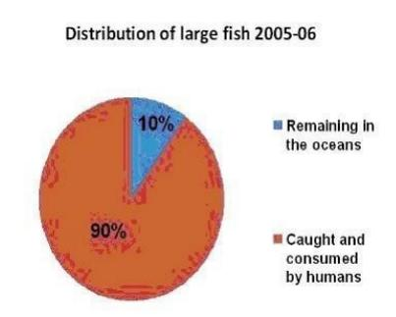

音频原文
In an article that you wrote that I just read, you said you wished you could take everyone
back to decades ago to look at the Florida keys. Fifty years ago. Think about how much
change has taken place in that short period of time. We have managed to consume on the order of ninety percent of the big ﬁsh in the ocean: the tunas, the swordﬁsh, the sharks,
they 're mostly gone. Until recently, people who had the belief that there isn 't much we puny human beings could do to change the nature of the ocean. But in fact, we have, not just
because of what we ' been taking out and the destructive means often applied to take ﬁsh and other creatures from the sea, but also what we 're putting into the sea, either directly or what we put into the atmosphere that falls back into the sea. So if you were going to give a grade on the health of the oceans today what would it be?
Well, it depends on which aspect. Across the board.The oceans are in trouble. It 's hard for me to assign a speciﬁc grade. Maybe C minus.
参考答案
The conversation starts with someone mentioning an author’s wish: taking people back 50 years to see Florida Keys, to show how much change has happened in that short time. It notes that about 90% of big ocean ﬁsh—like tunas, swordﬁsh, and sharks—have been
consumed and are mostly gone now.

Many people used to think humans are too small to change the ocean, but that’s not true.
Humans aﬀect the ocean in two main ways: ﬁrst, by taking out ﬁsh with destructive methods, and second, by putting things into the sea directly or releasing things into the atmosphere
that then fall into the sea.

Then the author is asked to grade today’s ocean health. The author says it depends on the
aspect, but overall the oceans are in trouble. It’s hard to pick a speciﬁc grade, but maybe a C minus.

assign - L3 - /ə ˈ saɪn/ vt. 分派 ，选派 ，分配； 归于 ， 归属； [法律] 把 （ 财产 ，权利、利息） 从一人转让给另一人； 把 编制；
ninety - L4 - / ˈ naɪnti/ num. 九十；

188. Edmund Wilson / 威尔逊 #1342 低频
音频原文
And I want to say that Wilson who died over 30 years ago, began his career before modern lit was taught and analyzed in the universities, as he said at one time and I think a piece about Christian golfs Gauss 's I called him Gauss as my father in his generation at Princeton a year or two after Wilson called him. When Wilson was studying there that the latest daring writers to get into the curriculum were widths of the 90s and maybe Gauss had his reputation as a
bohemian romantic because he had known Oscar in Paris, but there was no modern lit.

Wilson came then from a diﬀerent world and he became the focal point of a broad
mainstream American culture that thought that modern literature and wanted modern
literature to be able to be read and appreciated by ordinary people, they were not modernists in an abstract sense and certainly some of them like TS Eliot and Faulkner were too diﬃcult for some of their writings to be read by ordinary people, but this was a world before the
division between the brows or between a lead or whatever had established itself as part of our consciousness.
参考答案
一个叫 Edmund Wilson 的人在美国文学中的地位 ， American culture, 他是个批评家和文学家 ， 做了见什么事 ，然后影响到现在的 America study
Edmund Wilson(May 8, 1895 June 12, 1972) was an American writer and critic who notably exploredFreudianandMarxistthemes.
He inﬂuenced many American authors, includingF. Scott Fitzgerald, whose unﬁnished work he edited for publication. His scheme for aLibrary of Americaseries of national classic works came to fruition through the eﬀorts ofJason Epsteinafter Wilson 's death.

romantic - L1 - /roʊ ˈ mæntɪk/ adj. 浪漫的 ，谈情说爱的 ， 多情的 ，风流的 ，香艳的； 空想的 ，虚构的 ，怪诞的，想入非非的 ，不实际的 ，难实行的 （ 计划等） ；传奇 （ 怯） 的 ，小说般的 ，情节离奇的； 浪漫主义的；
focal - L2 - / ˈfoʊkl/ adj. 焦点的 ，有焦点的； 集中在点上的； 病灶的 ，病灶性的；
brow - L2 - /braʊ/ n. 眉 ，眉毛； 前额； 容貌 ，表情； 山脊；
golf - L3 - /gɑlf/ n. 高尔夫球； 高尔夫球运动；
modernist - L3 - / ' mɒdənɪst/ n. 现代主义者 ，现代派； 现代主义艺术家；

189. Engineers / 工程师 #1339 超高频 不可练习
回忆要点：
回忆1.题目有四幅小图 ， 第一幅是一个受伤的手 ，最后一张图是人躺着做 CT。 音频分3个阶段。 工程师发明设备understand themselves. 设备变得更加complicated, 为了治愈疾病,帮助cure wound和研究physiology. ECG (electrocardiography)可以研究心跳节律.设备更复杂, 可以研究脑电波。
回忆2.讲的是biotech engineering 制造仪器的几个阶段 ，第一阶段是制作一些简单的器械（simple machines） 是为了帮助自己了解自己 ，这个也是对应着左上角的那个方格； 第二阶段设备变得更加复杂了 ，为了去治病 cure wound ， 并且提到了 suture 这个词（对应着左下角手掌的=针） 也可以study physiology； 第三阶段就研究出来更复杂的器械了 比如说 ECG 可以让机器不进入你身体的情况下就研究到身体内部。还可以show human
brains function ， beneﬁt humans 等等；
The ﬁrst group of people that realize we can learn form ourselves is Engineers.

They invented machines to study human body, based on the studies, they created more complex machines.
By using those complex machines, they understand how human brains function and process.
And they use what they 've studied to to beneﬁt humans and solve problems, such as disease, etc.
suture - L3 - / ˈ sutʃɚ/ n. =合 ，=伤口； =线；

190. Poverty / 贫穷 #1338 中频 不可练习
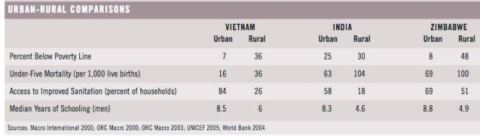
有一个图, ⽰意rural的poverty更严重, 然后听力就提及要我们应当着力解决rural 的poverty问题.原因是第一这个可以减少全球的贫困人口 , 第二个是这个也可以降低unbran 的poverty rate 因为urban 的贫困人口大多都是从rural去的
横向是India 越南 津巴布韦等国家 题目贫困对比图 ，纵向是几个分类 有level of
education, poverty degree什么的 对应了4个指标 ，包括死亡率 ，受教育率 ，可以照着读。是rural regions have a serious problem of poverty, 有75％ 的贫困人口生活在rural area, 最后提到了rural 和urban的关系。
Environmental problems including water pollution and the sanitation of drinking water, indoor smoke, gas emission. Poor people are especially aﬀected especially in terms of their health. The rising demand for energy consumption is likely to sustain until 2030, which will have an eﬀect on a range of environmental problems.

191. Wages and consumptions / 工资与消费 #1336 超高频 不可练习

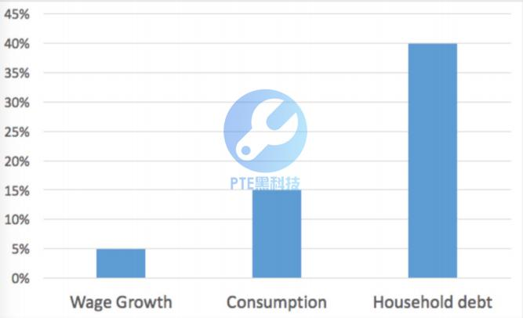
According to the speaker, the wage increase is 5%, which is very weak.
The consumption is about 15%, which seems decent.
The housing debt is about 40%, which is unusual. But can be understandable after the wage and consumption increase.
回忆要点：
回忆1.兩個朋友都说了考过这题！ 不是很难 ，就是顺着这个思路反复说 ，沒有太多岔开的信息：某年（或某期） 的工资涨幅只有5%,但是因为生活花费高了很多 ，所以造成了贷款比例增高很多。 我有点忘记是不是房屋贷款了。 loan /debt
回忆2.还有个柱图 ，三个柱子分别是工资 ，房价 ，消费 ，还有增长的数据 ，数据很清晰
的。 这次还考到知道rl, 好在是视频题 ，只记得出现一张图,然后图上有2排人物肖像 ，每排大概4个左右的人物 ，还有年份 ，最后还提到color,我不知道说的鬼。 不知道可有大神指点⼀⼆？
回忆3.the wages increase 5% which is slow, the consumption increase 15% which is
decent. However, a great increase of 40% on household house debt. Although people’s wages increase, most of the money will go against paying house debt. 我能回忆起来的原句。

192. Population / 人口数 #1335 高频 不可练习
回忆要点：
1.上面是一个表格是 UK 在四个不同的年份的人口 ，数字都是 million 以上。
表格下面是三个问题 ， UK 的三个不同城市有 national park 文章最开始把所有人口读出来。

然后说这个原因是第一个城市没有 national park ，第二个和第三个城市有 ，后面就讲这三个城市有什么问题。
2.一张关于UK 和 Scotland 的 population的表, London X,000,000, Wales X,000,000, Scotland X,000,000, British X,000,000.
London 有配一个表格, 上面有Scotland, Wales, London, UK 具体的人口 , 音频也读了这些数据. 一开始说London的人口差不多7m, 等于Wales跟Scotland的人口之和, 分别说了一下三个城市的人口数.
然后说大部分英国人都住在伦敦 其他国家人口就比较分散, 每几个在英国的人生活在伦敦,所以管理London比管理其它两个城市要困难, 主要是因为英国没有一个National party.还提到了用national party管理这些城市里的人 , 然后结尾一句很长的话.

193. Increasing Productivity / 渐增的生产率 #1334 超高频
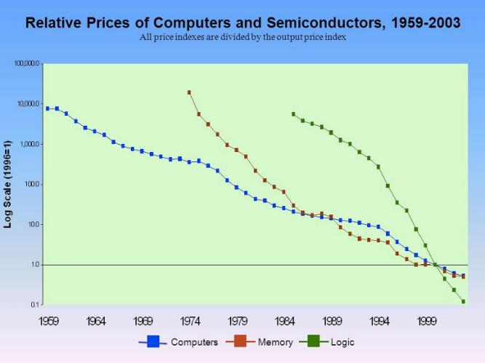
音频原文
About a ﬁfth of South Korea 's total exports are semiconductors, which have been booming in recent years and have helped drive the country's economic growth. But things are looking less certain for the industry in the new year. Analysts expect the prices of DRAM and NAND ﬂash chips, which are used to store data in our phones, computers and TVs, will keep falling. Jesse Yung reports. Industry insiders on Thursday said home prices are likely to fall in the

coming months. The global semiconductor industry began to suﬀer from sluggish growth
from the end of last year, and according to a report by market research ﬁrm Dynamics
Change. Oversupply, shrinking demand and a gloomy economic outlook are factors behind
this price fall. The report said if the current lack of demand continues to erode, prices will see a downward trend throughout 2019. It also projected a fall in NAND ﬂash prices due to
shrinking demand. The average price of eight gigabyte drams, the most widely used units
last month was seven U.S. dollars, down 10% from its peak in September. The average price of 128 gigabyte NAND ﬂash chips the most widely used NAND Flash also fell last month. The report said global chip makers, Samsung Electronics, SK Hynix and Micron Technology,
which make up the majority of the global volume, have started readjusting their chip
production and reducing investment in semiconductor facilities. However, some industry
insiders say prices could even rise towards the end of the year, citing a growing demand for chips driven by 5G or the ﬁfth generation of mobile communications as well as self-driving cars.
参考答案
The lecture discusses the signiﬁcance of semiconductor exports for South Korea 's economy, accounting for one-ﬁfth of total exports. It highlights challenges facing the global
semiconductor industry since late last year, including oversupply, declining demand, and
pessimistic economic outlook. Speciﬁc data shows price drops in both DRAM and NAND ﬂash chips. Major manufacturers like Samsung and SK Hynix are adjusting production and reducing investments. However, emerging technologies such as 5G and autonomous
vehicles may stimulate demand recovery by year-end.

analyst - L1 - / ˈ ænəlɪst/ n. 分析家 ，化验员； 〈美〉 精神病医师；
flash - L1 - /flæʃ/ vt.& vi. 使闪光 ，使闪烁； 拍出 ，发出 （ 电报等） ；〈口〉 炫耀；
chip - L1 - /tʃɪp/ n. 碎片； 缺口； （ 作赌注用的） 筹码； （ 足球） 高球；
electronics - L1 - /ɪ ˌ lek ˈtrɑnɪks/ n. 电子学； 电子学应用 ， 电子器件； 电子工业； 电子流行音乐； gloomy - L2 - / ˈ ɡlumi/ adj. 黑暗的； 令人沮丧的； 前景黯淡的； 悲观的 ， 阴郁的；
erode - L2 - /ɪ ˈ roʊd/ vt.& vi. 侵蚀 ，腐蚀；
semiconductor - L3 - /sɛmikən ˈ dʌktɚ/ n. <物>半导体；
sluggish - L4 - / ˈ slʌɡɪʃ/ adj. 行动迟缓的 ，反应慢的； 不机警的； 懒散的 ，不活泼的； 无精打采的； readjust - L5 - / ˌ riə ˈ dʒʌst/ vt.& vi. 再整理 ，再调整；

194. Biological Forgetting / 生物遗忘 #1333 超高频
音频原文
A study by the Harvard School of Public Health found that older people with high levels of social integration had a slower rate of memory decline over a six year period.
The exact reason remains unclear, but experts suspect that social interaction gives our brain a mental workout, just like muscle strength.

We have to use our brain or risk losing it.

But don 't despair.

There are several steps you can take to aid your brain in preserving your memories.

Make sure you keep physically active.

Increased blood ﬂow to the brain is helpful and eat well.

Your brain needs all the right nutrients to keep functioning correctly.

And ﬁnally, give your brain a workout.

Exposing your brain to challenges like learning a new language is one of the best defenses for keeping your memories intact.
参考答案
People forget things every day including experiences, feelings and thoughts, and we call this process biological forgetting.
Remembering is hard for people, and people try to overcome biological forgetting.

Humans’ memory is not ﬁxed, but it can be reconstructed and shaped by the past.

From the ancestors, people have always been trying to improve our memory.

workout - L2 - / ˈ wɜrkaʊt/ n. 锻炼； 练习； 试验；
despair - L3 - /dɪ ˈ sper/ n. 绝望； 使人绝望的人 （ 或事物） ；

195. Governments / 政府（疑似被淘汰机经） #1332 低频 不可练习
(With graph on the screen demonstrating the whole speech).
The lecture mainly talks about the use of web2.0 on helping government functions better and serve the public better.
There are three steps, The web collect information from users. Two government use the info to understand the public. Make better connection with citizens and response to their needs.
Government can use the information to understand the public and improve government service, making better connection with citizens and response to their needs.

196. Two Kinds of Tanks / 两种坦克（疑似被淘汰机经） #1331 中频 不可练习

German tiger panzer vs t-34, 比较这两个坦克的什么ﬁre power, armor, and mobility 结论就是虽然虎怯坦克在各方面都outperformed t-34 结构依然是 t-34 通过巨大的数量优势获胜。
This lecture talks about two kinds of tanks.
According to the speaker, he was mentioned some points of view.
There are two kinds of tanks, one named panzer tiger, the other one named T-34.
The panzer tiger is better than T-34 defeated the panzer tiger because the number of the T-34 is larger than that of the panzer tiger.
But in the end, the T-34 defeated the panzer tiger because the number of the T-34 is larger than that of the panzer tiger.
armor - L1 - / ˈ ɑrmɚ/ n. 装甲； 盔甲； 保障； 装甲部队；

197. Loggerhead Turtles / 红海龟 #1330 超高频
音频原文
I know it 's time for this young loggerhead turtles to go to work.

We can tether turtles in these little cloth harnesses, put them into this tank, and they'll swim in place.
University of North Carolina biologist Ken Lowman studies sea turtles that are programed from birth for an extraordinary journey.
The mother turtles bury the eggs on the beach and then return to the sea.

And the eggs hatch about 50 to 60 days later.

With support from the National Science Foundation.

Lohman is learning how these reptiles use the Earth 's magnetic ﬁeld to navigate a 5 to 10 year journey around the Atlantic Ocean.
The turtles seem to inherit a set of responses that tell them what to do when they encounter speciﬁc magnetic ﬁelds at particular locations.
This animal magnetism can be a lifesaver.

One ﬁeld on Portugal triggers the turtles to turn south.

If they don 't, they 'll likely die.

Swept into frigid North Atlantic waters in one lab test, turtles responded to magnetic ﬁelds similar to what they would encounter oﬀ the coast of Florida.

The great majority of them turned southeast.

Now, this is an exciting ﬁnding because southeasterly orientation in this part of the world would presumably take turtles further into the Gulf Stream.
So the turtles actually have what might be considered a crude global positioning system that is based on the Earth 's magnetic ﬁeld.
And check out this experiment.

These turtle moves may look odd.

The turtles will actually act out their swimming behavior in air.

But this wave simulator recreates the ﬁrst environmental cue.

Hatchling turtles respond to.

And so swimming in two waves is a highly reliable trick that the turtles use to guide themselves oﬀ shore.
I guess you could call it keeps the turtle positioning system.

And while we humans spend hundreds of dollars for devices like this that tell us where in the world we are.
The turtles.

Just no understanding how that works.

Well, help us protect the species.

Now, the only question is, how can we help them get out of their shell?

For Science Nation, I 'm Miles O 'Brien.

参考答案
The lecture talks about loggerhead turtle, one of the largest turtles in the world, and almost extinct in the USA. They have big heads and short necks.
Scientists put a tracker on a turtle’s shell, and use satellites to track and locate the migration route of the turtle.
They reach diﬀerent localities in diﬀerent time.

The migration takes three months, from the south Florida to the north.

sweep - L1 - /swip/ vt. 打扫 ，清理； 扫除； 彻底搜索； 掠过；

orientation - L1 - / ˌ ɔriɛn ˈteʃən , -ən- , ˌ or-/ n. 方向 ，定位 ，取向 ，排列方向； 任职培训 ，新生培训； （ 外交等的）方针[态度]的确定； 环境判定；
recreate - L1 - / ˌ rikrɪ 'eɪt/ v. 重现； 重建； 再创造； 娱乐； 消遣；
reptile - L2 - / ˈ rɛptɪl , - ˌtaɪl/ n. 爬行动物； 卑鄙的人；
inherit - L2 - /ɪn ˈ hɛrɪt/ vt.& vi. 继承；
crude - L2 - /krud/ adj. 粗糙的 ，粗杂的； 粗鲁的； 天然的 ，未加工的； 简陋的；
simulator - L3 - / ˈ sɪmjə ˌ letɚ/ n. 模拟装置 ，模拟器；
tether - L5 - / ˈtɛðɚ/ n. （ 拴牲畜用的） 系绳； 限度 ，极限；
frigid - L5 - / ˈfrɪdʒɪd/ adj. 寒冷的； 极冷的； 冷漠的； （ 尤指女人） 性冷淡的；

198. Black Hole / 黑洞 #1328 高频
音频原文
This simulation shows what you might see. If you are orbiting a black hole. The light and
position of background stars around the hole are distorted by its gravity and they seem to
spin around. On the right the constellation Orion appears to approach the event horizon the boundary from which nothing can escape. Orion stars look like they become separated and get spun around. Once the hole has passed by Orion reappears on the left and looks normal again. Users can also experiment with diﬀerent scenarios. This is what you might see if you were travelling towards a black hole with rocket engines slowing your descent. Another
simulation mimics free fall into a hole. In the middle the light of the entire universe appears to be concentrated in a bright ring.
参考答案
This video is about the black hole in the universe. From the video, it can be seen that the
middle area of the video is totally dark, that is the black hold, and all the planets are spinning around the black hole.
On the right side of the video, it can be observed that some planets can 't escape from the black hole and are being drawn to it.
We can also observe a bright ring around the black hole because that is the edge of the black hole so that the light can escape from it.
On the right side of the video, it can be observed that some planets can 't escape from the black hole and are being drawn to it.
We can also observe a bright ring around the black hole because that is the edge of the black hole so that the light can escape from it
descent - L1 - /dɪ ˈ sɛnt/ n. 下降； 血统； 倾斜；
distort - L2 - /dɪ ˈ stɔrt/ vt. 歪曲 ，扭曲； 曲解； 使变形； reappear - L4 - / ˌ riə ˈ pɪr/ vi. 再 （ 出） 现； 再发生；

199. Overweight problem / 超重问题 #1326 超高频
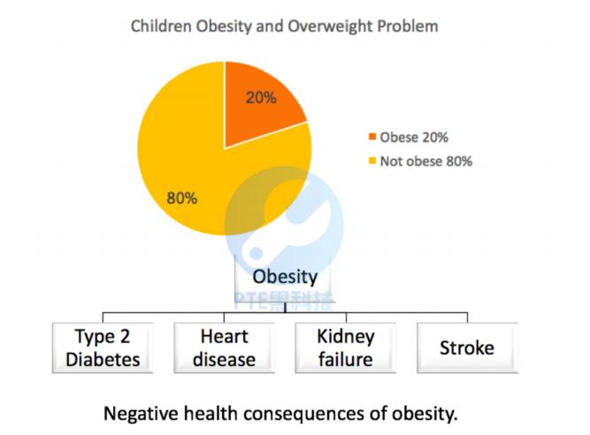
音频原文
Two studies have also found a link between obesity and variations in the bacteria species
that live in our digestive systems, no matter the cause. Obesity is an escalating global
epidemic. It substantially raises the probability of diseases like diabetes, heart disease,
stroke, high blood pressure and cancer. It aﬀects virtually all ages, genders and
socioeconomic groups in both developed and developing countries, with a 60% rise in child obesity globally over just two decades. The problem is too signiﬁcant to ignore. Once a
person is obese, the climb to recovery becomes progressively steeper. Hormonal and
metabolic changes reduce the body's response to overeating. After losing weight, a formerly overweight person burns less calories, doing the same exercises as the person who is
naturally the same weight, making it much more diﬃcult to shed the excess fat and as
people gain weight. Damage to signaling pathways makes it increasingly diﬃcult for the brain to measure food intake and fat storage. There is, however, some evidence that well
monitored long term changes in behavior can lead to improvements in obesity related health issues, in weight loss from sustained lifestyle changes or invasive treatments like bariatric
surgery can improve insulin resistance and decrease inﬂammation.

参考答案

This lecture talks about the overweight problem.

According to the speaker, he has mentioned some points of view.

There are 20% of children today have the overweight problems, which bring the heart diseases are more and more common in children, the smallest is 5 years old.
This situation makes the heart attack and other health problems become earlier and earlier.

This issue needs to be solved because the overweight problems will be in more serious situations such as diabetes type 2 and blindness.

obese - L1 - /oʊ ˈ bis/ adj. 极为肥胖的 ，肥大的；
metabolic - L1 - / ˌ metə ' bɒlɪk/ adj. 新陈代谢的； 变化的；
digestive - L2 - /daɪ ˈ dʒɛstɪv, dɪ-/ adj. 消化的； 助消化的；
escalate - L2 - / ˈ ɛskə ˌ let/ vt. 使逐步升级； 使逐步上升； 乘自动梯上升； socioeconomic - L2 - / ˌ soʊsɪoʊikə ' nɒmɪk/ adj. 社会经济学的；
shed - L3 - /ʃed/ n. 棚 ，库； 分水岭；
inflammation - L4 - / ˌ ɪnflə ˈ meʃən/ n. [医]炎症； 燃烧； 发火；

200. Pavlov Experiment / 巴普洛夫实验 #1325 中频 不可练习
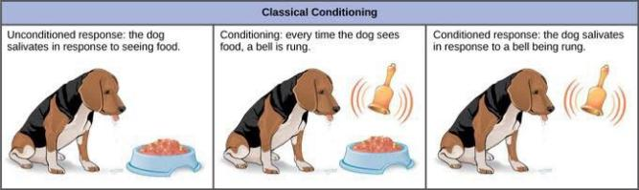
一个图上面分三个步骤, 和一条狗, 讲的是巴甫洛夫(Pavlov)实验, 关于狗的一个实 验, 图上有大 title, 有狗, 狗的饭盆, 貌似还有铃铛, 给狗狗喂食 条件反射, how motivation works, 响铃铛喂食, 然后以后一响铃唾液就会增加, Classical conditioning.
This lecture talks about the Pavlov experiment.
According to the speaker, he has mentioned some points of view.
There are 3 steps in the experiment.
Firstly, the unconditioned response means the dog salivates in response to seeing food.
Secondly, the conditioning means every time the dog sees the food, just ring the bell.
Finally, the conditioned response means although there is no food, you just ring the bell and the dog will salivate.

bell - L1 - /bɛl/ n. 钟 ，铃； 钟声 ，铃声； 钟状物； [建]圆屋顶； salivate - L5 - / ˈ sælə ˌ vet/ vi. （ 过量地） 分泌唾液；

201. Human behavior / 人类行为 #1324 超高频
音频原文
Determinant, human behavior is aﬀected by internal and external factors. At the end of lecture, the speaker mentioned that psychologists are interested in explaining human behavior.
Determinant is inﬂuenced by two factors, the personal factors which are internal and the
environmental factors which are external. The personal factors include people’s belief on certain things and their individual thinking about it, while the environmental factors include temperature, air pressure and the others’ thinking about them. In conclusion, one’s
determinant are aﬀected by both himself and the environment.

参考答案
This lecture talks about human behavior.

According to the speaker, he has mentioned some points of view.

There are so many psychologists are interested in explaining that human behavior.

The internal are external factors can aﬀect the human behavior.

The personal factors are internal and the environmental factors are external.

The personal factors include people’s belief and their individual thinking.

The environmental factors include temperature, air pressure and other’s thinking about him.

In conclusion, human behavior are determined by himself and environment.

202. Australian city / 澳洲的城市 #1323 中频
音频原文
Australia 's location is important for the world 's export, and it 's international trade is also very important. Since Australia has a broad territory, all towns are scattered around. There is a
huge expense for transportation for trains and ferries. The government also pays large
amount for its telecommunication to build up the connection among regions. The Australian people are mainly living in ﬁve cities, and they are Melbourne, Sydney, Perth and Brisbane and so on. The most special one is Perth, which is one of the most isolated cities in the
world. However, this does not aﬀect its state to be the largest city in Australia. Most large companies, like the two leading company, Telstra and Qantas, they are all based in Perth.

参考答案
This lecture talks about Australia.

According to the speaker, he has mentioned some points of view.

Australia’s location is important for the world’s export.

Its international trade is also important. Since Australia has a broad territory.

The Australian people are mainly living in 5 cities which are Melbourne, Sydney, Brisbane, Perth and so on.
Perth is one of the most isolated city in the world and there are two leading companies such as Telstra and Qantas which are based in Perth.

203. Narratives / 故事 #1322 超高频
音频原文
The comics I show you with lots of people chatting around in a room is a form of description. We use diﬀerent kinds of methods to describe a situation. Sometimes we have to use visual description, particularly when we do not witness the scenario. I was born during the Second World War and my hometown is X, for example when I asked my mother about the war, I
always ask her you have mentioned this or that when you talked to me when asked her
about the shelter, I asked her what the shelter looks like and when did you go to the shelter. From her response I could get more visual evidence as I can to write my book.
参考答案
This lecture is about visual description.

Firstly, the speaker mentions about the comics with many people chatting in a room and it is a form of description.
Secondly, the speaker mentions that people use diﬀerent kinds of methods to describe a situation.
Thirdly the speaker mentions that people have to use visual description when they don’t see the scene.
He used own experience as an example describing the second war, his home town and the shelter his mother went to.
In conclusion, in such way the speaker gets visual evidence to write his book.

comics - L3 - / ' kɒmɪks/ n. 连环画杂志； 连环漫画杂志( comic的名词复数 ) ；喜剧演员； （ 报刊上的） 连环漫画栏；

hometown - L4 - / ˈ hoʊmtaʊn/ n. 家乡 ，故乡； “ home town ”的变体；

204. Climate change / 气候变化 #1321 超高频
音频原文
Some adverse eﬀects of climate changes to agricultural productions. Some lands are
unsuitable for growing crops. There will be millions of people facing hunger in Africa in the near future. Climate change will result in less production and less food. It is diﬃcult for
developing countries to deal with climate change due to their ﬁnancial status and other issues. There are many people living in hunger especially in Africa.
The climate change has devastating eﬀects on world economy. The tropical areas on earth are dry and hot, and are originally not suitable for food production. The change of climate leads to extreme weather conditions such as ﬂoods and hurricanes, which exacerbates the food production.
As a result, it leads to a continuous decline in food supply annually around 10% to 17%. And this trend is perceived to be continuing in the future by 2070. The regions suﬀering the most will be some African countries.
参考答案
This lecture talks about the inﬂuence of climate change.

According to the speaker, he has mentioned some points of view.

Climate change will make less production and less food.

It is diﬃcult for developing countries to deal with climate change due to their ﬁnancial status and other issues.
There are many people living in hungry, especially in Africa.

The climate change will also have negative eﬀects on the world economy.

exacerbate - L1 - /ɪg ˈ zæsərbeɪt/ vt. 使恶化； 使加重； 激怒；
unsuitable - L2 - /ʌn ˈ sutəbəl/ adj. 不合适的 ，不适宜的 ，不相称的； 锄悟难入； 不当；

205. Changes in Economic Structure / 经济结构变化 #1320 低频 不可练习
The lecture is mainly about change in economic structure in Europe.
In the beginning of the lecture, the speaker mentioned that after industrial revolutions, around the beginning of 20th（or 19th century,） the economic structure in Europe
changed dramatically.

Lots of machinery had been used in manufacturing such as steam engine. Because of
this, the circulation of goods and services had become faster and so accumulated more wealth.
And this consequently leads to an expansion of middle class population. This again contributed to more accumulation of social wealth.

206. Civil Society Groups / 公民社会团体 #120 中频
音频原文
But in the face of this sense of dis-empowerment, there is no decline in involvement in
organizations, which seek to share wealth and opportunities, which seek to protect one
another 's rights and work towards the common good. According to the UN, civil society
groups have grown 40-fold since the turn of the last century. Sorry, since the turn of the year last century.
Internationally, the non-proﬁt sector is worth one trillion dollars, there are 700,000 not for
proﬁt organizations in Australia alone. The UN recognizes 37,000 speciﬁcally civil society
organizations across the globe working international relief, and gave accreditation for many of them.
This profound movement towards harnessing voices and resources from outside the realm of governments and oﬃcialdom reﬂects a growth in trust, the third sector NGO 's. Putnam
discovered in the ﬁeld of local government in Italy. The best predictor of governmental success was the strength and density of a region 's civic associations.
参考答案
This lecture is about civil society groups.

Civil society groups have grown by 40-fold since last century.

Nowadays, the non-proﬁt sector is worth 1 trillion dollars, and there are 700 thousand such organizations in Australia.
The UN recognizes 37 thousand organizations across the globe.

The speaker emphasizes the importance of NGO, which is called “the third sector” .

realm - L1 - /rɛlm/ n. 领域 ，范围； 王国； （ 学术的） 部门 ，界； （ 动植物分布的） 圈 ，带； predictor - L1 - /prɪ ˈ dɪktər/ n. 预言者 ，预报器；
accreditation - L4 - /ə ˌ krɛdɪ ˈteʃən/ n. 委派 ，信赖 ，鉴定合格；

207. Stars / 星星 #118 中频 不可练习

There are many stars in the galaxy.
Some stars ' temperature is very high so they self-burned.
Other stars are very cold.
There are average 7 new stars in the galaxy every year.
Only 20% are suitable, so every 5 years there will be a new suitable star.

208. Shuttle / 航天飞机 #117 中频
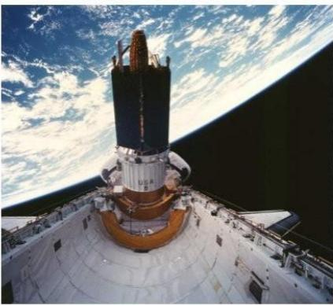
音频原文
The shuttle was designed to be a space truck. It 's a multipurpose vehicle. We 've done
tremendous number of diﬀerent things with it. It 's the most versatile space vehicle that has ever been built. We 've used it to launch satellites, we 've used it to repair satellites in orbit and put them back into orbit.
We 've used it to capture satellites and bring them back to earth for repair.

We 've outﬁtted it with the space lab built by our European partners and used it before the era of the space station to do scientiﬁc research.
We used it as part of our partnership with the Russians, which is still continuing ﬁrst as part of the Mir space station, where we actually prolonged the useful life of Mir by several years through logistical supply visits with the shuttle, and now of course, we 're using it to build the new international space station, which is a huge international partnership.
参考答案

The shuttle was a space truck it 's a multi-purpose vehicle.

The shuttle is the most versatile space vehicle that has ever been built.

People used it to launch and repair satellites and outﬁtted it with the space lab and used it to do scientiﬁc research.
People used it as part of the partnership with the Russians, which is still continuing.

People will use it to build the new international space station, which is a huge international partnership.

shuttle - L1 - / ˈʃʌtl/ n. （ 织机的） 梭子； 航天飞机； （ =纫机的） 滑梭； 短程穿梭运行的飞机 （ 或火车 ，汽车） ； repair - L1 - /rɪ ˈ per/ vt. 修理； 纠正； 恢复； 弥补；
versatile - L2 - / ˈvɜrsətl/ adj. （ 指工具、机器等） 多用途的； 多才多艺的； 有多种学问、技能或职业的； 多功能的；
logistical - L2 - // adj. 逻辑的； 后勤方面的；

209. Community Service Worker / 社区服务工作者 #115 中频 不可练习
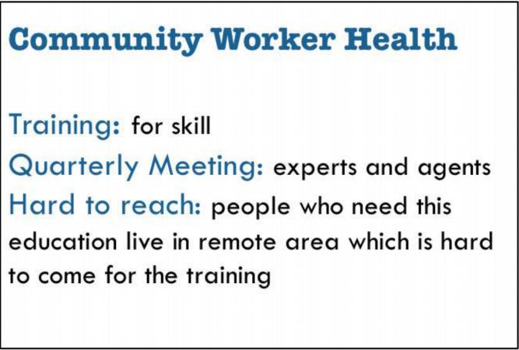
Ppt上有三点. basic advice and counselling skills. quarterly meetings. seminar gourps. india workers 只是在ppt的第二点提到 最后说 seminar groups are not suitable for
particular groups.

The lecture talks about Community Service Worker in India. And diseases, such as HIV, are diﬃcult to control.
Training is essential for workers to understand the precaution knowledge and prevent disease from spreading.
These trainings will be provided by big hospitals and professionals.
The regular meetings will be held to follow up.
Large workshops and seminars are not necessary in some cities.

training - L3 - / ˈtrenɪŋ/ n. 训练； 培养； （ 枪炮 ，摄影机等的） 瞄准； 整枝法；

210. Mega Cities’ Impact / 大城市的影响 #113 高频 不可练习
The lecture is about mega cities’ impact.
Global population has increased by 4 folds, from 1.5 billion in 1900 to 6 billion in 2000.
While resource consumption has increased more signiﬁcantly by 16 folds over the century.
Due to urbanization, cities, which only account for 2% of the land, have 50% of the total population and consume 75% of the resources.
People not only use every resource but also produce tons of wastes.

211. Marshmallow test / 棉花糖实验 #112 超高频
音频原文
They call it the marshmallow test. A four to six year old child sits alone in a room at a table facing a marshmallow on a plate. The child is told: "If you dont eat this treat for 15 minutes you can have both it and a second one. Kids on average wait for ﬁve or six minutes before eating the marshmallow. The longer a child can resist the treat has been correlated with
higher general competency later in life.

Now a study shows that ability to resist temptation isn 't strictly innate it also highly
inﬂuenced by environment. Researchers gave ﬁve year old used crayons and one sticker to decorate a sheet of paper. One group was promised a new set of art supplies for the project but than never received it. But the other group did receive new crayons and better stickers.
Then both groups were given the marshmallow test. The children who had been lied to
waited for a mean time of three minutes before eating the marshmallow. The group that got their promised materials resisted an average of 12 minutes.
Thus, the researchers note that experience factors into a child 's ability to delay gratiﬁcation. When previous promises have been hollow, why believe the next one?

参考答案
The lecture discusses ability of resisting temptation.

The marshmallow experiment shows that the longer time a child resist the treat, the higher competitive he or she will be later in life.
A study shows that the ability isn’t strictly innate but highly inﬂuenced by environment.

From controlled experiments, the group had been denied for prizes as promised resisted the treat on the following marshmallow experiment for less time than the group prized.
If pervious promise was denied, the ability of resisting temptation got hampered later.

crayon - L1 - / ' kreɪən/ n. 彩色蜡笔或粉笔；
hollow - L1 - / ˈ hɑloʊ/ adj. 空的； 空洞的； 虚伪的； 空腹的；
sticker - L2 - / ˈ stɪkɚ/ n. 张贴物； 固执的人 ，坚持不懈的人； 难题 ，使人为难的东西； 踌躇不决的人； lied - L2 - /lid/ n. 利德 （ 钢琴伴奏的德国独唱歌曲） ；

212. Economic Development / 经济发展 #111 高频
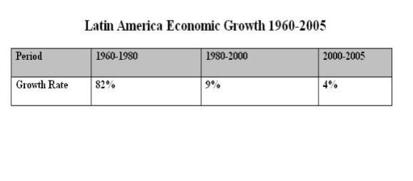
音频原文
What has happened in Latin America as a result of globalization? Well, they have had now
more than a decade of what is called reform, a decade of globalization. And throughout the continent, people are asking questions like has reform failed us? Has globalization failed us? Because clearly things have not worked out the way they were told they ought to. Just to
give you a picture, they were told that reform would lead to faster economic growth after a
decade. What are the numbers? In fact, recent growth is far slower than it was in the ﬁfties, sixties and seventies before reform. That is not a very inspiring success story. Even in the
beginning part of the nineties, growth was still below what it was in the ﬁfties, sixties and
seventies. But the growth it got in the beginning of the period was not sustainable and it was

not sustained throughout the region, poverty as measured on the two dollars a day standard as a percentage of the population was actually up.
参考答案
This lecture is about the economic development in Latin America.

Over the past 20 years, the economic development in Latin America grew by 80%.

After the globalization and reform, the growth slowed down from 80% to 10%.

The economic growth after reform has become unsustainable.

Some people start to consider if the reform is positive or not.

ought - L1 - /ɔt/ aux. 应该 （ 指道义上有责任） ；应当 （ 显⽰所采取行动正确或明智） ；可能会； 预料会做 （ 某事） ；
seventy - L2 - / ˈ sɛvənti/ n. 七十； 从七十到七十九的数目 、年数或温度；
ninety - L4 - / ˈ naɪnti/ num. 九十；

213. Wind Power / 风能转换器原理 #110 中频
音频原文
Wind turbine is a device that will convert wind into mechanical movement, which we can use to power water pump or electricity generator. Now the power that the turbine creates is
obviously depended on the wind speed, it also depended obviously on the number of sails,
the area of the sails and the angle of the sails makes to the wind. So you can imagine if the
turbine blades ﬂat onto the wind, the wind 's going to just bend it, if there is slight angle when the wind hits it, it 's going to turn the blades. We can use that for powering things. Now, we 're going to have a go, making some of the very, very simple paper windmills, a sort of things
that you can make from the bits and pieces lying around home, and use that to drive very small generator to power electronic devices
参考答案
In the lecture, the speaker talks about wind power plant.

At the beginning of the lecture, the speaker saves it is a device that can convert wind into mechanism energy, which can be used for water power pump or electricity generator.
Also, the speaker mentions the turbine created depend on the wind speed, the number of sails, the area of sails and the angles that sails make to the wind.
According to the speaker, as bending the angle of the blades, the wind hits them and could turn the blades, and then you can use it for powering things.
Lastly, the speaker indicates that we could make simple windmills to drive electronic devices.

blade - L1 - /bled/ n. 刀片 ，剑； （ 壳、草等的） 叶片； 桨叶； 浮华少年； windmill - L2 - / ˈ wɪnd ˌ mɪl/ n. 风车； 旋转玩具； <口>直升飞机；

214. Three Stages of Brain Development / 大脑发育三阶段 #109 超高频
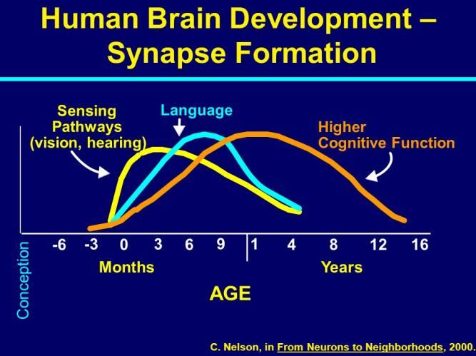
音频原文
Stages of Brain development- brain development during childhood, there are three stages, starting from the primitive brain, limbic brain, and ﬁnally to the neocortex. Although
interrelated, the three had its own function. Primitive brain functions to manage the physical to survive, manage reﬂex, motor motion control, monitoring body functions, and process
information coming from sensing. Limbic brain functioning as a liaison to process emotions and the brain thinks, and the primitive brain. While the thinking brain, which is the most
objective part of the brain, receiving input from the primitive brain and the limbic brain.

However, he needed more time to process information from the primitive brain and the limbic brain. The brain thinks the merger is also a place of experience, memory, feeling, and
thinking ability to give birth to ideas and actions. Nerve myelination of the brain takes place in sequence, starting from the primitive brain, the limbic brains, and brain thought. Neural
pathways are more frequently used to make more myelin thicken. Increasingly thicker myelin,

the faster the nerve impulses or signals travel alone nerves. Therefore, a growing child is encouraged to receive input from the environment in accordance with its development.
参考答案
The lecture talks about 3 stages of brain development, which are the primitive brain, limbic brain and neocortex.
Diﬀerent sections of the brain have diﬀerent function and ﬁnished development in diﬀerent times
For sensory pathways, including vision and hearing, develop from embryo time, peak at 3 month old, stop at more than 1 year old.
For language, develop from embryo time, peak around 9 months old, and stop at more than 1 year old.
For higher cognitive function, develop from embryo time, peak at 1 year old and develop for a longer period of time.
Moreover, higher level functions, such as logical thinking, based on lower level of development.

reflex - L2 - / ˈ ri ˌ flɛks/ n. 反应能力； 反射作用； 复印 ，复制； 影像 ， 映像；
liaison - L2 - /li ˈ eɪzɑ:n/ n. 联络 ，联络人； [语]连音； （ 尤指一方或双方已婚的） 私通； [烹]加浓料； thicker - L2 - // adj. 浓的( thick的比较级 ) ；厚的； 稠密的； 亲密的；
limbic - L5 - / ' lɪmbɪk/ adj. 边的 ，缘的；
neocortex - L5 - / ˌ nioʊ ˈ kɔrteks/ n. 新 （ 大脑） 皮层； 新皮质；
interrelate - L5 - / ˌ ɪntərɪ ˈ let/ vt.& vi. <书>相互关联[影响]； thicken - L5 - / ˈ θɪkən/ vt.& vi. （使） 变厚； 使更厚；

215. Thermodynamic Theory / 热力学理论 #106 低频
音频原文
Thermodynamics is the science of the ﬂow of heat. So, thermo is heat, and dynamic is the
motion of heat. Thermodynamics was developed largely beginning in the 1800 's, at the time of the Industrial Revolution. So, taming of steel. The beginning of generating power by
burning fossil fuels. The beginning with the problems with CO2 and global warming. In fact, it 's interesting to note that the ﬁrst calculation on the impact of the CO2 on climate was done in the late 1800 's by Arrhenius. Beginning of a generation of power moving heat from fossil
fuels to generating energy, locomotives, etcetera. So, he calculated what would happen to this burning of fossil fuels, and he decided in his calculation, he basically got the calculation right, by the way, but he came out that in 2,000 years from the time that he did the
calculations, human would be in trouble.

参考答案
The lecture is about thermodynamic theory and kinetic theory, which are major development of physics.
Thermodynamics is about heat and temperature transmission and their relation to energy and work.
The laws of thermodynamic are constant and statistical, describing how quantities behave under various circumstances.
Thermodynamics are obeyed under most situations, although there are exceptions where atoms move randomly with kinetic energy.
thermodynamics - L1 - / ˌ θɜrmoʊdaɪ ˈ næmɪks/ n. 热力学；

216. Underwater Detectors / 水下探测器 #105 超高频
音频原文
Science lets us know what is going on.

Underwater remote detector, which is called Antares, is a kind of camera installed underwater in cages for ﬁsh monitoring in the industry of marine aquaculture.
It is an advanced system of remote technology, by which researchers can remotely monitor ﬁsh on their computers in their universities.
The camera can detect surrounding environments as well as ﬁsh. This helps people ﬁnd out what they eat, what they don 't eat, and how much they eat.
Thus people can stop feeding them if necessary in some situation to save time and labor.

参考答案
The lecture talks about Underwater Antares detectors, which is a camera installed under the water for ﬁsh monitoring.
It is a remote technology system, some researchers can monitor ﬁsh in their computer in University.
The camera can detect surrounding environments and ﬁsh. This help ﬁnd out what they eat and do not eat.
They can stop feeding them if necessary in some situation to save time and labor

underwater - L1 - / ˌʌndər ˈ wɔtə(r)/ adj. 在水中的； 水面下的； detector - L1 - /dɪ ˈtɛktɚ/ n. 探测器； 检测器； 发现者； 侦察器；

217. A Survey with 100 CEO / 对百名CEO的调查 #104 中频

音频原文
In our survey, over a hundred CEOs who had recently been through an acquisition or merger were asked which areas of their activities needed the most eﬀort. As you can see, the most frequent response to this question was that information technology requires the most eﬀort.
According to 58% of those we surveyed, IT was the most time-consuming and needed the most work. This is understandable as many of the IT issues are extremely complex and the consequences of any change in IT can have a signiﬁcant impact. The key is how quickly and eﬀectively IT integration can be achieved. And there has to be a clear understanding of the consequences there may be of not getting it right. The two other areas requiring signiﬁcant attention: sales, marketing and business development on the one hand, and ﬁnancial
management on the other both were selected by 49% of the respondents.

参考答案
The lecture mainly talks about a survey with 100 CEO.

In the beginning of the lecture, the speaker mentioned that the survey is about which area of activity should contribute most eﬀort.
He further discussed that the result from the survey is IT, because IT make a huge inﬂuence on our society. And it is time consuming and complex.

At the end of the lectures, he concluded that other two are marketing of sales and ﬁnancial management and they are equally important.

218. Performance of boys and girls / 男女生学习差您 #103 超高频
音频原文
You can see that the two charts, each give quite a diﬀerent picture of the performance of
boys and girls in the two key subjects of Math and English. It shows that in English, girls
consistently outperform boys over a period of 6 years, achieving scores about 10% above their male peers. There is quite a diﬀerent picture when we look at the Math results with no real diﬀerence between genders in the results. What is the explanation for these key
diﬀerences? To answer this question, researchers look at biological and cognitive factors, and a range of social factors. The interaction between these diﬀerent components in early childhood development are seen as maintained and reinforced in the school context. And this leads to distinct gender patterns of behavior and skills with direct consequences for
school performance and achievement. The ultimate uses of this evidence (are) to show that biological factors, such as patterns of cognitive developments are closely linked to social
factor, such as learned gender categories. This cognitive skills are learned both pre-school and subsequently at school, supported by the responses of teachers, creating a
reinforcement of patterns.

参考答案
The lecture is about performance of math and English for boys and girls.

In English, girls outperform boys, which is 6% better.

In math, boys and girls have no real diﬀerence.

There are two factors, Including biological factors and social factors.

Girls ' pattern recognizing abilities are better than boys.

reinforced - L2 - /riɪn 'fɔst/ adj. 使更具说服力的；
reinforcement - L4 - / ˌ riɪn ˈfɔrsmənt/ n. 加强； 增援； 补给品； 援军；

219. Einstein / 爱因斯坦 #102 高频 不可练习
In the lecture, the speaker talks about Einstein.
In the past people believed that universe was absolutely ﬁxed and unchanged.
This has been transformed by Einstein 's concept of transformation (relative theory)
Einstein said the universe is continuous dynamical change, is changing all the time.
However, Einstein is not the ﬁrst person who proposed this theory.

dynamical - L4 - /daɪ ' næmɪkəl/ adj. 动力 （ 学） 的 ，有力量的；

220. Dark Energy / 暗能量 #100 中频 不可练习
The lecture is about dark energy.
Dark energy is an unknown form of energy, which is hypothesized to permeate all of space and accelerate universal expansion.
Dark energy constitutes most of total energy in observable universe though its density is low.
Two proposed forms of dark energy are cosmological constant and inconstant scalar ﬁelds.
A ﬁeld similar to dark energy that could inﬂate early universe is called big bang.

hypothesize - L1 - /haɪ ˈ pɑθəsaɪz/ v. 假设 ，假定 ，猜测；
inflate - L2 - /ɪn ˈflet/ vt.& vi. 使充气 （ 于轮胎、气球等） ； （使） 膨胀； （使） 通货膨胀； 物价上涨； observable - L4 - /əb ˈ zɜrvəbl/ adj. 观察得到的 ，应遵守的 ，应庆祝的；
scalar - L4 - / ˈ skelɚ , - ˌ lɑr/ adj. 梯状的； 分等级的； 数量的； 标量的；
permeate - L5 - / ˈ pɜrmieɪt/ vt.& vi. 弥漫； 遍布； 渗入； 渗透；
cosmological - L5 - / ˌ kɒzmə ' lɒdʒɪkl/ adj. 宇宙哲学的 ， 宇宙论的；
inconstant - L5 - /ɪn ˈ kɑnstənt/ adj. （ 感情） 易变的 ，无常的； 常变的；

221. Human's Creativity / 人类的创造性 #98 中频
音频原文
Here are three important factors in creativity: people, process and product. The most important one is the process.
First you have to create the right person through education with a creative mind. Second,
you have to create the right process to have people engaged in innovation process. Third,
you need to ﬁnd the right problem to work on. Human beings can survive and prosper largely depending on the creativity they have. If you identify and assess the creativity of a ﬁnished
product, it is taken as a proxy for the creativity of the person who produced such a product. Therefore, a creative product should be surprising, original, beautiful and useful. People
should have factors necessary for genius, ability, and right mindset. You should improve to imitate and change insight look from new perspectives, innovatively create something with imagination to expand conceptual spaces.
参考答案
The lecture talks about human 's creativity.

In the beginning of the lecture the speaker mentions that there are 3 elements, including creative person, creative process and creative product.
Of the most the importance is process.

At the end of the lecture, the speaker concludes that human beings can survive because their creativity.

prosper - L1 - / ˈ prɑspə(r)/ vi. 繁盛 ，成功；
conceptual - L1 - /kən ˈ sɛptʃ uəl/ adj. 观念的 ，概念的；
proxy - L2 - / ˈ prɑksi/ n. 代表权； 代理人 ，代替物； 委托书； 代理服务器；

222. Open Border / 移民与开放边境 #96 超高频
音频原文
I believe our borders should be open. But if that is not politically acceptable for now, Europe should at least open up a legal route for people from developing countries to come work
here. Over time, hopefully, we can move to a position where borders are completely open.
Persuading sceptic won 't be easy. That 's why I think the argument for free migration has to be made at several levels, a principled case, it increases freedom and reduces injustice. a
humanitarian case, it helps people much poorer than ourselves. an economic case, it makes us richer. and a pragmatic case, it is inevitable, so it is in everyone 's interests to make the
best of it. Freedom of movement is not just a matter of human rights and international
solidarity. it is in our self-interest. Opening our borders may seem unrealistic. But so too, once, did abolishing slavery or giving women the vote. Campaigning for people 's right to move freely is a noble cause for our time.
参考答案
Developed countries should open borders for other countries.

There are two important factors in economy and in humanity for opening borders.

Economically, people from developing countries can go to developed countries and work there, they can help to develop countries get richer.
Also, for humanity reason, it will allow more freedom for poor people in developing countries.

injustice - L1 - /ɪn ˈ dʒʌstɪs/ n. 不公平； 非正义； 待 不公正； 冤枉；
unrealistic - L1 - / ˌʌnriə ˈ lɪstɪk/ adj. 不切实际的； 不现实的； 空想的； 不实在的； pragmatic - L2 - /præɡ ˈ mætɪk/ adj. 实际的； 实用主义的； 好管闲事的； 国事的； solidarity - L2 - / ˌ sɑlɪ ˈ dærəti/ n. 团结；
sceptic - L5 - / ˈ skɛptɪk/ n. 多疑者； 怀疑宗教的人； 无神论者； 怀疑论者；

223. A New Weapon / 一种新的武器 #95 超高频
音频原文
Word comes from California of a new weapon in the war on household pests.

Two scientists working for a ﬁrm in Anaheim, California, have developed a method to eliminate insects without using dangerous chemicals.
The new poison? Hot air.

The basic idea is that insects cannot adjust to temperatures much above normal.

In laboratory experiments, cockroaches and termites can 't survive much more than a quarter of an hour at 125 degrees Fahrenheit, or about 50 degrees centigrade.
The new method involves covering a house with a huge tent and ﬁlling it with air heated to around 65 degrees centigrade.
Hot air is forced in with fans, and the tent keeps the heat inside the house.

Since termites try to escape by hiding in wooden beams, the heat treatment must be continued for a full six hours.
But when it 's all over, and the insects are dead, there are no toxic residues to endanger humans or pets, and no funny smells.
Scientists claim that there is no danger of ﬁre, either, since very few household materials will burn at 65 degrees centigrade.
In fact, wood is prepared for construction use by drying it in ovens at 80 degree centigrade, which is substantially hotter than the air used in this procedure.
参考答案
A new weapon to eliminate insects without using dangerous chemicals is hot air.

Because insects cannot bear high temperatures.

In the experiment, all the insects in the huge tent was killed by hot air without hurting humans or pets, and had no funny smells.
Also, there is no danger of ﬁre to use this method.

fan - L1 - /fæn/ n. 扇子 ，风扇； 迷 ，粉丝； 扇形物； 扬谷机；
residue - L1 - / ˈ rezɪdu/ n. 残余 ，残渣； 余渣 ，残余物； [法]剩余财产； [林]废材；

funny - L1 - / ˈfʌni/ adj. 有趣的 ，好笑的 ，滑稽的； （ 口） 稀奇的 ，古怪的 ，奇您的； 有病的 ，不舒服的； 狡猾的 ，欺骗 （性） 的 ，可疑的 ，不光明的；
oven - L2 - / ˈʌvən/ n. 烤箱 ，烤炉 ，灶；
poison - L3 - / ˈ pɔɪzən/ n. 毒药； 酒； 极糟的食物； 极有害的思想 （ 或心情等） ； tent - L3 - /tɛnt/ n. 帐篷； 帐篷状物； 塞子；
termite - L5 - / ˈtɜrmaɪt/ n. 白蚁；

224. Factors of Animal Survive and Reproduce / 动物生存繁殖的因素
#93 低频 不可练习

In this lecture, the speaker talks about the factors of animal survive and reproduce, which include temperature tolerance, body size, behavior and altitude they live.
For example, animals will die if put into a fridge. This shows the importance of seasons and climates to animal survival.
Some species even migrate to ﬁnd suitable habitats for diﬀerent climate and season.
Climate and season are vital factors for animal survival.

225. Eukaryotic Cell / 真核细胞 #90 低频
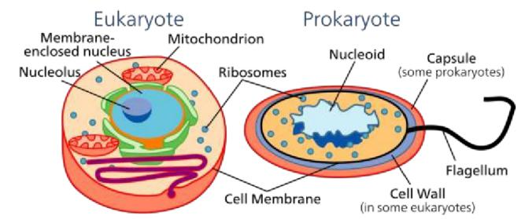
音频原文
The basis of all life on Earth is the cell. All creatures on Earth are made of cells. I am not
gonna dwell on the biology of cells and much it is not that relevant. But I do want to point out a few things. First of all, there are 2 sorts of cells. As we think all the prokaryotic cell, which is fairly simple and it is the thing that all bacteria are made of. And then we have a eukaryotic
cell, much more complicated beasts on the right, which did not appear until well into the
history of the biosphere on earth. And there are many single-celled eukaryotes. But there are also and importantly multicellular organisms and all of those are based on the eukaryotic cell.
参考答案

This lecture talks about eukaryotes and prokaryotes.

Eukaryotes have special membrane-bound compartments called organelles, which do not exist in prokaryotes.
Eukaryotes can be single-celled or multi-celled.

Cells are huge in comparison to bacteria.

The biggest diﬀerence between eukaryotes and prokaryotes is whether there is a nucleus.

beast - L1 - /bist/ n. 野兽； 人面兽心的人； 讨厌的人 （ 或事物） ；老顽固 ，坏蛋； biosphere - L1 - / ˈ baɪoʊsfɪr/ n. 生物圈； 生物界； 生物层；

226. Amory Lovins / 绿色节能先生 #88 低频
音频原文
Amory Lovins is an American consultant experimental physicist and he has been active at
the nexus of energy, resources, economy, environment, development and security in more
than 50 countries for over 40 years. He pays attention on energy saving and how to use
energy in a more eﬃcient and sustainable way. He built a house with plenty of energy-saving concepts. He 's an unusual character with a wide range of knowledge and a genius, but he 's not a scientist. He has a consulting company and lives in a house that build on a mountain. For 30 years, he used a lot of ways to save energy and solved problems with technologies
that already existed and demonstrate them. Some people think he is so crazy. A female writer wrote a book about him which is called Mr Green.
参考答案
This topic is described as Amory Lovins. He is an environmentalist with a wide range of
knowledge but not from the academic world. He runs a consulting company and is regarded a genius. He is dedicated himself to saving energy and resource problems, building a house by himself at the top of a mountain. In conclusion, a writer called him Mr Green, but other
people call him crazy Amory Lovins.

crazy - L1 - / ˈ krezi/ adj. 疯狂的； 不理智的； 离奇的； 生气的；
amory - L5 - // [人名] [英格兰人姓氏] 艾默里 Amery的变体； [地名] [美国] 埃默里；

227. Language extinction / 语言灭绝 #86 中频
音频原文
A language dies when the last person who speaks it dies. But you know, sometimes people say it dies when the second-last person who speaks it dies, because the last person has
nobody to talk to. Well, of course, languages have come and gone throughout history as

communities have come and gone. But what 's happening now is something really quite extraordinary.
Well, there are about 6,000 languages in the world at the moment, more or less. Nobody
knows the exact number. Of these, people think about half of them are so seriously
endangered that they are likely to die out in the course of present century. Now the present century is a hundred years, half is 3,000 languages. So, that means one language is dying out somewhere in the world on average every two weeks.
There are all kinds of reasons why languages die: One is the physical reason when people
are aﬀected by famine, and disease and earthquake. Another is genocide, when some
countries deliberately try and stamp out a small language. The main reason is globalization. That is, there are some huge languages in the world, like English, and Arabic, and Spanish
and French. And these are like stream rollers crushing the smaller languages that they ﬁnd in their path.
A great deal can be done to preserve an endangered language. The ﬁrst thing is that the
people themselves must want the language to be preserved. That 's very important. The
second thing is the powers that be must want the language to be preserved. They must have a respect for the minority languages that are in their care. The third thing that has to be there, of course, is cash. It costs quite a lot of money to preserve an endangered language. Think
about it, you have to train the teachers. You have to write books for the children. And all that sort of thing. It doesn 't cost an extraordinary amount of money, but it does cost a bit. So
without money, endangered languages don 't have a positive future.

参考答案
This lecture talks about the endangered language.

Firstly, the speaker mentions that there are many languages in the world and half of them are in danger and may die out.
Secondly, the speaker says that many reasons contributing to languages’ death, including physical reason and genocide.
The main reason is globalization driven by huge languages, such as English.

Thirdly, the speaker talks about language preservation.

Both people and powers must want to preserve languages and respect the minority and the cash is needed.
In conclusion, without money, endangered languages don’t have a positive future.
genocide - L3 - / ˈ dʒɛnə ˌ saɪd/ n. 种族灭绝； 灭种的罪行； 斩尽杀绝； crush - L3 - /krʌʃ/ vt. 压破 ，压碎； 镇压； 弄皱； 挤榨 ，榨出；

228. Hallucination / 幻想 #85 低频
音频原文
A mild form of hallucination is known as a disturbance, and can occur in most of the senses above. These may be things like seeing movement in peripheral vision, or hearing faint
noises and or voices. Auditory hallucinations are very common in schizophrenia. They may be benevolent (telling the subject good things about themselves) or malicious, cursing the subject etc. Auditory hallucinations of the malicious type are frequently heard, for example people talking about the subject behind his or her back. Like auditory hallucinations, the
source of the visual counterpart can also be behind the subject 's back. Their visual
counterpart is the feeling of being looked or stared at, usually with malicious intent.
Frequently, auditory hallucinations and their visual counterpart are experienced by the subject together
参考答案
The lecture discusses hallucination’s impact on human.

Mild hallucinations are known as disturbance and it can occur in most senses.

For example, hearing or seeing falsely.

Auditory hallucinations are very common in schizophrenia and they can be benevolent or malicious.
Visual hallucinations are usually with malicious intent, such as feeling being looked or stared at.
Auditory and their visual counterpart are often experienced by the subject together.

faint - L1 - /fent/ adj. 微弱的 ，模糊的； 软弱的； 无勇气的； 将昏倒似的； intent - L1 - /ɪn ˈtɛnt/ n. 意图 ， 目的； 意思 ，含义；
benevolent - L2 - /bə ˈ nɛvələnt/ adj. 好心肠的； 与人为善的； 乐善好施的； 慈善的； malicious - L2 - /mə ˈ lɪʃəs/ adj. 恶意的 ，有敌意的； 蓄意的； 预谋的； 存心不良的； stare - L3 - /ster/ vi. 盯着看； 显眼； 倒立 ，直竖起；
hallucination - L4 - /hə ˌ lusə ˈ neʃən/ n. 幻觉 ，幻想； 错觉；
schizophrenia - L4 - / ˌ skɪtsə ˈfriniə , - ˈfrɛniə/ n. [医]精神分裂症； 矛盾；

229. Churchill / 丘吉尔对社会的贡献 #84 中频
音频原文
The Right Honorable Sir Winston Leonard Spencer-Churchill, was a British statesman, best known as prime minister of the United Kingdom during the Second World War. At various

times a soldier, journalist, author, and politician, Churchill is generally regarded as one of the most important leaders in British and world history. Considered reactionary on some issues, such as granting independence to Britain 's colonies and at times regarded as a self-
promoter who changed political parties to further his career, it was his wartime leadership
that earned him iconic status. Some of his peacetime decisions, such as restoring the Gold Standard in 1924, were disastrous as was his World War I decision to land troops on the
Dardanelles. However, during 1940, when Britain alone opposed Hitler 's Nazi Germany in the free world, his stirring speeches inspired, motivated, and uplifted a whole people during their darkest hour. Churchill saw himself as a champion of democracy against tyranny, and was
profoundly aware of his own role and destiny. Indeed, he believed that God had placed him on earth to carry out heroic deeds for the protection of Christian civilization and human
progress. A providential understanding of history would concur with Churchill 's self-
understanding. Considered old-fashioned, even reactionary by some people today, he was actually a visionary whose dream was of a united world, beginning with a union of the
English-speaking peoples, then embracing all cultures. In his youth, he cut a dashing ﬁgure as a cavalry oﬃcer as seen in the 1972 ﬁlm Young Winston directed by Richard
Attenborough, but the images of him that are the most widely remembered are as a rather
overweight, determined, even pugnacious looking senior statesman as he is depicted to the right.
参考答案
This lecture talks about Churchill 's contribution to the society.

In the beginning of the lecture, the speaker mentioned Churchill was one of the most important leaders in British and world history.
He further discuss that during 1940, his stirring speeches inspired a whole people during their darkest hour.
At the end of the lecture, the speaker mentioned he was a champion of democracy who supported the protection of Christian civilization and human progress.
In conclusion, Churchill is a great leader in the world.

deed - L1 - /did/ n. 行为； 行动； <律>契约； 证书；
reactionary - L2 - /ri ˈ ækʃəneri/ n. 反动派； 保守分子； 保守派；
troop - L2 - /trup/ n. 军队； 一群； [军]骑兵连；
tyranny - L2 - / ˈtɪrəni/ n. 暴虐； 专横； 暴行；
heroic - L2 - /hə ˈ roʊɪk/ adj. 有英雄气概的 ，英雄的 ，英勇的； 记叙英雄及其事迹的； 夸张的； honorable - L3 - / ˈ ɑnərəbəl/ adj. 可敬的 ，荣誉的 ，光荣的；
stirring - L3 - / ˈ stərɪŋ/ adj. 激动人心的； 鼓舞人心的； 令人激情澎湃的；
destiny - L3 - / ˈ dɛstəni/ n. 命运； 天命 ，天数； 命运的三女神； 主宰事物的力量；
cavalry - L3 - / ˈ kævəlri/ n. 骑兵 （ 队） ；骑兵部队 ，装甲部队； 骑者；

statesman - L4 - / ˈ stetsmən/ n. 政治家；
promoter - L4 - /prə ˈ moʊtə(r)/ n. 助长者； 发起人； 促进者；
wartime - L4 - / ˈ wɔrtaɪm/ n. 战时；
darkest - L4 - // adj. 黑暗的( dark的最高级 ) ； （ 颜色） 深色的； 暗色的； （ 皮肤、毛发等） 棕黑的； concur - L4 - /kən ˈ kə/ vi. 同意； 互助； 同时发生； 共同作用；
visionary - L4 - / ˈvɪʒəneri/ adj. 空想的 ，幻想的； 预言性的； 有远见的； 有智慧的；
dashing - L4 - / ˈ dæʃɪŋ/ adj. 时髦的 ，华丽的； 劲头十足的； 打扮漂亮的； 勇敢的 ，有锐气的； peacetime - L5 - / ˈ pis ˌtaɪm/ n. 和平时期； 平时；
providential - L5 - / ˌ prɑvɪ ˈ denʃ l/ adj. 凑巧的 ，幸运的；
pugnacious - L5 - /pʌɡ ˈ neʃəs/ adj. 好战的 ，好斗的 ，好挑衅的；

230. Variation in Frogs / 青蛙变您的影响 #82 超高频
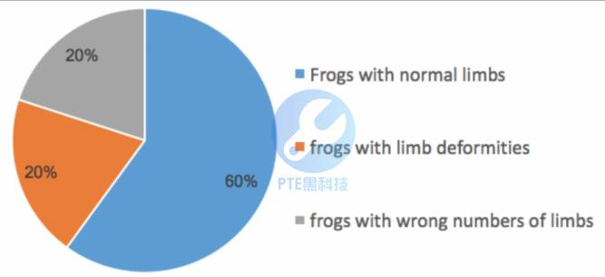
音频原文
Frogs are a diverse and largely carnivorous group of short-bodied, tailless amphibians
composing the order Anura. The oldest fossil proto frog appeared in the early Triassic of
Madagascar, but molecular clock dating suggests their origins may extend further back to
the Permian, 265 million years ago. Frogs are widely distributed, ranging from the tropics to subarctic regions, but the greatest concentration of species diversity is found in tropical rain forests. There are approximately 4,800 recorded species, accounting for over 85% of extant amphibian species. They are also one of the ﬁve most diverse vertebrate orders.
Besides living in fresh water and on dry land, the adults of some species are adapted for
living underground or in trees. Adult frogs generally have a carnivorous diet consisting of
small invertebrates, but omnivorous species exist and a few feed on fruit. Frogs are
extremely eﬃcient at converting what they eat into body mass. They are an important food source for predators and part of the food web dynamics of many of the world 's ecosystems.

The skin is semipermeable, making them susceptible to dehydration, so they either live in moist places or have special adaptations to deal with dry habitats.
Frogs produce a wide range of vocalizations, particularly in they are breeding season, and
exhibit many diﬀerent kinds of complex behaviors to attract mates, to fend oﬀ predators and to generally survive. Frog populations have declined signiﬁcantly since the 1950s. More than one-third of species are considered to be threatened with extinction and over one hundred
and twenty are believed to have become extinct since the 1980s. The number of
malformations among frogs is on the rise and an emerging fungal disease, chytridiomycosis, has spread around the world. Conservation biologists are working to understand the causes of these problems and to resolve them. Frogs are valued as food by humans and also have many cultural roles in literature, symbolism and religion.
参考答案
The graph shows tree types of frogs in diﬀerent region, indicating their life habits and their inﬂuence on human.
The variation of frog has been existing for many years that some have more limbs while some have fewer limbs.
The lecture also explains the reason for the gene mutation.

Many people are worried that river those frogs live will be polluted by them and aﬀect our health.

tropics - L1 - / 'trɒpɪks/ n. 热带地区； 回归线( tropic的名词复数)； 热带 ，热带地方；
vertebrate - L1 - / ˈvɜrtbrət/ n. 脊椎动物；
dehydration - L2 - / ˌ dihaɪ ˈ dreʃən/ n. 脱水； 干燥 ，极度口渴； 失水；
moist - L2 - /mɔɪst/ adj. 潮湿的； 微湿的； 多雨的； 含泪的；
fend - L2 - /fɛnd/ vt.& vi. 谋生； 防御 ，保护； 供养； 闪避 ，挡开；
fungal - L2 - / ˈfʌŋɡəl/ adj. 真菌的 ， 由真菌引起的； 同 “fungous ”；
susceptible - L3 - /sə ˈ sɛptəbəl/ adj. 易受影响的； 易受感染的； 善感的； 可以接受或允许的；
carnivorous - L4 - /kɑr ˈ nɪvərəs/ adj. （ 动物） 食肉的； 肉食；
extant - L4 - / ˈ ɛkstənt , ɛk ˈ stænt/ adj. 现存的 ，仍然存在的；
symbolism - L4 - / ˈ sɪmbə ˌ lɪzəm/ n. 象征主义 ，象征手法； 符号使用； 象征主义； [宗]符号象征；
amphibian - L5 - /æm ˈfɪbiən/ n. 两栖动物； 水陆两用车； 水旱两生植物； 水陆两用飞行器；
invertebrate - L5 - /ɪn ˈvɜrtɪbrət/ adj. 无脊椎的；
omnivorous - L5 - /ɑm ˈ nɪvərəs/ adj. （ 尤指动物） 杂食性的； 肉草兼食的； 对任何事物均感兴趣的； 什么书都看的；
vocalization - L5 - / ˌ voʊkələ ˈ zeɪʃ n/ n. 发声法；
malformation - L5 - / ˌ mælfɔr ˈ meɪʃ n/ n. 难看 ， 畸形；

231. Coﬀee / 咖啡市场的变化 #81 低频
音频原文
Take the coﬀee industry. The ﬁgures are roughly these. The coﬀee market in the world is
worth about 60 billion. The growers get 5.5 billion. Ten years ago, the market was about 30 billion and the growers got a third of that. What has happened? What has happened is that well-meaning people, Americans, Germans, Europeans, decided that they would help
Vietnam. And so they created a coﬀee industry there, which is now the second-biggest
producer in the world. This has serious eﬀects on other countries like Columbia that depend on coﬀee exports.
参考答案
The lecture talks about the changes in coﬀee production.

Coﬀee production has increased from 30 billion to 60 billion during past 10 years. US and Germany help Vietnam to establish coﬀee industry.
The huge demand of Europe and America has made Vietnam the second biggest producer.

It greatly aﬀected Columbia 's production. The output of Central America drastically decreased.
People 's drinking habit changing and the population growth also have great impact on coﬀee industry.
grower - L1 - / ˈ groʊə(r)/ n. 种植者 ，栽培者； 以某种方怯生长的植物；

232. Tertiary education expenditure in Europe / 欧洲高等教育的学费
#80 超高频

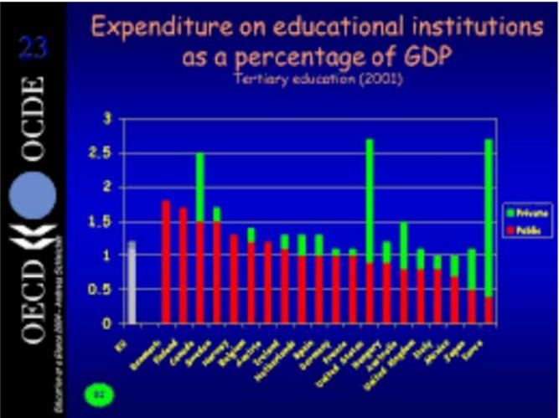
音频原文
To begin with, how underfunded is UK higher education? The table shows the proportion of gross domestic products spent on institutions by the main OECD countries for the latest year for which we have statistics. Twenty o one, it shows that UK spending public and private on higher education institutions was at one point zero eight percent, well below the OECD mean of one point three four percent of GDP. The table clearly shows that the UK is in the bottom
ﬁve countries of the twenty in the table in terms of public expenditure on Tertiary education, its spending being proportionately equal to that of Italy and Mexico. At the other end of the table, we see that Denmark and Finland allocate most public money to Tertiary education
spending, twice as high a proportion of GDP on it as does the UK.

参考答案
The lecture compares the expenses of education institution among diﬀerent European countries.
UK spent 1.08% of its GDP on education institutions, which was insuﬃcient compared to other European countries including Italy, Denmark and Spain.
The expenditure of Italy and France is close to that of the UK.

Denmark and Finland spent much more than the rest of the European countries.

Northern European countries’ tertiary educational expenditure is high.

tertiary - L1 - / ˈtɜrʃ ieri/ adj. 第三的； <医>第三期的； (T-)<地>第三纪的； <化>叔的；

233. NON-Governmental Organization (NGO) / 非营利政府组织 #79
高频
音频原文
A non-governmental organization (NGO) is an organization that is neither a part of a
government nor a conventional for-proﬁt business. Usually set up by ordinary citizens, NGOs may be funded by governments, foundations, businesses, or private persons. Some avoid
formal funding altogether and are run primarily by volunteers. NGOs are highly diverse
groups of organizations engaged in a wide range of activities, and take diﬀerent forms in
diﬀerent parts of the world. Some may have charitable status, while others may be registered for tax exemption based on recognition of social purposes. Others may be fronts for political, religious, or other interests.
The number of NGOs in the United States is estimated at 1.5 million. Russia has 277,000
NGOs. India is estimated to have had around 2 million NGOs in 2009, just over one NGO per 600 Indians, and many times the number of primary schools and primary health centres in
India. NGOs are diﬃcult to deﬁne, and the term 'NGO ' is rarely used consistently. As a result, there are many diﬀerent classiﬁcations in use. The most common focus is on "orientation "
and "level of operation ".

参考答案
An NGO 's orientation refers to the type of activities it takes on.

These activities might include human rights, environmental, improving health, or development work.
An NGO 's level of operation indicates the scale at which an organization works, such as local, regional, national, or international.

classification - L1 - / ˌ klæsəfɪ ˈ keʃən/ n. 分类； 分级； 类别； （ 动植物等的） 分类学；
orientation - L1 - / ˌ ɔriɛn ˈteʃən , -ən- , ˌ or-/ n. 方向 ，定位 ，取向 ，排列方向； 任职培训 ，新生培训； （ 外交等的）方针[态度]的确定； 环境判定；
charitable - L3 - / ˈtʃærɪtəbəl/ adj. 仁慈的 ，慈善的； 宽恕的 ，宽厚的； 慷慨的；
exemption - L3 - /ɪɡ ˈ zɛmpʃən/ n. （ 义务等的） 免除； 免 （税） ； （ 收入中的） 免税额；

234. Australian Export Business / 澳洲与多国的出口业务 #78 超高频
不可练习

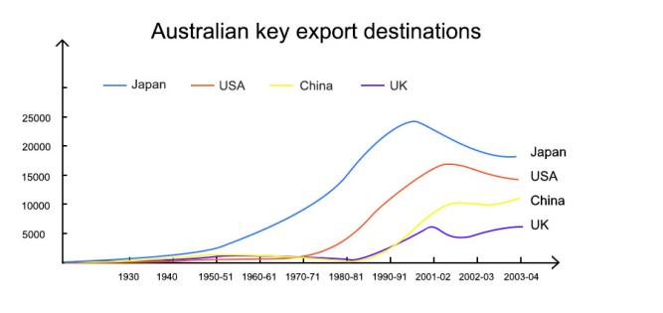
讲澳洲对日本、 美国、 中国近几十年来的出口业务, 以及澳大利亚应该怎么趁亚洲这个好势头促进自己的出口业, 日本中国美英对澳出口的变化从1985到现在.
The lecture talks about China, japan, US 's export business.
In the past, Australia was concerned about its geographical location, which may result in Australia being isolated from North America, UK, and later America.
Nevertheless, nowadays with the rise of Asian countries, especially China, Australia has become a great export country with a perfect location.
Currently, Japan is the largest exporting country to Australia, but China may become the largest one in the future. Australia should take the advantage of China 's raise to develop its exports.

235. Vitamin D / 维生素D的作用 #77 中频
音频原文
Vitamin D refers to a group of fat-soluble secosteroids responsible for increasing intestinal
absorption of calcium, iron, magnesium, phosphate, and zinc. In humans, the most important compounds in this group are vitamin D3 (also known as cholecalciferol) and vitamin D2
(ergocalciferol). Cholecalciferol and ergocalciferol can be ingested from the diet and from supplements.
Very few foods contain vitamin D. Synthesis of vitamin D in the skin is the major natural
source of the vitamin. Demmel synthesis of vitamin D from cholesterol is dependent on sun
exposure (speciﬁcally UVB radiation). Vitamin D from the diet or dermal synthesis from
sunlight is biologically inactive activation requires enzymatic conversion (hydroxylation) in the liver and kidney. Evidence indicates the synthesis of vitamin D from sun exposure is
regulated by a negative feedback loop that prevents toxicity, but because of uncertainty about the cancer risk from sunlight, no recommendations are issued by the Institute of Medicine (US) for the amount of sun exposure required to meet vitamin D requirements.

Accordingly, the Dietary Reference Intake for vitamin D assumes no synthesis occurs and all of a person 's vitamin D is from food intake, although that will rarely occur in practice. As
vitamin D is synthesized in adequate amounts by most mammals exposed to sunlight, it is
not strictly a vitamin, and may be considered a hormone as its synthesis and activity occur in diﬀerent locations. Vitamin D has a signiﬁcant role in calcium homeostasis and metabolism. Its discovery was due to eﬀort to ﬁnd the dietary substance lacking in rickets.
参考答案
The lecture talks about Vitamin D. Vitamin D is not dietary if without sunshine.

Vitamin D is not a real vitamin it’s a hormone. Very few foods contain vitamin D

synthesis of vitamin D in the skin is the major natural source of the vitamin and need sunlight to absorb.
Some regions people less expose in sunlight do not have enough vitamin D and the same in winter when people wear more clothes.

absorption - L1 - /əb ˈ sɔrpʃ n/ n. 吸收； 专注； 合并；
zinc - L1 - /zɪŋk/ n. [化]锌；
ingest - L1 - /ɪn 'dʒest/ vt. 咽下； 获取 （ 某事物） ； 吸收； 接待；
synthesis - L1 - / ˈ sɪnθɪsɪs/ n. 综合； <化>合成； 综合体； 综合推理；
activation - L1 - / ˌ æktɪ 'veɪʃ n/ n. 活化 ，激活 ， [化]活化作用； 致活；
conversion - L1 - /kən ˈvɜrʒn/ n. 变换 ，转变； 改装物； 财产转换 ，兑换； [逻] 换位 （ 法） ；
kidney - L1 - / ˈ kɪdni/ n. 肾 ， 肾脏； （ 可食用的动物的） 腰子； 脾气 ，性格；
inactive - L2 - /ɪn ˈ æktɪv/ adj. 不活动的 ，不活跃的； 懒散的 ，怠惰的； 闲置的； [化]钝性的；
synthesize - L2 - / ˈ sɪnθɪ ˌ saɪz/ vt. 综合； 人工合成； （ 通过化学手段或生物过程） 合成； （ 音响） 合成； magnesium - L3 - /mæɡ ˈ niziəm ,-ʒəm/ n. [化]镁 （ 金属元素） ；
phosphate - L4 - / ˈfɑsfeɪt/ n. 磷酸盐； （ 含有少量磷酸的） 汽水；
toxicity - L4 - /tɑk ˈ sɪsəti/ n. 毒性 ，毒力；
enzymatic - L5 - /enzaɪ ' mætɪk/ adj. 酶的； 酶促； 酶催化；
rickets - L5 - / ˈ rɪkɪts/ n. 软骨病 ，佝偻病 ，驼背；

236. Western Country Child Birth Rates / 西方国家出生率 #76 高频
音频原文
The western countries women are becoming more and more reluctant to give birth to babies.

However, the male 's status in society remains as strong as it ever has in recent years. The
birth rates increased during 20 's century but it starts to decrease over these last two
decades. In the year 2000, as an example, the birth rate remained at around 1%. There are even some negative birth rates in other countries. Birth rates dropped to its lowest point that

has never been seen in the society. It also has impacts on male in the society especially young man, and it might have some connection with unemployment rates as well.
参考答案
The lecture talks about the child birth rates in European countries.

In the beginning of the lecture, the speaker mentioned that the rate decreases to historical low in about 1.1-1.2% in recent years.
The reason is that women in Europe are unwilling to give birth especially those young women under 30 years old.
At the end of the lecture, he concluded that the phenomenon would aﬀect man 's position of life, which will increase their unemployment rate.

237. Bomb calorimeter / 燃烧计测量原理 #75 超高频
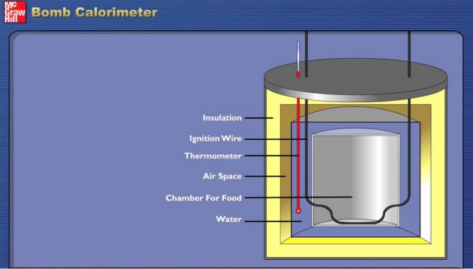
音频原文
This is a bomb calorimeter; this is the actual piece of equipment that researchers used to
calculate the energy content of either biodiesel or maybe even the potato chips that you had for lunch today. When they calculate the amount of energy. They’re going to calculate it in
heat unites which would either be joules or calories. I want you to look inside the bomb
calorimeter inside here, you can see that there’s a silver bucket water goes all in here and
this is actually the bomb is the smaller silver cylinder what you do is put your fuel sample in
there then these two electrodes are connected to the bomb. These provide the spark that will ignite your sample when your sample burns or combust that gives oﬀ energy. So how is the

energy collected or how did a scientist ﬁgure out how much energy is being given oﬀ . Well,
it’s a closed system, there’s a lid here that goes on top of this calorimeter and what’s in here in the lid is a stirrer. The stir is going to stir the water. That’s in this big pool here so that the
heat given oﬀ from the sample is going to warm the water in a uniform way. This is the
temperature probe, this goes down in the water also and measures the change in
temperature because as the sample is burned, it will give oﬀ heat and the temperature the
water will increase. So the lid goes on the sample is prepared. The last thing that you need to make a combustion reaction happen is oxygen and at some point during the process, some oxygen is added by a tank. That’s connected to the calorimeter here. So we are going to
burn a sample of the biodiesel that you’ve prepared and get some feedback on the energy content of it. You’ll be able to use this to compare it to petroleum-based fuels like octane.
参考答案
The bomb calorimeter is a device researchers use to measure the energy content of
substances like biodiesel or even potato chips, calculating the energy in joules or calories.
Inside the calorimeter, a silver bucket holds water, and a smaller silver cylinder, the "bomb, " contains the fuel sample. Electrodes provide a spark to ignite the sample, and as it burns,
the energy released heats the water uniformly. A stirrer in the lid ensures even heat
distribution, while a temperature probe measures the temperature increase. Oxygen is added from a tank to facilitate combustion. By analyzing the temperature change in the water,
scientists can determine the energy content of the sample, allowing for comparisons with petroleum-based fuels.

bomb - L1 - /bɑm/ n. 炸弹； 彻底的失败； [橄榄球] 长传； 高压贮罐；
chip - L1 - /tʃɪp/ n. 碎片； 缺口； （ 作赌注用的） 筹码； （ 足球） 高球；
spark - L1 - /spɑrk/ n. 燃烧的颗粒； 火星 ，火花 ，余火； （ 金属的） 发光的颗粒； 电火花；
combustion - L1 - /kəm ˈ bʌstʃən/ n. 燃烧 ，烧毁； 氧化； 骚动；
cylinder - L2 - / ˈ sɪləndɚ/ n. 圆筒 ， 圆柱； 汽缸； （ 尤指用作容器的） 圆筒状物；
electrode - L2 - /ɪ ˈ lektroʊd/ n. 电极； 电焊条；
lid - L2 - /lɪd/ n. 盖子； 限制； [口]果盖； [口]遮盖；
stir - L2 - /stɚ/ vt.& vi. （使） 移动； 搅拌； （使） 行动； （使） 微动；
petroleum - L2 - /pə ˈtroʊliəm/ n. 石油；
ignite - L4 - /ɪɡ ˈ naɪt/ vt. 点燃； 使燃烧； 使激动； 使灼热；
calorimeter - L5 - / ˌ kælə ˈ rɪmɪtɚ/ n. 热量计； 测热计；

238. Welsh Speaker / 威尔士语使用者 #74 高频
音频原文
Welsh is a Celtic language spoken in Wales by about 740,000 people, and in the Welsh
colony in Patagonia, Argentina by several hundred people. There are also Welsh speakers in England, Scotland, Canada, the USA, Australia and New Zealand. At the beginning of the

20th century about half of the population of Wales spoke Welsh as an everyday language.
Towards the end of the century, the proportion of Welsh speakers had fallen to about 21%. According to the 2001 census 582,368 people can speak Welsh, 659,301 people can either speak, read or write Welsh, and 797,717 people, 28% of the population, claimed to have
some knowledge of the language. According to a survey carried out by S4C, the Welsh
language TV channel, the number of Welsh speakers in Wales is around 750,000, and about 1.5 million people can 'understand ' Welsh. In addition, there are an estimated 133,000
Welsh-speakers living in England, about 50,000 of them in the Greater London area.

参考答案
The lecture talks about Welsh which is a Celtic language spoken in Wales, Wales's colony, England, Canada, USA.
At the beginning of the 20th century about half of the population of Wales spoke Welsh as an everyday language, towards the end of the century, the proportion of Welsh speakers had
fallen to about 20%.

According to the 2001 census about 750,000 people speak, read or write Welsh and 28% of the population have some knowledge of the language.
In the end, the number of Welsh speaker has a positive prediction.

239. Dimensions / 维度 #73 中频 不可练习
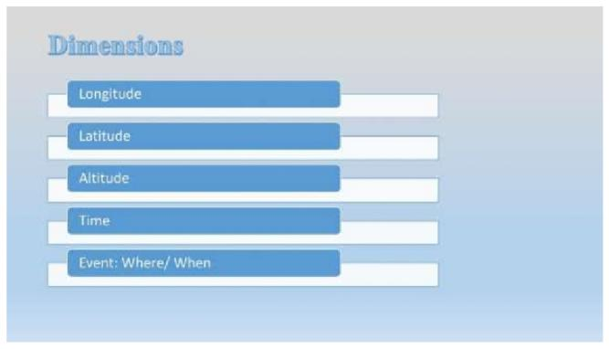
Dimensions can be deﬁned as the number of space or variables used to describe events.

One dimension refers to one variable, which means longitude.
Two dimensions contain two variables: namely, longitude plus latitude.
Three dimensions contains 3 variables: longitude, latitude and altitude.
Four dimensions include the above-mentioned variables and time.
We can use these dimensions to represent every event. however, we seldom use 4 dimensions.
回忆要点：机经基本正确。但是要补充几点 ，作为机经的完善。On the equator of the
earth, we use 1 dimension.; On the surface of the earth, we use 2 dimensions; in space, we use 3 dimensions; the 4 dimensions contain 3 dimensions plus time; we also have 5 dimensions. 最后一句是 we can describe any event by using longitude, latitude, altitude and time. 总体来说不难。 语速适中 ，大家RL时记得把Key word一定要发音清晰
seldom - L2 - / ˈ sɛldəm/ adv. 很少 ，罕见； 难得； 不大；

240. Galaxy Darkness / 银河系黑暗之迷 #72 超高频
音频原文
Our friends at the Highlands Museum and Discovery Center in Ashland, Kentucky, asked a very good question. Why is it dark in space?
That question is not as simple as it may sound. You might think that space appears dark at night because that is when our side of Earth faces away from the sun as our planet rotates on its axis every 24 hours. But what about all those other far away suns that appear as stars in the night sky? Our own Milky Way galaxy contains over 200 billion stars, and the entire
universe contains over 100 billion galaxies. You might suppose that many stars would light the night like daytime.
Until the 20th century, astronomers didn 't think it was even possible to count all the stars in the universe. They thought the universe went on forever. In other words, they thought the
universe was inﬁnite.

Besides being very hard to imagine, the trouble with an inﬁnite universe is that no matter
where you look in the night sky, you should see a star. Stars should overlap each other in the sky like tree trunks in the middle of a very thick forest. But, if this were the case, the sky
would be blazing with light. The problem greatly troubled astronomers and became known as Olbers Paradox. A paradox is a statement that seems to disagree with itself.
So, to try and explain the paradox, some 19th-century scientists thought that dust clouds
between the stars must be absorbing a lot of the starlight so it wouldn 't shine through to us. But later scientists realized that the dust itself would absorb so much energy from the
starlight that eventually it would glow as hot and bright as the stars themselves.

Astronomers now realize that the universe is not inﬁnite. A ﬁnite universe --- that is, a
universe of limited size --- even one with trillions and trillions of stars, just wouldn 't have enough stars to light up all of space.
Although the idea of a ﬁnite universe explains why Earths sky is dark at night, other causes work to make it even darker.
参考答案
This lecture talked about the darkness between galaxies. A picture from NASA explains the darkness.
This picture is copyright free and can be found on newspapers, magazines and on the Internet.
According to the lecturer, gaps between galaxies are not dark.

The reason why we cannot see it is because our eyes are not able to detect the infrared light.

To conclude, the darkness between galaxies still remain mysterious to us.

blaze - L2 - /blez/ n. 火焰； 光辉； 爆发； 光彩；
troubled - L2 - // adj. 焦虑的； 担忧的； 混乱的； 存在诸多问题的；
absorbing - L2 - /əb ˈ sɔrbɪŋ/ adj. 吸引人的； 非常有趣的；
glow - L2 - /gloʊ/ vi. 发光 ，灼热； 脸红； 洋溢 ，喜形于色；
highland - L3 - / ˈ haɪlənd/ adj. 高地的 ，高原 （ 地区） 的； 苏格兰高地的；
suns - L3 - // n. 日 ( sun的名词复数 ) ；太阳； 日光； 恒星；
milky - L4 - / ˈ mɪlki/ adj. 像牛奶的 ，乳白色的； 浑浊的 ，柔弱的； （ 食品） 加了牛奶的； （植物） 分泌乳汁的； starlight - L4 - / ˈ stɑrlaɪt/ n. 星光；

241. Haussmann's renovation of Paris / 拿破仑修缮巴黎 #71 超高频

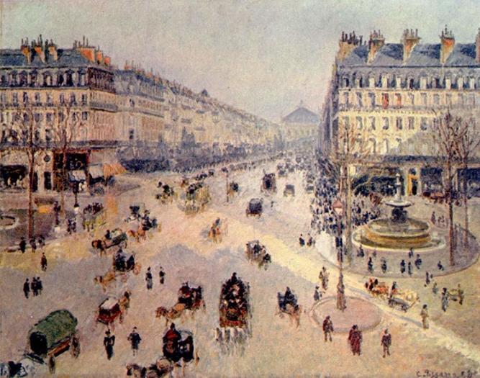
音频原文
Cities are interesting places. Some cities are carefully planned, though for a reason and
reﬂect the needs of people as it grows. Others are less conscientiously designed. Paris, for example, was originally founded in the third century as a small village. And with every
passing generation, it grew in size and importance. It grew from a medieval city to a modern city. But the transition was not always smooth. Emperor Napoleon III had to hire someone to oversee the rebuilding of Paris. The man he chose was George Eugene Haussmann.
In 1853, Haussmann began the process of renovating France’s capital city. His basic
instructions were to bring light and air into the central districts, improve the sanitation and
living areas, and make Paris a more modern beautiful city, not your average weekend
renovation. Haussmann’s projects included the destruction of the old medieval
neighborhoods, widening of streets, building large parks and public squares and addition of fountains and sewer lines.
To add to all of this, the size of Paris had to be increased, doubled actually. And Napoleon III issued oﬃcial decree annexing nearby suburbs to make them part of the city. One of the
main priority of this massive renovation was to connect all of the districts together. If we think of Paris like a house, each district was its own room, existing essentially, independently of
the other districts. Napoleon III wanted it to be easier to travel between the most important

districts. And to create a sense of this being one uniﬁed city, not a series of independent
neighborhoods. So Haussmann created large avenues that connected the districts. More
than that, he made all the avenues look roughly the same. Buildings on a major avenue were required to be roughly the same height and style, and even had to use the same creme-
colored stone for the facade.

The result was to remove any local characteristics and create a uniform Paris. For the ﬁrst time, the city had a speciﬁc look, a style that people began to associate not with a district but with Paris itself.
参考答案
Cities are interesting places, some are carefully planned and others are carelessly designed.

Firstly, Paris grew from a medieval city to a modern one but its transitions wasn’t smooth.

Secondly, Haussmann, hired by the emperor, began renovating Paris, making it more beautiful and destructing the old neighborhoods.
Thirdly, Pairs’ size had to be increased and one of the priority was to connect all districts together, so Haussmann created large, roughly the same avenues for that.
In conclusion, this renovation created a uniform Paris, and for the ﬁrst time, people began to associate not by districts but by Paris itself.

oversee - L1 - / ˌ oʊvər ˈ si/ vt. 监督 ，监视； 俯瞰； 错过 ，宽恕 ，省略；
rebuild - L1 - /ri ˈ bɪld/ vt. 重建； 重新组装； 再形成某事物； 恢复；
neighborhood - L1 - / ˈ nebɚ ˌ hʊd/ n. 地区； 某地区的人； 与某处邻近的地区； 临近街坊；
unified - L1 - / 'junɪfaɪd/ adj. (unify 的过去怯和过去分词)； 统一的； 统一标准的； 一元化的； medieval - L2 - / ˌ midi ˈ ivəl/ adj. 中古的 ， 中世纪的；
decree - L2 - /dɪ ˈ kri/ n. 法令 ，命令； （ 法院的） 判决 ，裁定； （ 教会的） 教令；
renovate - L3 - / ˈ rɛnə ˌ vet/ vt. 翻新 ，修复 ，整修； 革新 ，更新； 恢复 （ 精神） ；
fountain - L3 - / ˈfaʊntn/ n. 人造喷泉 ， 喷泉水； 泉源； 液体贮存器 ，汽水桶 ，冷饮柜； 源头 ，来源； avenue - L3 - / ˈ ævənu/ n. 林荫路； 大街； 途径 ，手段； 〈美〉 （ 南北向） 街道；
sewer - L4 - / ˈ suɚ/ n. 阴沟 ，污水管 ，下水道； 裁=师；
annex - L4 - /ə ˈ nɛks , ˈ æn ˌ ɛks/ vt. 附加 ，追加； 吞并 （ 国家、地区等） ，兼并； 获得 ，得到； facade - L4 - /fə ˈ sɑːd/ n. 建筑物的正面； 外表； 虚伪 ，假象；

242. Inﬁnite Monkey Theory / 猴子打字理论 #69 超高频
音频原文
The inﬁnite monkey theorem states that a monkey hitting keys at random on a typewriter keyboard for an inﬁnite amount of time will almost surely type a given text, such as the
complete works of William Shakespeare. In this context, "almost surely" is a mathematical

term with a precise meaning, and the "monkey " isn 't an actual monkey, but a metaphor for
an abstract device that produces a random sequence of letters ad inﬁnitum. The theorem
illustrates the perils of reasoning about inﬁnity by imagining a vast but ﬁnite number, and vice versa. The probability of a monkey exactly typing a complete work such as Shakespeare 's
Hamlet is so tiny that the chance of it occurring during a period of time of the order of the age of the universe is minuscule, but not zero.
But technologies can help monkeys to write. If the monkeys are given a pen and some
papers to spell the word monkey, they can only scratch on the paper. By contrast, if they are given a typewriter, it will take them over 10 years to produce the right spelling. However, if
they can use computer programing, they can ﬁnish the task within a day.

参考答案
In this lecture the speaker talks about inﬁnite monkey theorem.

According to the speaker she mentions that on a keyboard, a monkey will almost surely type a given text such as the complete works of William Shakespeare.
She indicates that it is a metaphor for an abstract device that produces a random sequence.

She suggests that if they are given a pen and some papers they can only scratch on the paper.
This lecture talks about inﬁnite monkey theorem and the beneﬁts of technology.

peril - L2 - / ˈ pɛrəl/ n. 危险； 冒险；
hamlet - L2 - / ˈ hæmlɪt/ n. 村子； 〈英〉 （ 无教堂的） 小村庄； 〈比喻〉 优柔寡断的人； 哈姆雷特； theorem - L3 - / ˈ θiərəm/ n. [数] 定理； （ 能证明的） 一般原理 ，公理 ，定律 ，法则；
infinity - L3 - /ɪn ˈfɪnɪti/ n. <数>无穷大； 无限的时间或空间；
minuscule - L5 - / ˈ mɪnə ˌ skjul , mɪ ˈ nʌs ˌ kjul/ adj. 非常小的 ，极不重要的；

